Thursday 14th May 2020
SPaG
Spellings – Suffix - ous
Find the total value for each word in your spelling list.

Consonants are worth 2 points
Vowels are worth 5 points

joyous
dangerous
hazardous
poisonous
riotous
mountainous
momentous
scandalous

Word of the Day – mock

Definition ____________________________________________
_____________________________________________________
_____________________________________________________
Used it in a sentence: ____________________________________________________
_________________________________________________________________________
Word Class: ____________________________________________________
Synonyms

English
We are going to look back on one page from The Egyptian Cinderella

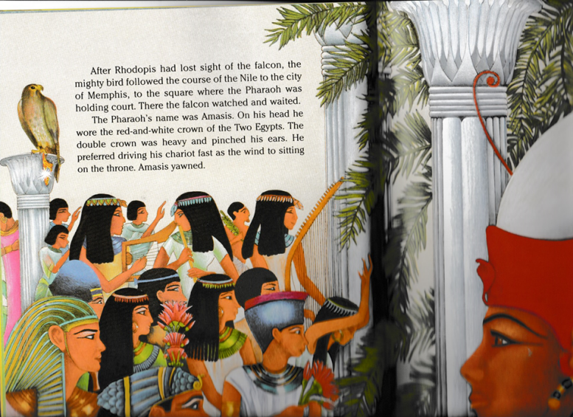

Is the Pharaoh having a good time at the party?

Are there any actions that help us to infer how he feels?

Imagine that Pharaoh was able to send a text message to a friend about how he feels at that moment of the party. Write down his text message.

Pharaoh seems like a man who prefers powerful actions to sitting still.

Can you underline any verbs, adverbs, conjunctions or prepositions you have used?
Maths – Mental
Write the missing numbers and the rule for each number sequence.
1) 70 ____ ____ 100 115 130

2) 650 600 550 ____ ____ 400

3) ____ 843 ____ 643 543 443

4) ____ 515 518 521 524 ____
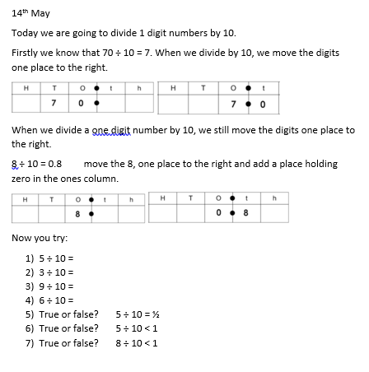
Maths – Main Lesson
History
Use the clues to help you complete the word search

