Thursday 4th June 2020
SPaG
Spellings – Suffix ly
happily
angrily
gently
simply
humbly
nobly
frantically
dramatically

Word of the Day –

Definition ____________________________________________
_____________________________________________________
_____________________________________________________
Used it in a sentence: ____________________________________________________
_________________________________________________________________________
Word Class: ____________________________________________________
Synonyms

English
Task
Use the fact cards to plan where you will put different information into your
newspaper report ready to write it tomorrow. Add in any notes which you think will be useful when writing your report.

Fact Cards

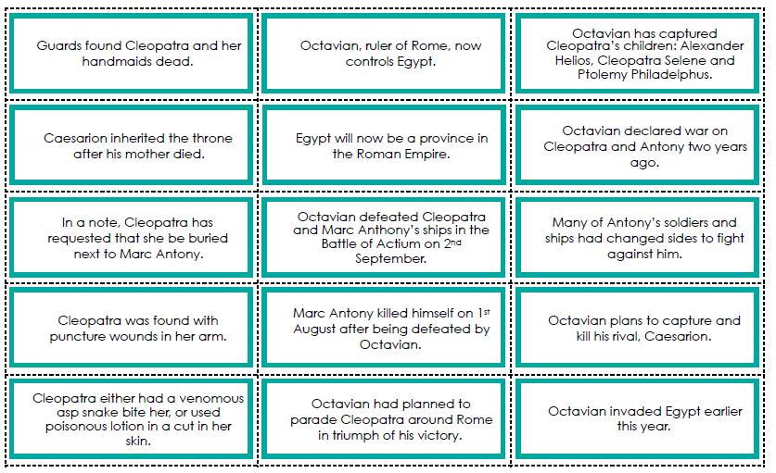

You can use the internet to research facts about Cleopatra’s death. Some suggested websites
are:
• https://kids.kiddle.co/Cleopatra
• https://www.natgeokids.com/uk/discover/history/egypt/cleopatra-snake-scientists-impossible/
• https://easyscienceforkids.com/cleopatra-facts/
• https://www.coolkidfacts.com/queen-facts-for-kids/
• https://www.ducksters.com/history/ancient_egypt/cleopatra_vii.php

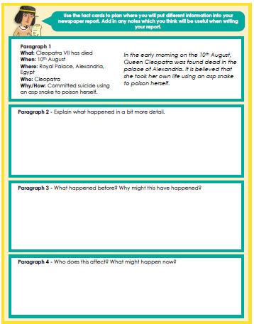

Maths
Watch the rest of the video from yesterday, start at 3 minutes.
https://vimeo.com/418154723
Have a go at more problems involving fractions greater than 1.
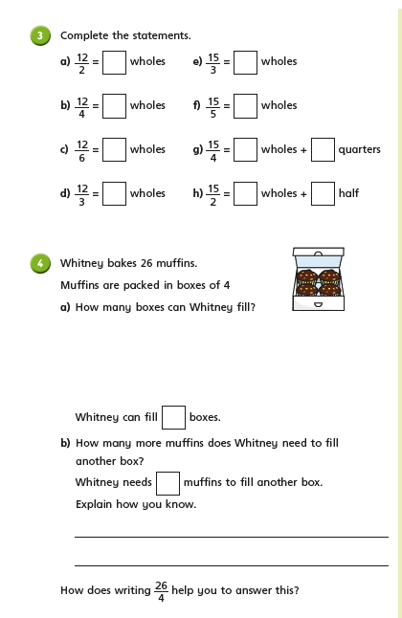

Thursday –music
Ask somebody in your house what their favourite piece of music is and listen to it carefully.
Title of the piece:
Performer:
Composer or Writer:
Year composed/ written:
Genre/ Type of music:
What instruments can you hear?
What word would you use
To describe the piece?

Did you like the piece? Why or why not?

_________________________________________________________________________________
_________________________________________________________________________________
_________________________________________________________________________________

