Friday 3rd April 2020
SPaG
Spellings - Word Families based on common words, showing how words are related in form and meaning.
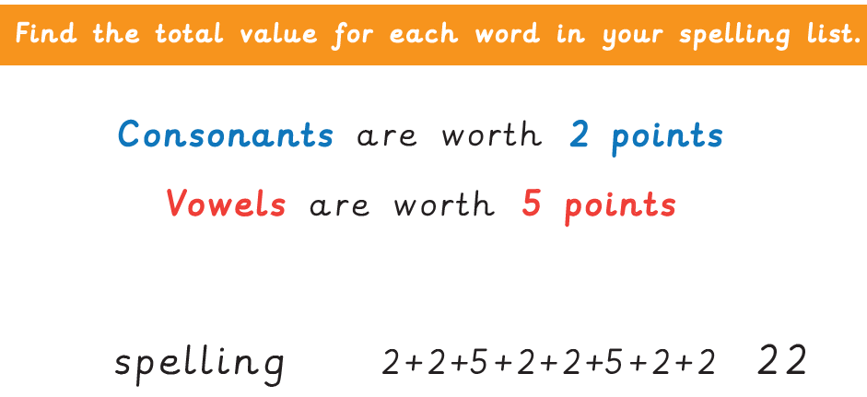
Practise your spellings
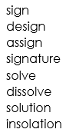

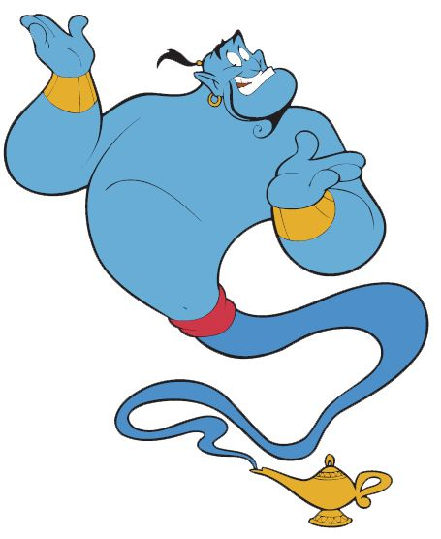
Word of the Day – develop

Definition ____________________________________________
_____________________________________________________
_____________________________________________________
Used it in a sentence: ____________________________________________________
_________________________________________________________________________
Word Class: ____________________________________________________
Synonyms

English – Read the following text and then answer the Viper questions
The Sky Turtle
Flight
The sky turtle is well-adapted to its environment and can breathe, and fly, at very high altitudes. Turtles use strong muscles, located in their chest, to ‘flap’ their flippers and give them the thrust to move through
the air. Their lightweight shells and hollow bones make it easier for them to take flight and stay airborne, whilst their streamlined design makes them the perfect shape to move through the air with ease. Incredibly, the turtle can remain in the air for lengthy periods of time (several hours) though they tend to only do this while migrating and must ingest 3-4kg of insects as they fly. Without eating as they fly, the sky turtles would need to keep stopping to find food on the land.

Sleep
Whilst in flight, it is essential that sky turtles take it in turns to form small groups (around 3 to 4 animals) and allow the weakest in the group to take short sleep breaks on their backs. They do this to keep going over
longer distances. At night, they often roost in trees and often use the abandoned nests of dragons to stay safe.

Predators
Unfortunately, sky turtles form part of the diet of air orcas, and their shells, despite being strong, are no match for the teeth of an adult shark.

Did you know…
A sky turtle can reverse in the air by altering the direction that their flippers flap.

Question - Recall

 | True | False
Sky turtles have lightweight shells and
hollow bones.
Sky turtles take short naps in the sky.
Sky turtles eat air orcas.

Question - Explain

How are sky turtles’ bodies well adapted to flying in the air? Find 3 things.
______________________________________________________________________________________________________________________________________________________

Question – Recall
What two things do sky turtles need to do when they are in the air so that they don’t need to keep stopping and can fly over longer distances?
_______________________________________________________________________________________________________________________________________________________________________________________________________________________________________________________________________________________________________________________________________________________________________________________

Question – Vocabulary

Find a word that means the same  as force. | Find a word that means the  opposite of solid.
Find a word that means the same  as stay. | Find a word that means the  opposite of strongest.

Maths – Mental

1) 56 ÷ 8 =

2) 3 x 9 =

3) 240 ÷ 10 =

4) A television programme starts at 3:15pm and finishes at 3:35pm. How long does the programme last?

5) Maisie was born in 1992. How old was she in 2012?

6) How many millilitres are there in half a litre?

7) Which two numbers make 300? 146 122 154 188

Maths – Shape

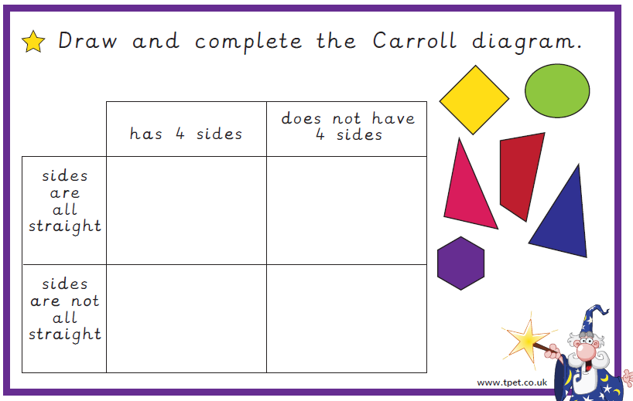

History / Art – Romans

To make a mosaic, you will need:
• a piece of paper to put your mosaic on;
• a pencil;
• small squares of different coloured paper (cut paper into strips and then into squares) you could use old magazines, adverts or newspaper
• scissors;
• glue.

What to do: 1. Choose what your mosaic is going to be of. It could be a pattern or a picture. Look at the examples on the next page if you need inspiration. 2. Lightly draw your design with a pencil. This will help you know where to place the coloured squares. 3. You may want to arrange your pieces of paper into same-coloured groups. 4. Stick the squares in the right place on your design. You might need to cut the squares into different shapes. 5. Some mosaics have a border of black squares; you may wish to add one when you are finished.

