Hello Puffins, Owls and Wrens!

How are you all? We hope you are all well and had a really nice first week after half term. We can’t wait to hear what you’ve been up to over the last week!
We always love to hear what fun things you have been doing over the week and we look forward to seeing your work and photos 😊
We hope you enjoyed the wonderful weather, kept hydrated and safe.
We all have been busy preparing lots of fun activities for you and we hope you will enjoy them.
Please find the next week’s Home Learning pack attached to this letter. Have a go and as always try your best. We are very proud of all of you for trying hard and completing the activities we sent you every week. We can’t wait to see how you are going to impress us and your grown-ups this week! If you have any questions about any of the activities, please just let us know. We are here to help.
Also, here is a little clip to cheer you up and tell you how you can stay safe, enjoy!
https://www.youtube.com/watch?v=DYkIKU_PcBc

Take care, look after yourselves and your families and keep smiling

We miss you all,
Mrs. Cox, Mrs. Milligan, Mrs. Jochacy and Mrs. Athanasiou xxxx

Year 1 Phonics activities – Summer 2 – Week 2 and Year 1 spellings

Session 1 - Monday 8th June 2020  Warm up activity – listen to the ‘tricky word song’  Encourage your child to sing along and have a go at writing the words.  https://www.youtube.com/watch?v=3NOzgR1ANc4  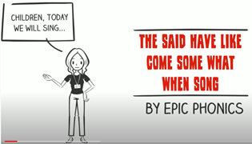  At the end of the clip see if they can write a sentence using one or more of the tricky words they have written down. | Session 1 - Main activity  Split digraph i  (i__e – e.g., time, fine, shine, inside)  Introduction to split digraph i – watch the video to introduce the sound.  You will need to login to ‘Espresso’ which can be accessed from the school website – ‘kids area’ and follow the link  https://central.espresso.co.uk/ (once logged in please go to – Espresso/Key Stage1/ English/Phonics / Ash’s Phonics /i-e)  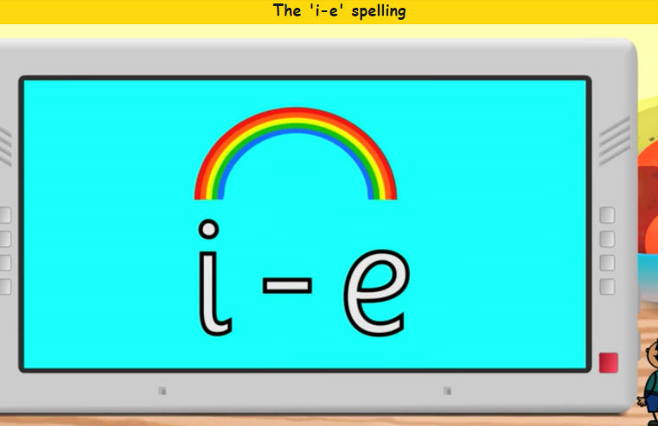  Have a go at making a list of split digraph i_e words together.  If for any reason you are unable to access Espresso then please use the YouTube link below which will give you some split digraph i words to read.  https://www.youtube.com/watch?v=4-swf3Gy_40  Read some i split e digraph words: ride, like, inside, seaside
Session 2 - Tuesday 9th June 2020  Warm up activity – Tricky words and Year 1 Common Exception Words:  thought, work, today, of, said, says  Write down the words on a piece of paper. Use look, say, cover, write and check to practise those words.  Look – have a look at one of the words  Say – say the word out loud  Cover – cover the word  Write – write the word down on a separate piece of paper  Check – uncover the word and check your spelling | Session 2 - Main activity  Have fun reading and sorting i_e split digraph real and nonsense words!  Divide a piece of paper into 2 (nonsense and real words) and write down the words.  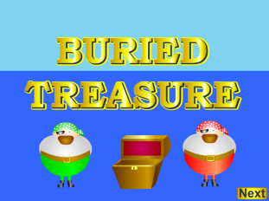  https://new.phonicsplay.co.uk/resources/phase/5/buried-treasure
Session 3 - Wednesday 10th June 2020  Warm up activity –  How many words with split digraph i_e can you make in 2 minutes? | Session 3 - Main activity  Sorting graphemes (igh, ie, i-e)  Look at the letters at the top of each box and say the sound for each. Remember its same sound using different letters. Read the words and sort the words in to the correct boxes.  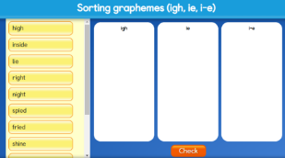  https://central.espresso.co.uk/espresso/primary_uk/subject/module/activity/item819127/grade1/module63425/index.html
Session 4 - Thursday 11^{h} June 2020  Warm up activity – Recap phase 3 and 5 digraphs (2 letters together that make one sound)  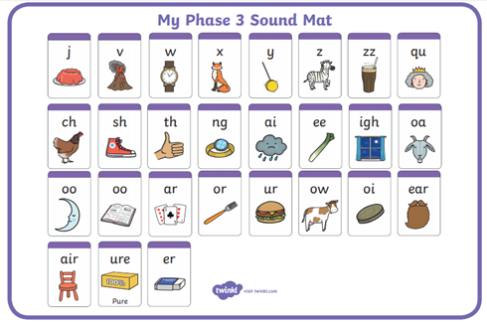  How many digraphs can your child write in 2 minutes? Maybe you could have a go too and see who gets the most! Encourage your child to check your words. Did you miss any? | Session 4 - Main activity  Can you think of words with the long ‘i’ sound?  How are they spelt? Split a paper into 4 and write words under each heading.
Session 5 - Friday 12th June 2020  Warm up activity– Phase 5 digraphs (2 letters together that make 1 sound)  Use the sound mat below– choose a digraph and ask your child to write it down/make it with magnetic letters/paint it outside on the pavement using paint brushes and water/chalk etc.  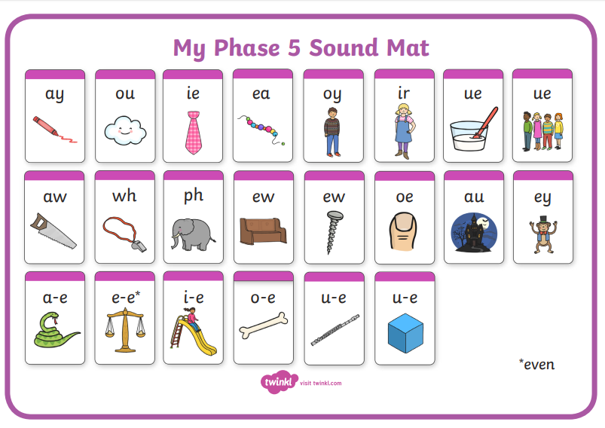 | Session 5 – Main activity – Tricky words  Children to choose words and think of a sentence.  Children to say the sentence and then write it down.  They could ask you to write their sentence down and then be the teacher and check it! Or you could think of a sentence, write it down and ask your child to highlight the tricky words they can see!  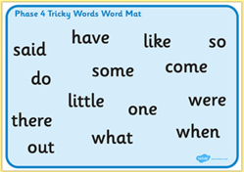

Year 1 spellings
Weekly spellings:

Dear Parents/ Carers,
We will be continuing to add weekly spellings to the bottom of the phonics planning. Please continue to practise them at home as you had been doing before school closed. We find the ‘look, read, cover, write, check’ approach the best way to learn the spellings.
At school the children are usually ‘tested’ on their spellings on a Monday. Please feel free to keep to this structure.
The children should hopefully remember which group they were in for their spellings. If any children from group 1 or 2 want to challenge themselves with more spellings please feel free to let them have a go.

Year 1 English Activities – Summer 2 Week 2
This week’s English will be based around the book ‘Tiddler’ by Julia
Donaldson. If you have the book at home, read it either on your own or to a grown up.
If you don’t have the book you can watch the video here...
https://www.youtube.com/watch?v=pBRT5vsfE3U
Before reading/ watching the video, look at the book cover, where do you think this story is going to be set?
Do you think it is a fiction or non-fiction book? Why?
Monday  8th June | We are going to be writing a character profile on Tiddler. What is a character profile? (A character profile describes a character in detail). To help you write a character profile, start by collecting/writing down adjectives (*) to describe Tiddler (his appearance and character/personality).  Write a sentence to describe Tiddler’s appearance and /or character including some of your adjectives.  *adjective - an adjective is a word that describes an animal, person, thing, or thought. Adjectives include words that describe what something looks like and what it feels like to touch, taste, or smell.
Tuesday  9th June | What lessons might the fish have at their school? Write a diary entry from the point of view of one of the fish, giving their thoughts about their lessons at school.
Wednesday 10th June | A 'shoal' is the collective noun for a group of fish. Can you find out other collective nouns? Can you make a poster showing them and the creatures that they refer to?
Thursday 11th June | Imagine that you could go diving underwater. What might you see? What words could you use to describe things? Watch this video to get some ideas:  https://www.youtube.com/watch?v=hX7eEWFAiFE
Friday 12th June | Write a story about one of the other sea creatures shown in the illustrations. Could you write a story about one of Tiddler's school friends?

Year 1 Maths Activities – Summer 2 week 2
This week we are looking at halving.
Do you know what halving means? Can you think of other words which mean/describe halving?
Vocabulary:
half – one of two equal parts
equal – things that are the same
½ - representation of a half using fraction (one part out of two parts)
Fraction – is a part of one whole thing. When a slice of cake is taken out, it becomes a fraction, i.e. a piece of the entire cake

Monday 8th June 2020
Here is a short clip about halves and halving:
https://www.bbc.co.uk/bitesize/clips/z6bq6sg
Activity:
Find a range of objects which can be shared or cut in half. Discuss how you can ensure that sharing is fair. Remember that halves must always be equal parts.
Remember to point out that one half is 'one piece out of two' and is written like this: 1/2.
Challenge:
Can any of your objects be cut in half in more than one way?

Tuesday 9th June 2020
Activity:
Can you colour in one half of the following shapes: ½

Can you colour in 2 halves of these shapes:

Colour in ½ of these shapes:

Draw some shapes and colour in 1 half of them.

Challenge:
Can you colour in one quarter of these shapes: ¼

Wednesday 10th June 2020
Activity:
The best way to show children halving, is to actually give them an even number of objects (for example: sweets, pasta shapes or counters). Ask them to divide the group into two groups of the same number. They may not be sure of how to do this, so you may need to draw two big circles on a piece of paper and show them how to share the objects, one by one, into the two circles.
Challenge:
Choose a number card. How can you show half of that number? Show with objects.

Thursday 11th June 2020
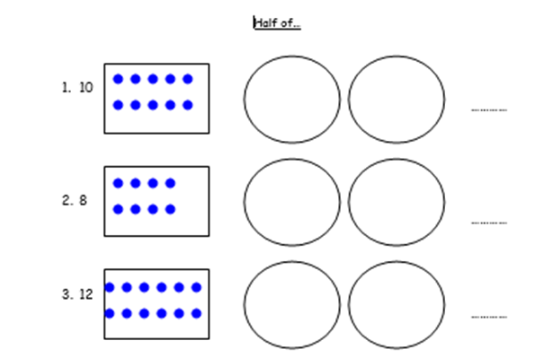
Activity:

If you prefer, you can use small counters/ raisins or other objects instead of the above worksheet, then draw two circles and divide the objects of your choice equally between the two circles. How many did you get in each circle?
Challenge:
Can you show what you did using a sentence? e.g. ½ of 10 is 5

Friday 12th June 2020 – word problems
Challenge:
Ben ate 30 hot dogs. Anna only ate half of those. How many hot dogs did Anna eat?
Tom had 16 playing cards and he gave half of them away to his friend. How many does he have now?
If 18 cups of water will fill up a bottle, how many cups would fill half a bottle?
Year 1 Theme activities – Summer 2 Week 2
Date: | Activity:
Monday 8th June 2020 | Food Safety Week (6-12 June)  Food Safety Week is an annual event held to promote the importance of good food hygiene in the home.  What is food hygiene? Is it important, why? What do we have to do to maintain good food hygiene? Discuss.  Watch the video:  https://www.youtube.com/watch?v=qkx03bgbdlI  Can you make a poster to show what good food hygiene is?
Tuesday 9th June 2020 | Science – Seasonal changes  Draw 4 pictures, one representing each season. Name each season, then look for some pictures from colour magazines, internet etc. of different clothing you would wear in each season, or you can draw the clothes. Lastly, match the outfit to the season, then write a sentence for each picture explaining what they are wearing. E.g. In winter I wear a coat. Can you explain/ write why? (e.g. In winter I wear a coat because it is cold outside)
Wednesday 10th June 2020 | Science – plants  How do plants grow from seeds? How do pants change as they grow? Discuss and watch a video  https://www.youtube.com/watch?v=w77zPAtVTuI  Choose your own plant seed and plant it in your house or in your garden. Draw a picture of what your seed looks like now and what it will grow into over the next 5 weeks. Write what plant the seed is going to grow into and a sentence to describe the seed.
Thursday 11th June 2020 | Science – plants  Go for a walk. While you are outside, see if you can spot and name any plants? Write down names of the plants you see.  At home divide a page in two. Write headings: Flowers and Trees. Stick the 6 photos or draw pictures under the correct heading and name plants. Don’t forget to add the names and/or pictures of the plants you saw on your walk.  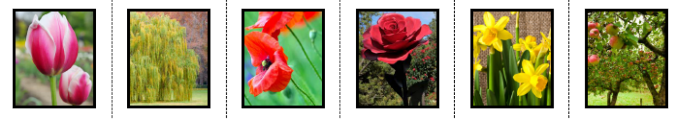  Can you write a short sentence describing each plant?
Friday 12th June 2020 | PSHRE (Personal, Social, Health, Relationships and Emotional Development)  Mindful Me - Focus Breathing  Paying attention to your breathing is a quick and easy mindfulness technique.  Focus Breathing is a quick and easy mindfulness technique.  It can help you calm your mind, relax and focus your attention to whatever it is you’re a doing right now and enjoy the moment!  This is a great technique to build into your everyday life to connect with your breathing, your mind and your body…and you’ll feel great afterwards!  Activity:  - Make sure you are comfortable either sitting or standing in a quiet place if possible.  - Close your eyes and take some slow deep breaths through your nose.  - Concentrate on your breath flowing in and out of your body.  - Notice how it is cooler when you breathe in and warmer when you breathe out.  - Continue until you feel calm and relaxed.

