MARCH NEWSLETTER
19th March 2019

Dear Parents/Carers,

Welcome to our March newsletter. We have already had an incredibly busy second half of the spring term: thank you for supporting us in providing the children with so many varied opportunities again. Please note events that are underlined and in italics are new since the previous newsletter.

Wednesday 20th March – Dance Festival Y3
Thursday 21st March – Foundation Stage Walk to the Post Office
Friday 22nd March – 3 – 3:30pm PTA Uniform Sale in the dining hall
Wednesday 27th March – 9am-9:45am Triple P follow up coffee ‘stop’ – come and talk to the pastoral team informally about behaviour or parenting issues, Year 4 (Starling Class) Science afternoon with the Firs at Russell, Danny Butler Extreme Stunt Show to children
Thursday 28th March – Open the Book Assembly, Y4/5 Alameda Cross Country event at 4:15pm
Friday 29th March – Wear a hat for Harry – if you would like to help raise money for a local boy’s medical treatment, wear a hat and bring a donation and we will pass it on, Year 1 trip to Whipsnade
Monday 1st April – Easter Assembly
Tuesday 2nd April – Egg Judging day, Easter Assembly with Cannon Trodden from St Andrew’s Church
Wednesday 3rd April – 7:30pm – PTA meeting
Thursday 4th April – Violin/Viola assembly to parents at 3pm
Friday 5th April – Easter breakfast morning 8am – 10:30am, Easter hunt (gifts from PTA), Easter Raffle drawn, Big Pedal Ends, Break up for Easter at 3:30pm

Easter Holiday 6th April to 22nd April 2019

Monday 22nd April – Easter Monday – Bank Holiday – all children at home
Tuesday 23rd April – All children back at school today, St George’s Day (Cubs and Scouts can wear their uniform to school), 9am and 2:45pm Parent Helper sessions
Wednesday 24th April – Year 3 swimming begins
Friday 26th April – 9am Condover Hall Year 4 Residential Trip meeting, Year 4 Bikeability
Monday 29th April – Group Photos, Finance and Premises Governors meeting at 6:30pm
Wednesday 1st May – Year 4 Quad Kids at Alameda
Thursday 2nd May – Local elections taking place – SCHOOL OPEN, Open the Book Assembly
Friday 3rd May – Year 4 Bikeability
Monday 6th May – Bank Holiday – SCHOOL CLOSED
Wednesday 8th May – Year 4 Residential to Condover Hall
Thursday 9th May - Year 4 Residential to Condover Hall
Friday 10th May - Year 4 Residential to Condover Hall
Monday 13th May – Year 4 Quick Cricket
Thursday 16th May – Open the Book Assembly, Outdoor Classroom Day
Monday 20th May – Walk to School week begins, leadership and Management Governors Meeting at 6:30pm, Year 3 Celtic Harmony
Thursday 23rd May – Y1/2 Multi-skills Festival at Alameda
Friday 24th May – Year 4 Bikeability

Half term - 27th May to 31st May 2019

Monday 3rd June - All children back at school today – there is NOT an INSET Day, Drumming assembly at 1:15
Thursday 6th June – Open the Book assembly
Friday 7th June – From 8:50 – 10:30am, parents invited in to help with Gala preparation, Tennis festival for Year 3
Thursday 13th June – New Intake Meeting (Foundation Stage 2019) at 6:30pm
Saturday 15th June – PTA Summer Fayre (pm)
Thursday 20th June – Open the Book Assembly
Monday 24th June – Year 1 Scootability sessions, Year 4 Transition Festival
Tuesday 25th June – Sports Day (am) and picnic on the field (12 – 12:45pm)
Wednesday 26th June – Year 4 Internet Safety Sessions from Hazzard Alley, Year 2 Scootability sessions
Tuesday 2nd July – Year 3 Tennis festival at Woodland Middle School
Thursday 4th July – Open the Book assembly
Friday 5th, Saturday 6th and Sunday 7th July – Ampthill Festival Weekend
Monday 8th July – Teaching, learning and standards governors’ meeting at 6:30pm
Tuesday 9th July – 2:30pm and 6pm – Year 1 Performances to parents
Wednesday 10th July - 2:30pm and 6pm – Year 4 Performances to parents, letters home to Y2 parents and children letting them know which class they are in from September
Thursday 11th July - 2:30pm and 6pm – Year 3 Performances to parents, Year 4 Transition Day to Middle Schools, ‘Class Swap’ morning at Russell
Friday 12th July – Reports go home – all year groups
Monday 15th July – 7pm Alameda meet the tutor and Year 4 information night, Full Governors’ meeting at 6:30pm
Tuesday 16th July – Year 4 Leavers’ Assembly to parents (Year 4 parents may stay and look at children’s books straight after the assembly), 2:30pm Open Afternoon for all parents (children may go straight home with parents once they are finished)
Wednesday 17th July – Year 4 Leavers’ Party 1:30 – 3:30pm

SAVE THE DATE – RUSSELL LOWER SCHOOL BALL – SATURDAY 5TH OCTOBER

Please see the school website for more dates beyond this

More detailed information on the above events will follow in due course

Nathan’s Garden:
Thank you for your patience whilst we make Nathan’s Garden useable again. As you will remember, we removed the fence to enable all children to have access to the garden and extend the play area. This has been ‘too successful’ and, with 180 children regularly on the grass in the garden, we soon had no grass left! We had to decide either to restrict access to the garden again, or get some more ‘astro’ turf fitted, as we did around the trim-trail. We chose the latter as the children tell us they love the extra space and quieter garden space, but it took a little longer than expected due to ‘Storm Gareth’. Thank you for your patience. We look forward to enjoying the garden again.

New Foundation Stage Terrace Equipment:
We have been saving for a long time in order to replace the very ‘tired’ equipment on the Foundation Stage terrace. We now have all the pieces in school and at some point over this week we will get the new equipment out. Can we please make an enormous plea that you ask you children NOT to play with, and on, the school equipment before and after school. We desperately want to keep the new equipment in good order. School budgets are getting tighter and tighter every year and we simply won’t be in a position to replace equipment in the future. Thank you very much in advance for your support.

Year 3 drains update:
Thank you again for your patience while we have been investigating the repairs needed to the drainage in the Year 3 corridor. Finally – after years! – we have a solution and are ‘smell free’. I cannot thank you enough for your patience. It has been hugely frustrating for us as a school, waiting for others to do their job, but finally, we are there. Thank you very much again.

Photos and videos at school:
Please can I take this opportunity to remind you of our school policy regarding photos and videos? We are always happy for you to take photos and videos for your own personal use, but we do ask you not to post any of these images on any part of the internet or social media, unless they only have your child in them. Thank you for supporting us with this policy which is designed to ensure everyone’s wishes are respected and children are safe.

School attendance:
Thank you for supporting us and enabling us to keep Russell Lower School’s attendance figures high. We do want ‘every second to count’. In order for us to achieve this, can we ask that if your child has a medical appointment, you only collect them/keep them off school for the time needed to attend the appointment? We are very happy for children to come in a little late or be collected and returned during the school day. Please just ensure your child is signed in and out at the school office. Thank you.

Book Fair and World Book Day:
Thank you for taking part in World Book Day with us. The children looked incredible in their enormous range of wonderful costumes. We thoroughly enjoyed a wide range of book-related activities on the day. Thank you for supporting the Book Fair in such numbers too. We had sales of over £625.00 which we earn a very healthy commission on, so we have around £300 to spend on more books for our library and book shelves for the children to enjoy. Once again, thank you for your incredible generosity!

Sports for schools:
Thank you for supporting us so whole-heartedly when ‘Sports for Schools’ and Steve Frew visited school last month. We had some wonderfully inspiring workshops and assemblies and raised a staggering £3 538.63 to support athletes. Equally, school will benefit with equipment to the tune of £1 779.38 in commission. Thank you: the children will love the new resources.

Parents’ Evening:
Thank you to all the parents who came back to school to talk to their child’s teacher during our recent parents’ evenings. We really do value the partnership between home and school and know that children thrive when this is working well. You may have received a telephone call to make an appointment with you if you were unable to attend on this occasion. This reflects the importance we place on discussing your child’s progress and well-being with you.

PTA Disco:
Thank you to the PTA for another incredibly popular and successful Spring Disco. Once again, the PTA and an army of parents did an incredible job of organising the whole event and the children and teachers had a wonderful time dancing!
This was one of the most successful PTA discos ever: thank you so much for your continued support!

‘Mad about Harry’ - Wear a hat for Harry on 29th March:
Harry Banks is a local ten-year-old boy, who many of our Russell community know and would like to support.
In late 2014 his family were given the devastating news that Harry had Stage 4 Neuroblastoma, a very rare and aggressive children’s cancer. All was going well and Harry had two and a half years in remission. However, devastatingly once again, in November of 2018 they were given the news that he had a relapse and had to have an emergency operation to remove a tumour from his brain.
'Mad About Harry' was set up in 2014 to raise funds for Harry in the event he would need a ground-breaking trial abroad (which he now does).
If you feel you would like to support this cause, then the children can ‘Wear a hat for Harry’ on 29th March and bring in a donation which we will pass on.
For more information, you can go to the following page.
https://www.gofundme.com/madaboutharry

Reminder - Triple P and coffee follow up:
Thank you so much to everyone who turned out on three very cold January Tuesdays (one even snowed!), to listen to Pete Barras deliver the Positive Parenting Programme (Triple P). Pete has never had such a turn out from a school, and was staggered to have over a hundred parents in regular attendance. We all agreed that it was fantastic ‘training’ and gained some wonderful tips and advice. We have now produced 3 Power points to accompany each session and have placed these on the website under the Parent Workshops tab.
We also want to invite you to a follow up ‘coffee stop’ session. This will be very informal and a chance to chat to our Pastoral team about any behaviour or parenting issues – you don’t even need to have attended Triple P! This will take place between 9am and 9:45 on Wednesday 27th January. If you cannot make it, but would like some support, do not forget our email address: pastoralsupport@russell-lower.co.uk
We look forward to seeing you.

More Pastoral Support News:
Please see below for details of CAMHS (Child and Mental Health Service) rolling programme of support sessions. There are lots of very good sessions available. Keep an eye out on the CAMHS website: https://www.elft.nhs.uk/service/189/CAMHS-MID-Bedfordshire-. You can also find the most recent CHUMS workshop slides and resources on anxiety that took place at school earlier this month. This can be found under the ‘Pastoral Support’ tab on our school website.

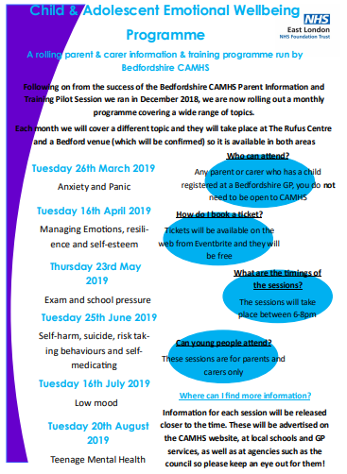

The Great Russell Spring Clean:
At Russell we encourage children to take on some responsibilities where possible. A good example of this is the ‘monitor duties’ in Year 4 where children help in the lunch hall, playgrounds and corridors at lunchtimes. Another example is the ‘Great Russell Spring Clean’. Two children from each class have again been joining me to ‘litter pick’ around the school site following an assembly about the importance of keeping our environment clean and litter free. You would be amazed at how popular it has been!
A further example of developing responsibility and independence is how we encourage Year 4 to walk to and from school with increasing independence in the summer term. A letter with further details of this (and permission slip) will be sent home soon. Thank you for your support with these initiatives.

Masquerade 40 Celebration Events in Ampthill:
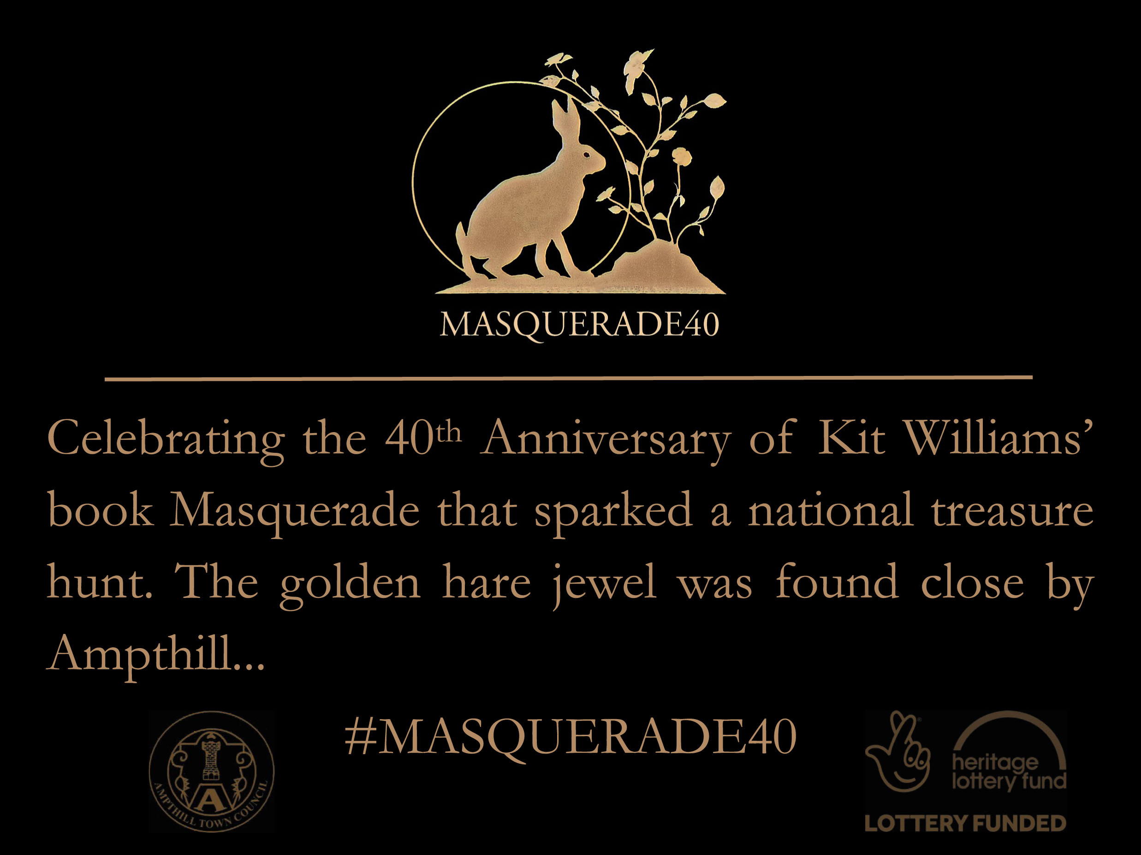

On Saturday, 23rd March at noon ~ Cllr Stephen Addy (Mayor) launches Masquerade40 which includes children crafts and guided walks to Katherine’s Cross where the Golden Hare was found almost 40 years ago.

We wait for AmpLiterary Festival to hear who will win the 750 words writing competition which has ‘Masquerade’ as its theme. There is still time to polish and submit your entry by 1st April to litfest@ampthillfestival.co.uk along with your name, date of birth and contact details.

The Masquerade40 steering group has created a colourful programme of events for celebrating Masquerade:

27th April AmpLiterary Festival
6th July AmpProms
7th July AmpGala Day
7th August The Tale of Jack’s Parade
28th September Masquerade Ball
25th October A Night of Masquerade

You can follow Masquerade40 on FaceBook or contact Ampthill Town Council to discover more.

Easter fun!
Planned Easter ‘Events’ this year include:
Easter assembly during the final week
Design an Egg competition (to be in no later than the morning of Tuesday 2nd April for judging)
Easter Hunt during Friday 5th April (Thank you to the PTA for the gifts)
Easter Egg Raffle (thank you to staff who kindly donated the eggs and prizes, and to the office staff for running the event. Tickets available to buy from the school office on the breakfast morning too)
Easter Breakfast and Easter related activities until 10:30am on Friday 5th April (Egg competition entries will be on display around the library)
We look forward to seeing you.
PE/Festival news:
Well done to all the children who took part in the year 4 swimming competition at the beginning of the month. The children who took part in the main pool placed second and the children in the smaller pool placed 1st, fantastic results all round!
As well as all the festivals taking place next half term year 3 will also begin swimming lessons for the first half of the summer term. At Russell, we feel that learning to swim and water safety are extremely important life skills and therefore have taken the decision, this year, to fund some non-curriculum swimming for our year 3’s through the use of the sports premium. We hope that the children will both enjoy and develop skills prior to their year 4 curriculum swimming sessions the following year.

Redborne Internship Opportunity:
Redborne Upper School, Ampthill - 17th June 2019 to 12th July 2019
There is a Teaching Internship opportunity this summer at Redborne Upper School in Ampthill. If you know of an undergraduate, who is due to graduate from university in Summer 2020, and they are undertaking a degree in science, technology, engineering or maths (or a subject that has a significant maths/physics element) AND they have an A level in maths/physics, they could earn up to £300 a week as one of our Teaching Interns.
Applicants will need to complete a written application and attend a selection meeting, which we will run in an informal manner. We all know that students can find it very difficult to get paid work, so please do pass this information on. Our programme will give them valuable experience. Please note - we only have limited places so please urge anyone interested to apply sooner rather than later!
Thank you all for your support.
Best wishes


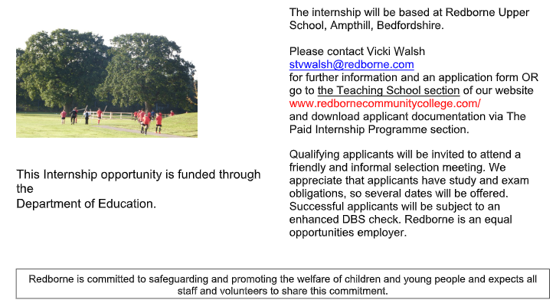

Thank you for taking the time to read this newsletter, and for your on-going support. Have a safe, fun and restful Easter holiday. We look forward to seeing you all back at school on Tuesday 23rd April (straight after the Bank Holiday Monday).

Yours sincerely,

Mrs. N. Walker
Headteacher

