Year 2 Phonics/Spelling Practice – Monday 6.7.20.
Last week we learned to use the prefix in-. This week we will look at a new prefix re-.
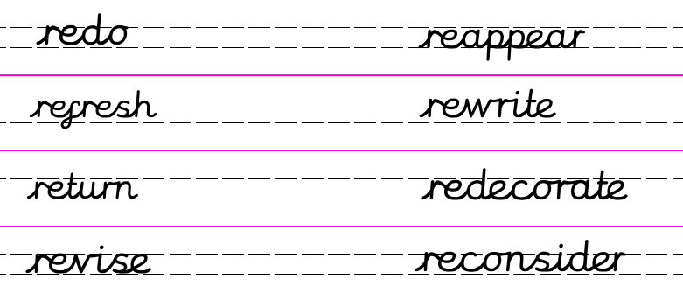
Can you work out what effect the re- has on the root word?
Re = do whatever it is again. ie. reread = to read again.
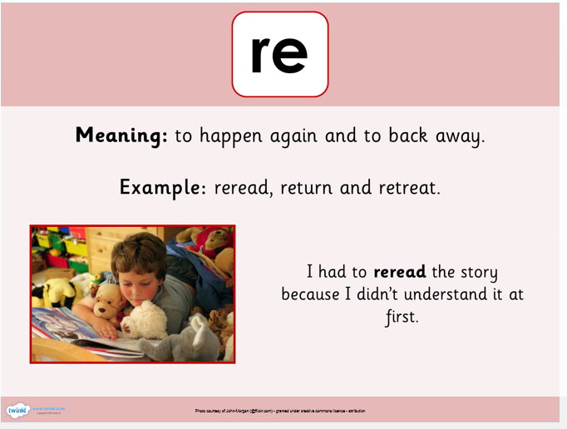
Dictation:
Ask someone to read out the sentence below so that you can write it down – try not to look until after you’ve written it. Check your punctuation and spelling.
Please redo your work and then refresh your water bottle.
Maths 6.7.20
Measure mass in grams
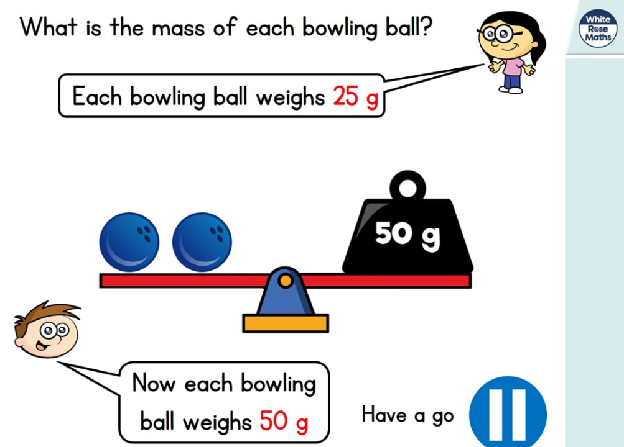
https://whiterosemaths.com/homelearning/year-2/ (w/c 29.6.20)
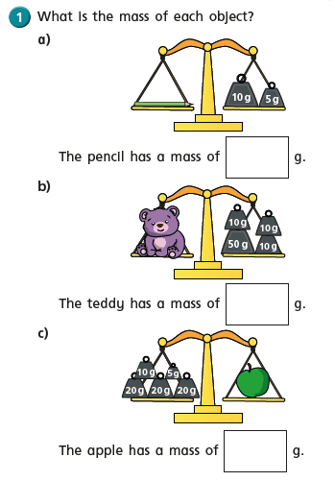
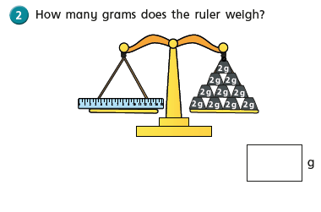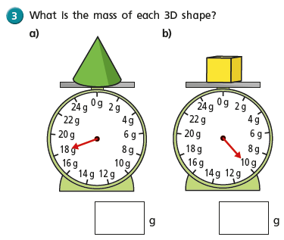
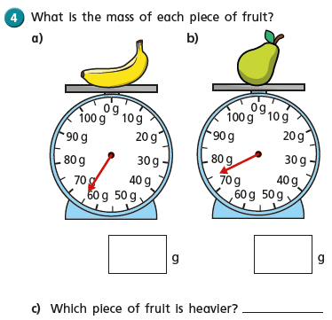
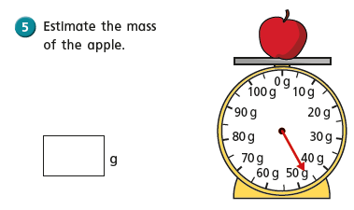

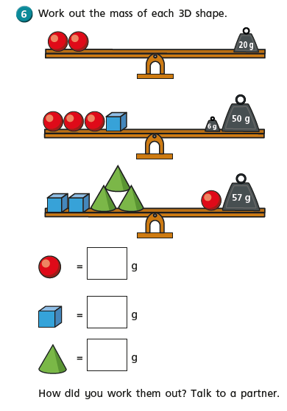

English - Monday 6TH July 2020

DON’T FORGET TO WATCH THE VIDEO ON THE KIDS AREA OF THE LEARNING PLATFORM.

Fact of the day: It is impossible for most people to lick their own elbow! Try it!

WALT write a diary entry.

Good morning, it’s just another Manic Monday! I hope you all had a good weekend. Can you believe we have only two weeks left of the school year!

Today we are going to continue reading our book ‘The Giraffe, The Pelly and Me’.

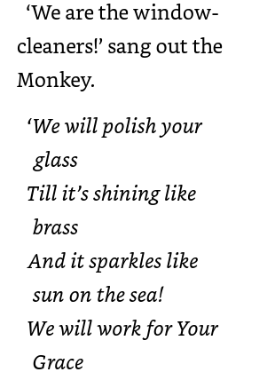  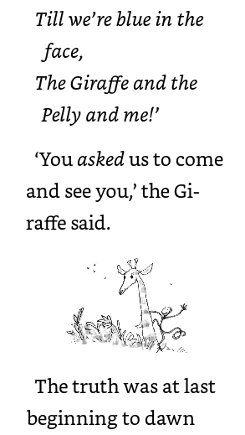  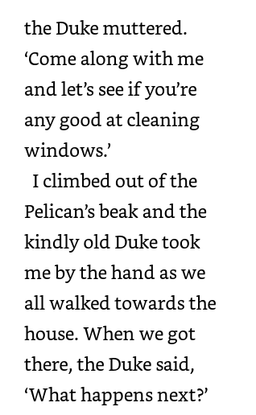  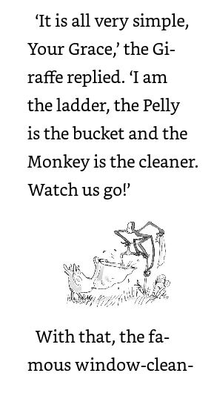  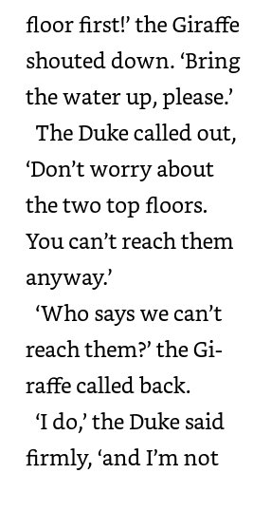  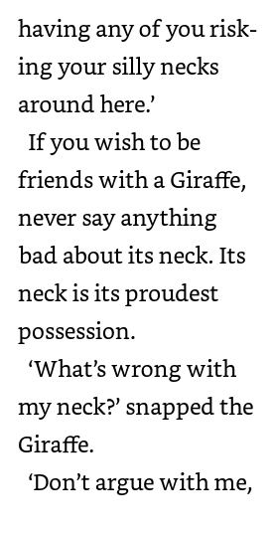  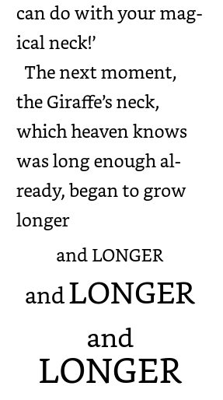  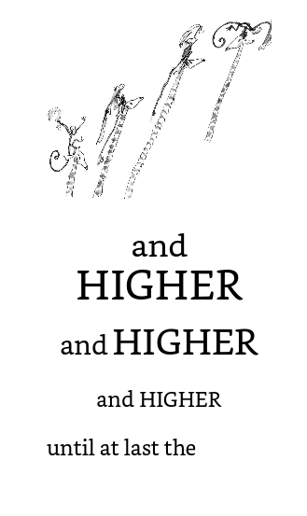  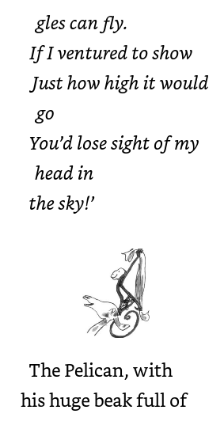  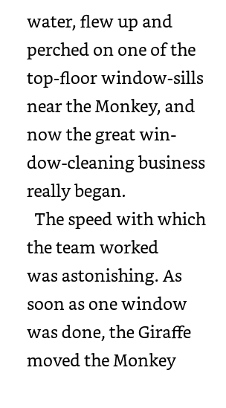  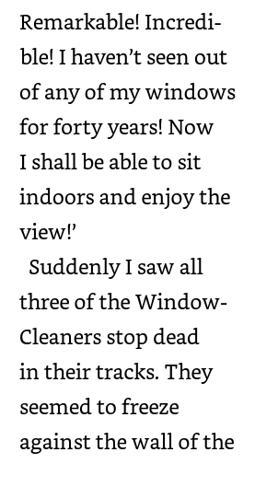  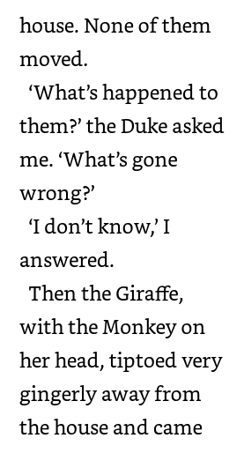  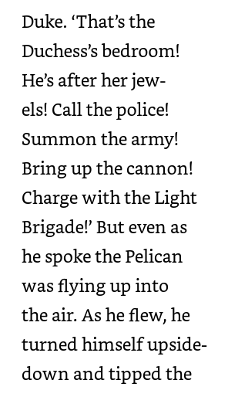  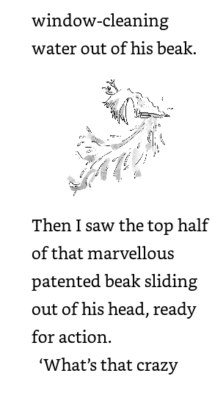  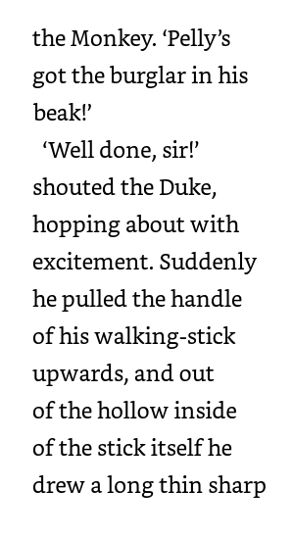  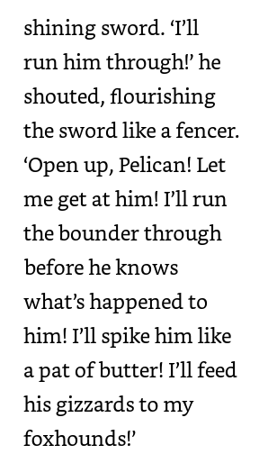  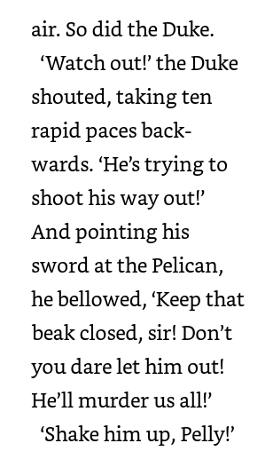  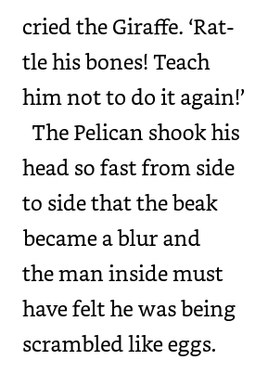  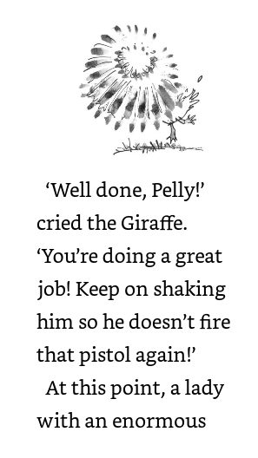  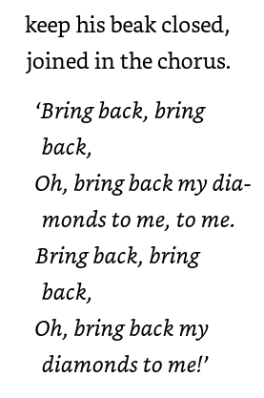  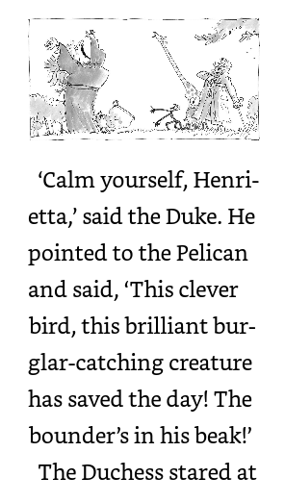  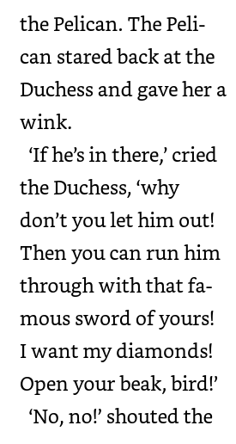  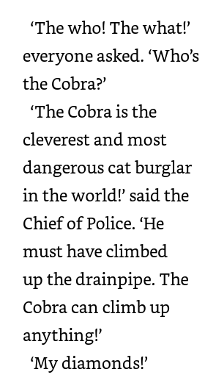  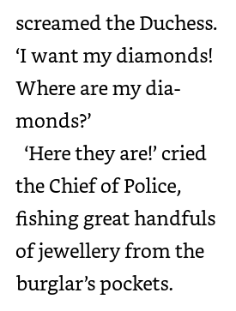  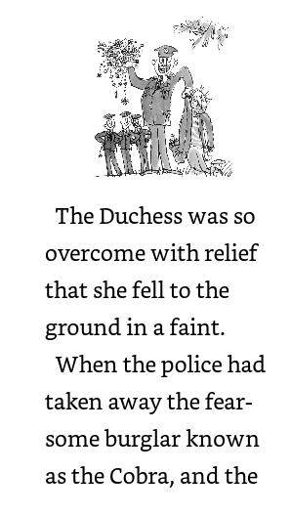 | 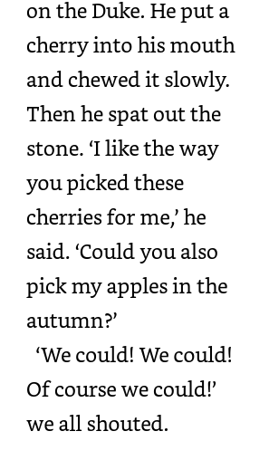  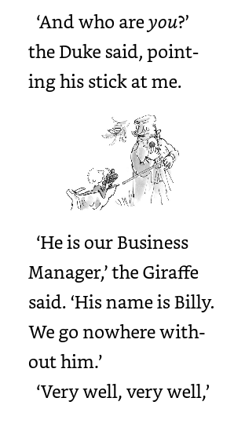  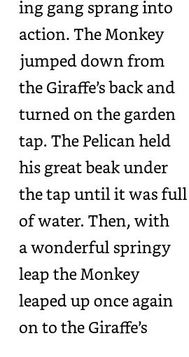  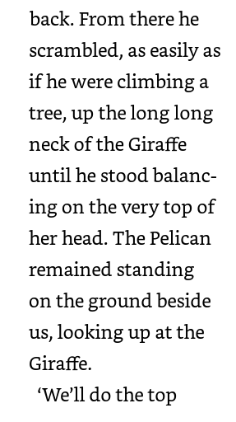  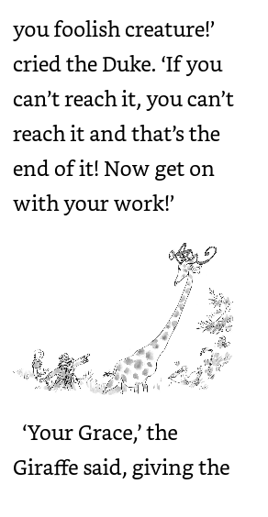  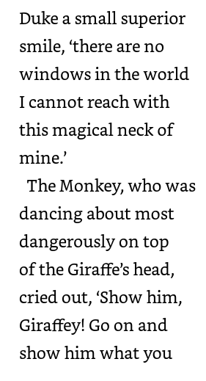  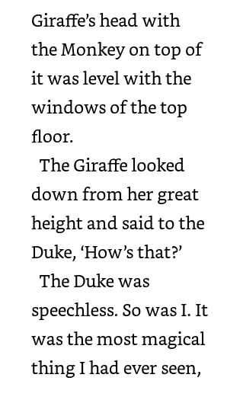  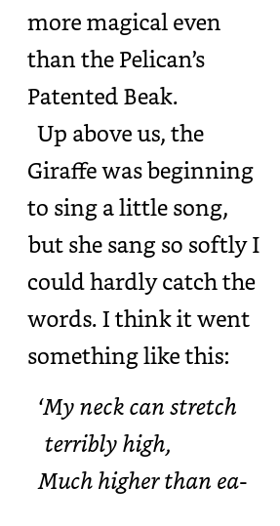  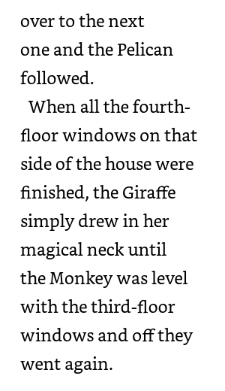  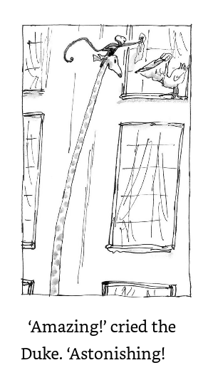  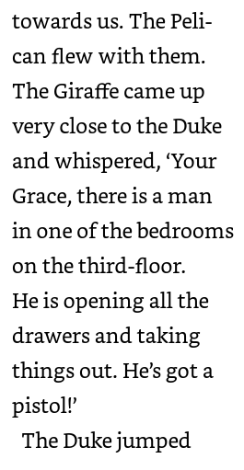  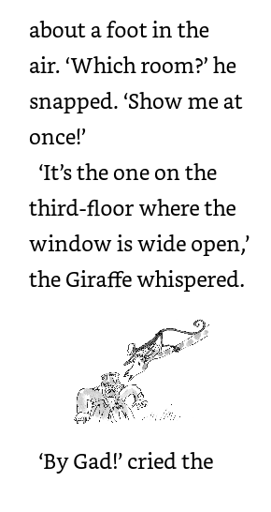  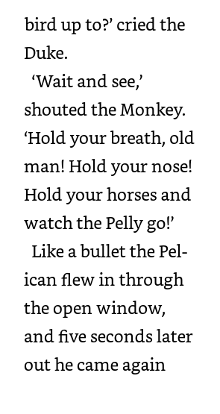  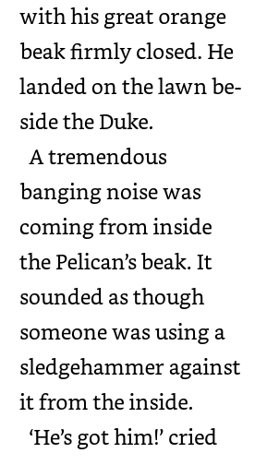  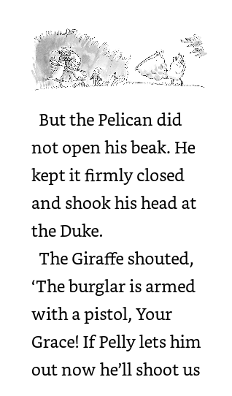  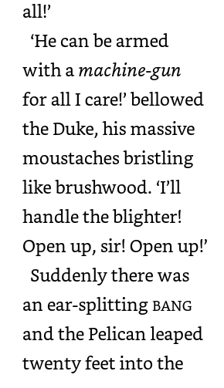  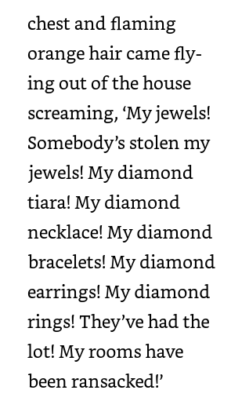  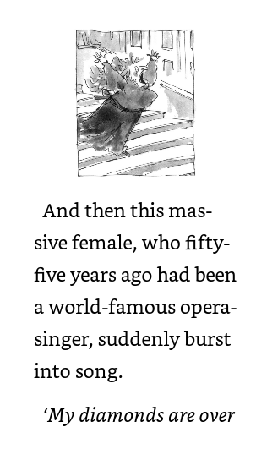  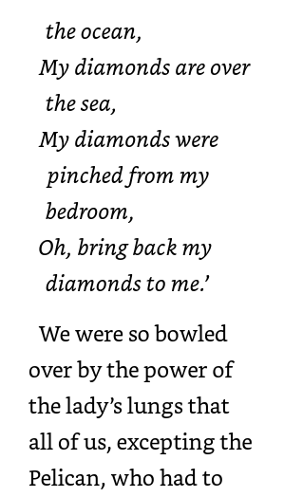  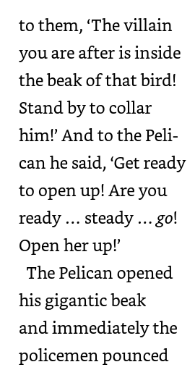  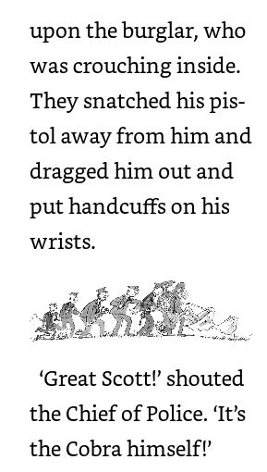  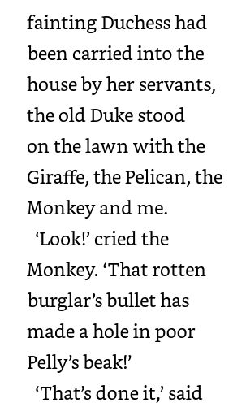

Wow that was a lot of reading today. I am trying to read more each day so that we can finish the book together by the end of this week.
Prediction!
What do you think will happen to poor Pelly now? How can he possibly continue to clean windows if there is a hole in his beak?How exciting that the Window Cleaning gang were at the Duke’s at just the right time. What a wonderful name for the jewel thief ‘The Cobra’. Why do you think he is called the cobra?
Today’s task is to write a diary entry as Pelly about the day he caught the infamous cobra.
You are all good at writing diaries and I am hoping you can all remember the features of a diary.
Let’s remind ourselves.
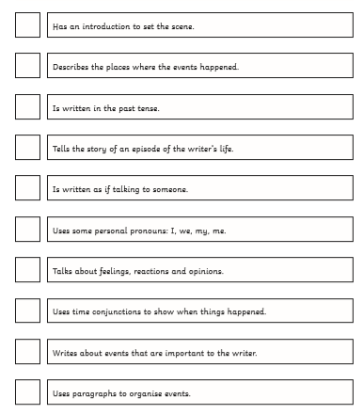
Remember to make your writing interesting by using adjectives, time connectives, verbs, nouns and adverbs.
I have started you off with an entry.
Dear Diary
What a day! You really wouldn’t believe it. This morning we were literally on our last legs, starving hungry, no money just a dream to get us by! By the time I wrote this entry my belly is full and I have plenty of money in my pocket and a future to look forward to...... Let me tell you more…..
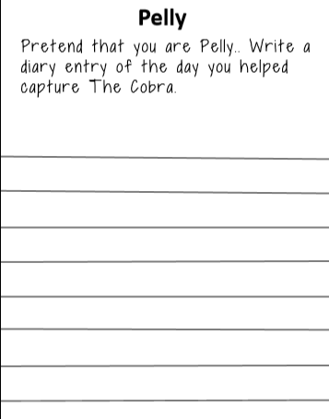

PSHRE 6.7.20
Acts of Kindness
Watch these clips of random acts of kindness and others that you might find on YouTube.
I know that you may not be seeing many other people at the moment but can you think of any acts of kindness that you can do? Maybe phone a grandparent to say Hello and ask how they are, help around the house, do something for a sibling, look after the pet…
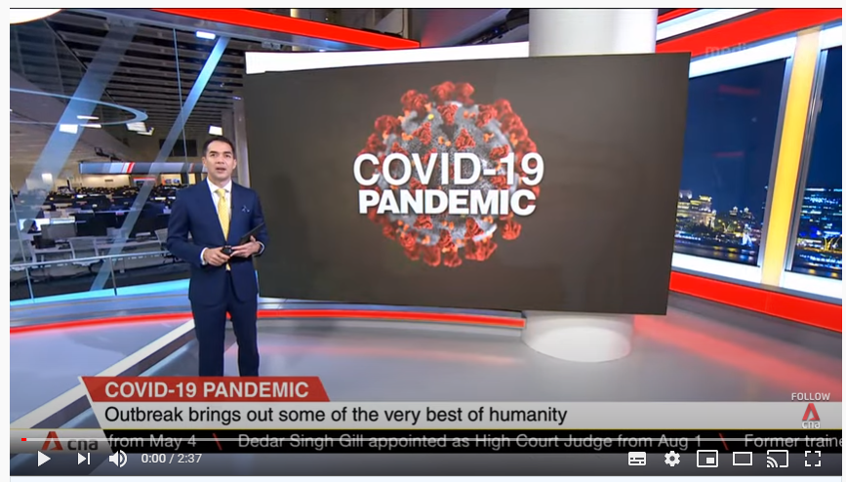
https://www.youtube.com/watch?v=8qNJyA--rvc
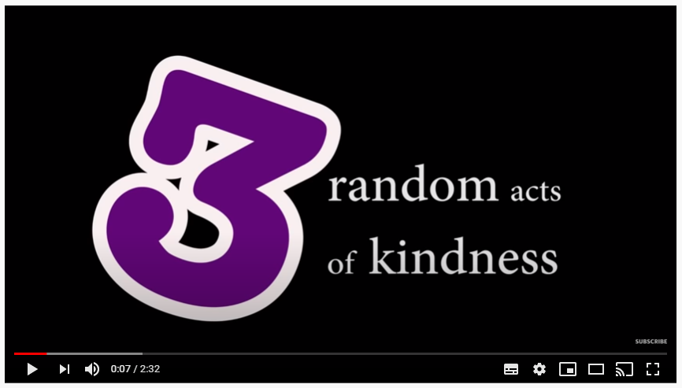
https://www.youtube.com/watch?v=KTCd3LB2Mcs

