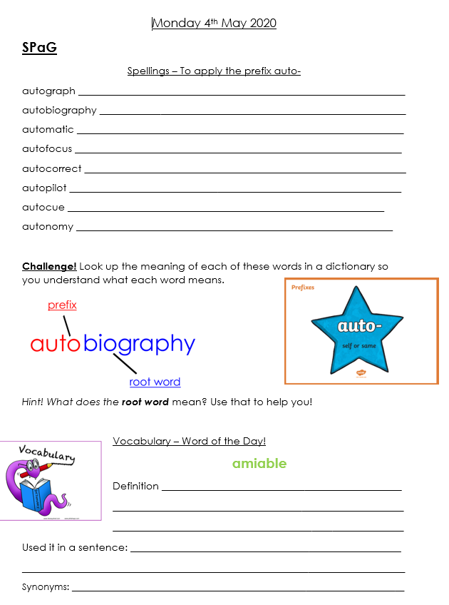

English
Word Detective
Today you are going to become a word detective! Reread Chapter 1 of The Iron Man and search for examples of powerful verbs. Ted Hughes uses some really interesting and ambitious action words to describe the movements and state of the Iron Man. Some good examples are ‘toppling’ and ‘tumbling’. See how many you can find in Chapter 1!
Challenge!
Can you sort them into verbs that describe activity and verbs that describe stillness?
STAR Challenge!
Can you use a thesaurus to up level any of the verbs that you have found? Can you think of an adverb to go with each verb that you have found?

Chapter 1 - http://bathwickstmary.org/wp-content/uploads/2020/03/Y3-text-TheIronMan.pdf

