Writing | Number work | Art and Design /  Design and Technology | Science
Create a factsheet, poster, collage or drawing of your favourite animal or your own pet (and label) to share with the class. | Can you order the jobs a farmer must do during the day?  Research the jobs they do and link these to times during the day. Can you order the events and the times from morning to evening? Can you draw a clock face/write the digital time to show the time each job is done? | Make an animal habitat. Research a particular animal and the habitat they live in – can you create their habitat through drawing, painting, collage or a 3d model? | Explore the different animals you see out an about (take photos/draw them/write them down). Can you sort them into groups? E.g. wings/no wings, legs/no legs, mammals/reptiles/birds etc.
Create your own word search using animal names for your friends to complete. | Create your own animal board game – this could link to more/less/addition/subtraction/  doubling/halving. These could then be played in class! | Create an animal jigsaw puzzle. Draw your favourite animal and then cut it up into pieces – can you put them back together? Can you bring it in to school for a friend to try? | Can you grow and observe your own plant? Could you create a ‘plant diary’ drawing and writing about how the plant grows and changes over time?
Write a poem about an animal of your choice. Look at books such as – ‘Rumble in the Jungle’ and ‘Commotion in the Ocean’ to give you some inspiration!  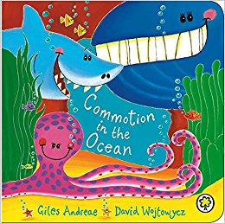 | Create your own farm or pet shop at home. Children to label items with prices and use coins to buy different items. Can they work out which coins they need? If they do not have the correct coins can they work out how much change they would get? Take photos to share with the class.  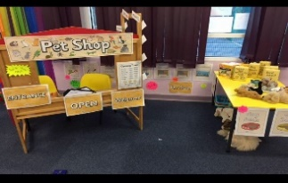 | Complete an observational drawing of your pet or a family members pet.  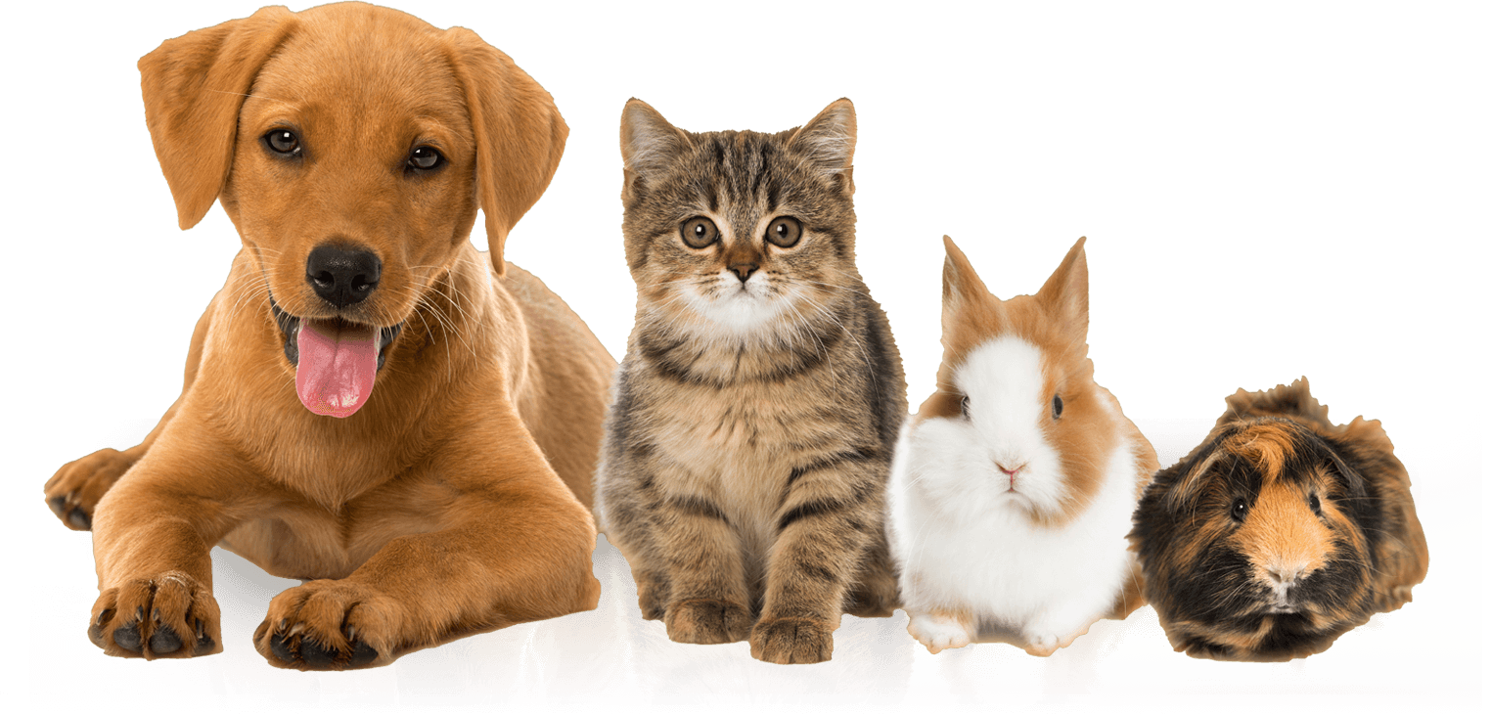 | Measuring weather.  Can you make your own rain gauge for your garden? Can you measure the rainfall over a period of time (a week or 2?) and record how much rainfall there has been each day?  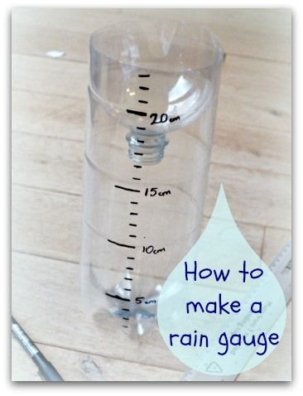
Write a recount of an ‘animal trip’ you have been on. Or write your own animal adventure story! | Use junk modelling materials to create a 3D model of your favourite animal or pet. Discuss the 3D shapes you have used and their properties. | Design and create your very own animal! It can have features of a range of different animals e.g. the trunk of an elephant, the neck of a giraffe, and the body of a horse. Can you make up a name for your new animal? | Seasonal changes.  Can you research what happens in each season? What is the weather like, what types of plants and animals are there? Create a fact sheet, collage, poster or model of the 4 different seasons (or you could create just your favourite season).

