Sports Premium 2015-2016
What is the Sports Premium?
The Government is providing additional funding for the next academic year 2015 to 2016 to improve provision of physical education (PE) and sport in primary schools. This funding has been provided jointly by the Departments for Education, Health and Culture, Media and Sport. This funding is ring-fenced and therefore can only be spent on provision of PE and sport in schools.
Each school will receive £8000, plus £5 for each pupil in years 1 – 6.
The total that Russell Lower will receive this year, is £9145. We have a carry-over from last year of £ 4472.22. This was allocated to be spent on improving our outdoor space and encouraging activity. Giving us a total of £13,617.22
Schools must spend the additional funding on improving their provision of sport and PE, but have the freedom to choose how they do this.
When considering the spend we kept in mind the five key indicators:
- The engagement of all pupils in regular physical activity – kick starting healthy active lifestyles.
- The profile of PE and sport being raised across the school as a tool for whole school improvement
- Increased confidence, knowledge and skills of all staff in teaching PE and sport
- Broader experience of a range of sports and activities offered to all pupils
- To increase participation levels in competitive sport and healthy activity of pupils.
Possible uses of the funding include:
- Hiring specialist PE teachers or qualified sports coaches to work alongside Primary teachers when teaching PE
- New or additional Change4Life sports clubs
- Paying for professional development opportunities in PE/sport
- Paying cover to realise teachers to attend professional development opportunities in PE/sport
- Running sports competitions or increasing participation in school games
- Buying quality assured professional development modules or materials for PE/sport
- Providing places for pupils on after school sports clubs

How do we intend to spend the funding?
At Russell Lower we intend to use the sports premium funding to:
Provision | Estimated Cost | Link to aims of the funding
- Join the Redborne School Sport Partnership (SSP). This provides support for local schools including professional development for teachers and entry into all local school festival and transition events. | £2000 | Continued professional development opportunities  To increase participation levels in competitive sport and healthy activity of pupils.  A range of festivals attended including Paralympic
- Children to take part in sports ambassador training | Included in above cost. | To increase participation levels in competitive sport and healthy activity of pupils.  To increase the engagement of all pupils in regular physical activity.  The profile of PE and sport being raised across the school
- Payment of qualified dance coaches to come and team teach with all staff members for a half term topic of work. Monday afternoon every week for full year. | £2,240 | Staff acquiring new ideas and strategies to use within their own lessons.  To promote PE specialisation in the primary level workforce
- Purchase of cyber coach | £435 | To increase the engagement of all pupils in regular physical activity.
- To purchase new playground markings/equipment that will help to promote physical activity during playtimes across all three playgrounds. | £6755 | To increase the engagement of all pupils in regular physical activity.
- Improve outdoor space and encourage activity with purchase of freestanding equipment. | £ 1200 | The increase the engagement of all pupils in regular physical activity.
- PE coordinator to attend PE conference. | £170 | Continued professional development
- Yr4 Bikeability course paid for all who were interested. | £140 | The profile of PE and sport being raised across the school  To increase participation levels in competitive sport and healthy activity of pupils.
- Skipping workshop for all children | £482 | The profile of PE and sport being raised across the school  To increase the engagement of all pupils in regular physical activity.  To increase participation levels in competitive sport and healthy activity of pupils.
- Supporting Russell Raiders | £270 | The profile of PE and sport being raised across the school  To increase participation levels in competitive sport and healthy activity of pupils.
- Bought in sports coaches to provide a wider variety of extra-curricular clubs. Offered at a reduced rate to parents £3 instead of £4. U | Any shortfall accounted for | Broader experience of a range of sports and activities offered to all pupils
TOTAL | £13,692
Over spend | £74.78

Impact

Point above/pictures | Details | Impact/ Number of participants/statistics
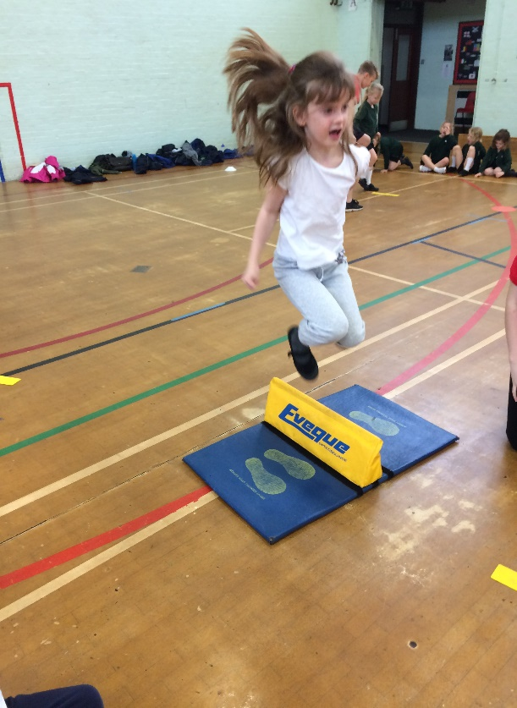  1 | Through RSSP Children are given the opportunity to attend a range of festivals and transition events.  CPD opportunities are also offered throughout the year. 3 staff members due to attend. | Pupils who attend the festivals are awarded a certificate and these are presented in our whole school assemblies in order to raise the profile of PE.  There is a large emphasis placed on the fact that the children are representing their school and to do their best, but the main message portrayed is for the children to enjoy themselves and have fun.  Year 1 – 36  Year 2 – 60  Year 3 – 104 (every child to attend at least 2 events)  Year 4 – 118 (every child to attend at least 2 events)  See Evolve for feedback about each festival/event.  Feedback from staff regarding courses to follow.
2  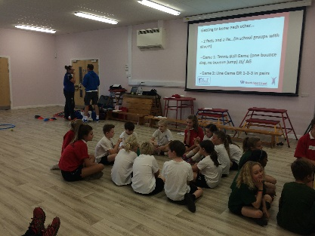 | Through signing up to the RSSP we will gain access to the Leadership Programme where members of the Redborne Partnership will train 10 selected year 4s on how to become good sports leaders. An afternoon will be spent training the selected children. | 100% enjoyed the training  80% thought the training would help them to lead other children in being active at break times. 20% were unsure whether the training would help them.
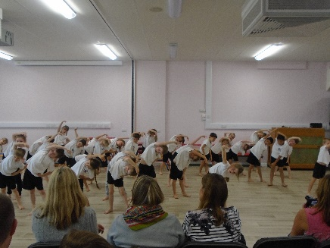  3 | Hiring of specialist dance coaches to work alongside teaching staff to deliver a unit of work linked to the year group’s current topic.  To widen the range of dance opportunities and give access to high quality dance choreography. | All staff and all children to be involved.  FS – 82% enjoyed the sessions, 9%were unsure and 9% didn’t. 67% would like to do more dance, 19% were unsure and 14% wouldn’t.  100% of support staff were confident at teaching dance after sessions, 100% enjoyed the experience and 100% thought it was a valuable experience.  Year 1 – 79% enjoyed the sessions, 21% didn’t. 78% would like to do more dance, 3% were unsure and 19% wouldn’t.  100% of staff were confident at teaching dance after sessions, 100% enjoyed the experience and 100% thought it was a valuable experience.  Year 2 – 86% enjoyed the sessions, 12% were unsure, 2% didn’t. 84% would like to do more dance, 9% were unsure and 7% wouldn’t.  100% of staff were confident at teaching dance after sessions, 100% enjoyed the experience and 100% thought it was a valuable experience.  Year 3 – 86% enjoyed the sessions, 10% were unsure, 4% didn’t. 60% would like to do more dance, 18% were unsure and 22% wouldn’t.  100% of staff were confident at teaching dance after sessions, 100% enjoyed the experience and 100% thought it was a valuable experience.  Year 4 - 93% enjoyed the sessions and 7% were unsure. 82% would like to do more dance, 16% were unsure and 2% wouldn’t.  100% of staff were confident at teaching dance after sessions, 100% enjoyed the experience and 100% thought it was a valuable experience.
4 | Purchase of cyber coach. | All children in the school to have access to this via their class teacher.  64% said they enjoy it  24% are unsure  12% do not like it
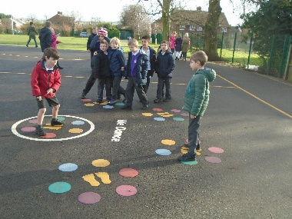  5 | To purchase playground markings/games in order to encourage greater activity at break, lunchtime and after school to encourage healthier lifestyles.  The children will be asked their opinion and what they would like to have around their schools. | All children in the school to benefit from this and to be asked their opinion via the school council. The school council were asked for input. Playground markings were installed 21st and 22nd December 2015.  See photos.  In FS:  95% said the like the new markings  3% were unsure  2% said they didn’t  92% felt the new markings and equipment help then to be more active  In years 1 to 4:  90% said the like the new markings  9% were unsure  1% said they didn’t  31% said they use them every day  66% said 2-3 times a week  3% said never  85% said they like the new equipment/toys  14% said they were unsure  1% said they didn’t  33% said they use the equipment every day  64% said 2-3 times a week  3% said never  84% felt the new markings and equipment help then to be more active.
6 | Equipment and resources purchased to improve outdoor space and encourage activity. | All children to benefit and discussion to be had with them about what they would like.  78% said they liked the new equipment  20% said they were unsure
7 | PE co-ordinator to attend the PE conference in March 2016. | PE co-ordinator attended the conference and came away with some useful ideas to try within school.
8 | Bikeability for all year 4 children who expressed interest. | All children who want to sign up to be given the opportunity.  76% of year group uptake.  Children’s feedback to follow.
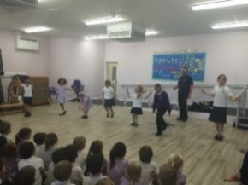  9 | Skipping workshop for all children | 59% said they liked skipping before the workshop  27% said they were unsure  14% said they didn’t  80% said they enjoyed the workshop  12% said they were unsure  8% said they didn’t  75% said they would now do more skipping  17% said they were unsure  8% said they wouldn’t
10 | Full range of clubs offered to children across the year (see below) following feedback from PE questionnaire. In order to help maintain the increased uptake from last year we decided this year to charge for the clubs however at a reduced rate. | Attendance for clubs is averaging around 17 (20 is capacity). These extra-curricular clubs provide opportunity for the pupils to develop their skills in various sports beyond the curriculum content. Due to the build work last year we had to limit our clubs but we are now offering a much broader range and many more opportunities. Priority is given to PP, overweight children and children who have not attended a club previously.

Festival participation
Our emphasis is placed on ensuring that as many children participate in as many festivals as possible. We do not focus on sending our ‘best’ children but rather ensuring parity and fairness.
Year | Date | Festival | Number of teams | Outcome
4 | 15.10.15 | Tag rugby | 2 | Won 3 games lost 1
4 | 20.10.15 | Paralympics | 2 | Non-competitive
2 | 10.11.15 | Multisports | 2 | 4th
3 | 17.11.15 | Badminton skills | 2 | 4th and 6th
2 | 29.1.16 | Sporthall athletics | 2 | 2nd and 5th out of 10
3 | 29.1.16 | Sportshall athletics | 2 | 9th and 10th out of 10
4 | 3.2.16 | Swimming | 2 | Team 1 12th out of 12  Team 2 5th out of 10
3 | 25.4.16 | Quadkids | 2 | Cancelled
1 | 10.5.16 | Multiskills | 2 | Cancelled
4 | 18.5.16 | Kwik Cricket | 2 | Team 1 5th Team 2 1st and into county finals
3 | 14.6.16 | tennis | 2 | Cancelled
4 | 21.6.16 | Transfer event | 2 | Now happening on site with own children
1 & 2 | 29.6.15 | Multiskills | 2
3 | 13.7.16 | Rounders | 2
4 | 4.7.16 | Netball | 2

Clubs
 |  | Autumn | Spring 10 weeks | Summer 12 weeks
KS1 | Mon lunch | Gymnastics 20 | Gymnastics 20 | Gymnastics 20
 | Thurs after school | Football 15 | Football 13 | Summer sports 20
 | Friday lunch | Multi-sports 21 | Dodgeball 20 | Fencing and archery 20
KS2 | Monday after school | No club | Street dance 19 | Gymnastics 13
 | Wed after school | Football 11 | Rugby 9 | Summer sports 13
 | Thurs lunch | Gymnastics 19 | Gymnastics 18 | Fencing and archery 20
 | Friday after school | Multi-sports 13 | No club | No club

Priorities for next year:
- Improve lunchtime activities and games – positive play by Val Sabin
- Further upskill staff through CPD opportunities

