Year 2 Phonics/Spelling Practice – Thursday 9.7.20. 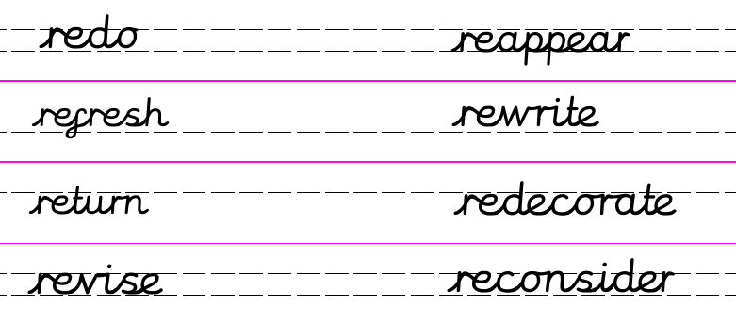
Practise:
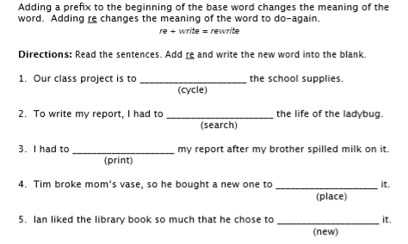
Dictation:
Ask someone to read out the sentence to you – try to write it from memory.
It is better to recycle before you replace.

Maths 9.7.20
Millilitres
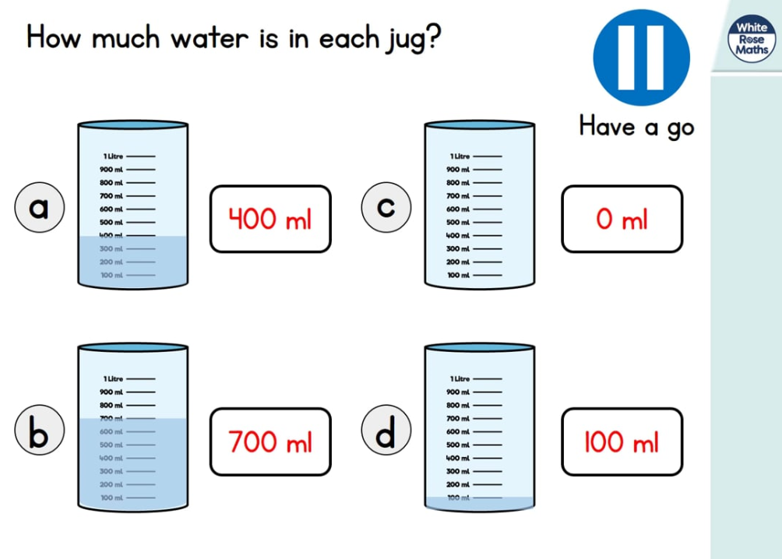
https://whiterosemaths.com/homelearning/year-2/ (w/c 29.6.20)
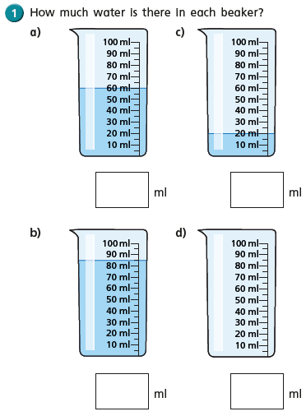
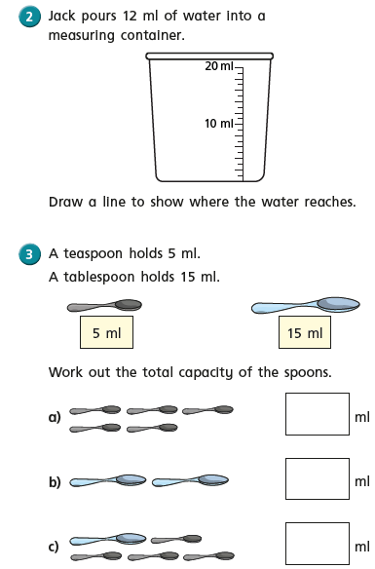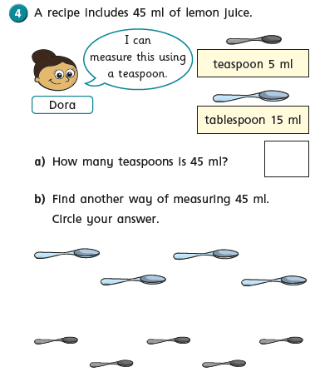

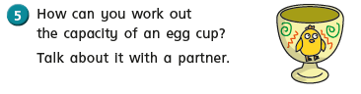
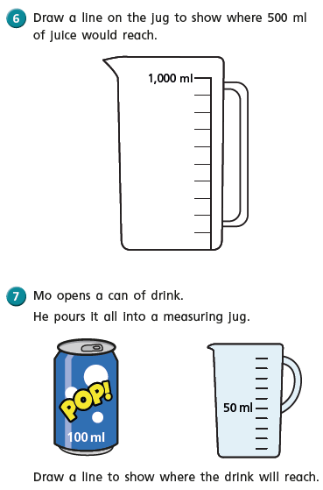
English - For the rest of this week we are going to concentrate on writing about our experiences from reading the book. We have three activities.
A blurb.
My favourite part of the story and which part you enjoyed the most and why.

Can you remember what we need to include in a blurb?
Which part did you like best? Why?
I hope you have enjoyed reading this story and have enjoyed the work set.

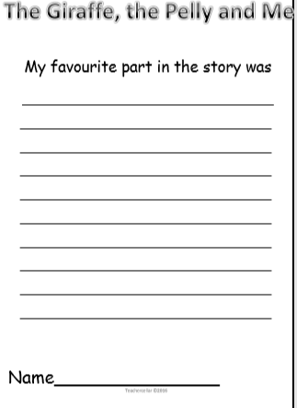

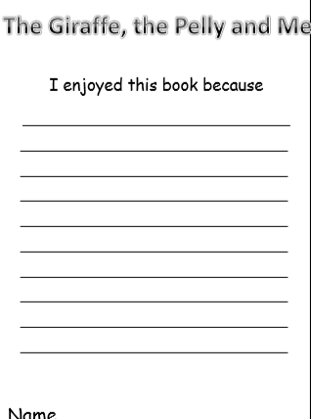
Art - 9.7.20
Self Portraits
This week in Art you are going to produce a self-portrait. A portrait is an artwork that has been created about a person or persons (sometimes of animals) which tells us something about them.
A self-portrait is when an artist produces a portrait of themselves.
Sometimes a portrait doesn't seem to look like the person it is meant to be, but it may still show us something about that person. For instance if bright lively colours like reds, yellows and oranges are used we might feel that the person is a lively and happy person.

Many famous artists have painted self-portraits:
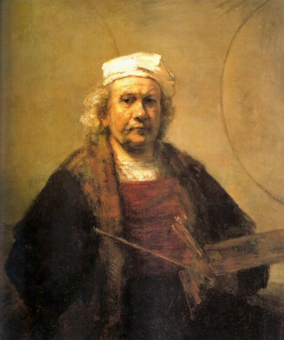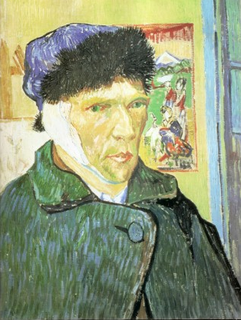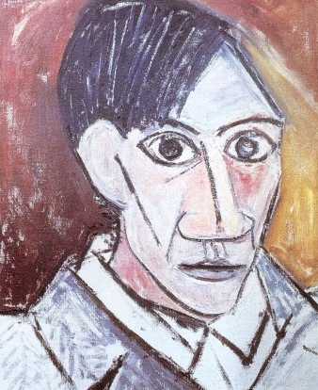
Rembrandt (1606-69) Van Gogh (1853-90) Picasso (1881-1973)

Your task is to produce a self-portriat. You can choose what media to use: felt-tip pens, pencil crayons, paints, or anything else you have at home.
Try to show something about yourself through the colours that you use. A mirror will be useful so that you can carefully study your own face for details.

You can use the frames below or you can use plain paper.
You can send any completed self-portraits to you class teacher. We’d love to see them…

