Monday 27th April 2020 Year 2 Phonics/Spelling Practice – w
This week we will be learning the sound spelt ‘or’ and ‘ar’ that comes after ‘w’.
Practise writing your new spelling words each day using your best Russell handwriting.
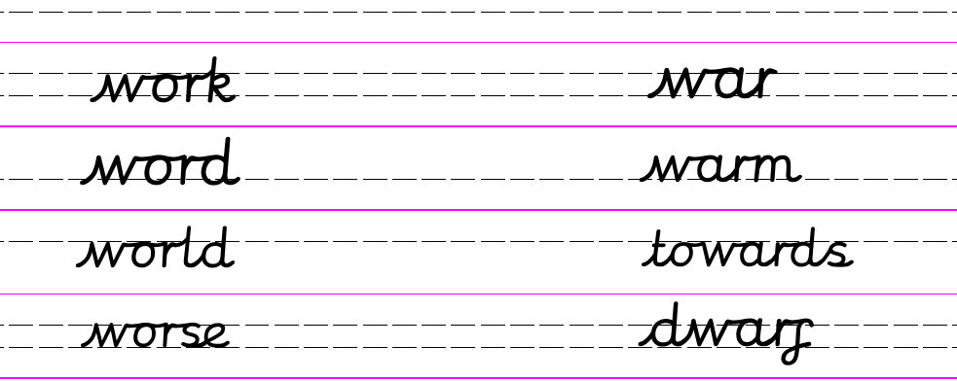
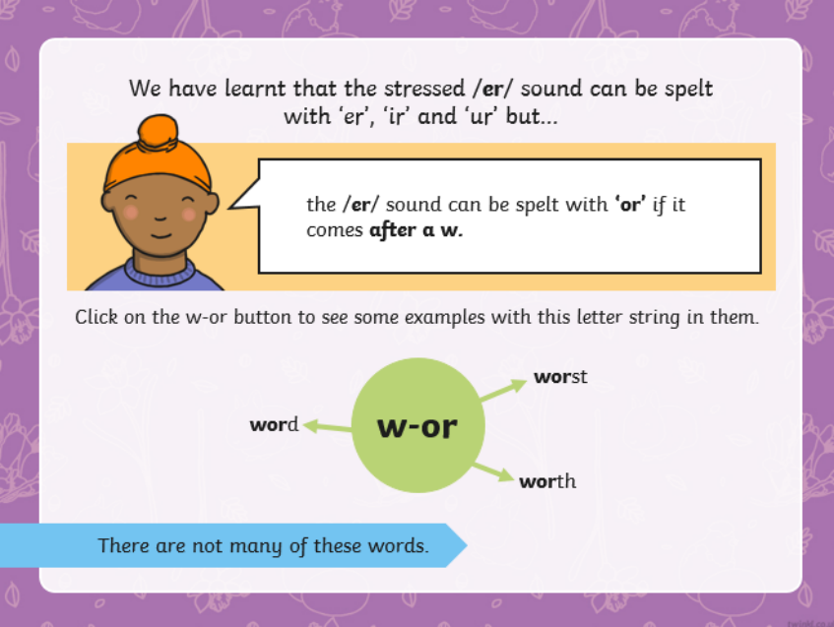
Choose the correct spelling to complete the sentence.
Is he a ____________ knight?  wurthy  worthie  worhey  worthy | This is a carpenter's _____________.  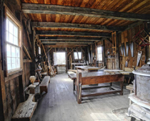  workshup  workshopp  workshop  workshope
She was the ____ witch!  worst  worste  worset  worss | He held three ____ in his hands.  worm  werm  worms  woerms
Maths 27.4.20
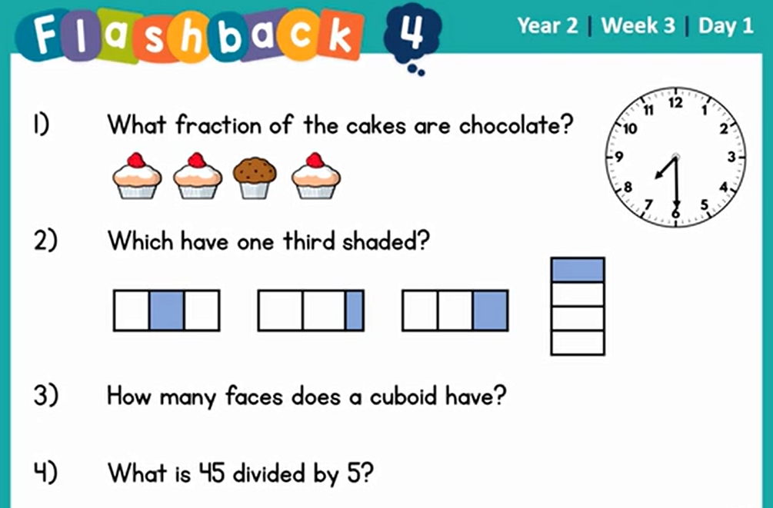
Measurement: Time
Can you match the events to the nearest time of day?
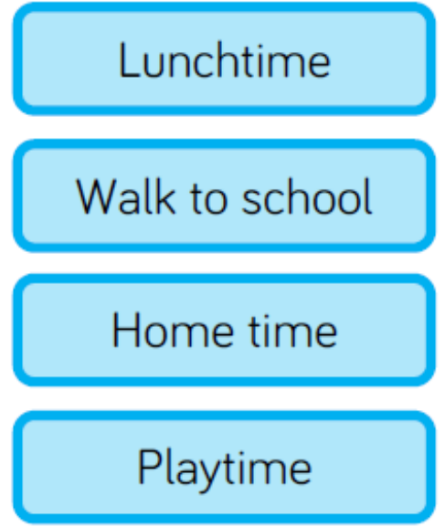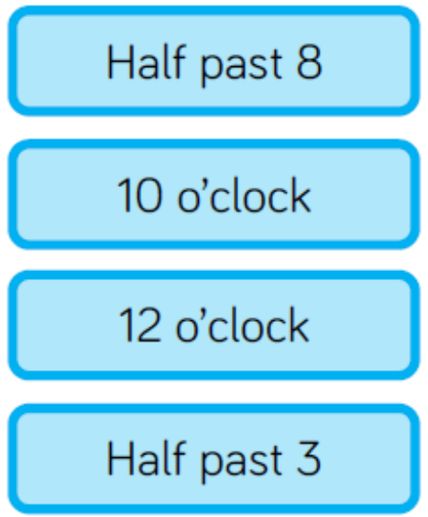
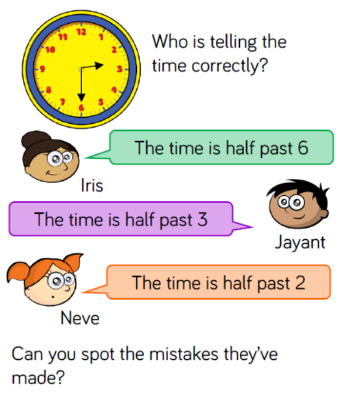
Can you see the mistakes that the children have made?

How would you explain where they have gone wrong?

Throughout the day can you make a note of the time that you do any activity? It could be: eating lunch, taking a shower? Playing outside, walking the dog or getting a daily walk?
How long does each activity take? 10 minutes? Half an hour?
27.4.20 – English Monday 27th April 2020
WALT identify adverbs.
Word of the week cautiously.
As always, we have a word of the week! This week’s word of the week is ‘cautiously’. Can you find a definition, a synonym and put the word in to a sentence?
Last week we looked at adjectives – describing words. Did you find lots of different, exciting words outside? Today we are going to look at adverbs. Who can remember what an adverb is?

Adverb
An adverb is a word that describes how an action is carried out. Adverbs can change or add detail to a verb, adjective, another adverb or even a whole clause.
Adverbs are sometimes said to describe manner or time. To put it simply, they tell you how, when, where or why something is being done.
In general, we use adverbs after the verb (doing word – walk, run, sleep, jump..) in a sentence, however in modern spoken English, this is not always the case.
Adverbs often end in ly.
Today we are going to revise our knowledge of adverbs and try to put some into sentences.

I have attached three differentiated word searches. They all contain adverbs, to help familiarise you with a variety of different adjectives. Once you have identified the adverbs can you use them in a sentence.

NMP
WALT recognise adverbs and use them in full sentences.
Spot the adverbs in the word search, then choose your 4 favourites and put them in interesting sentences with adjectives.
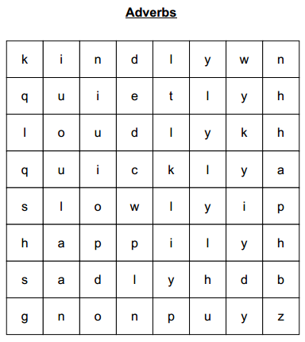

quickly, slowly, loudly,
quietly,
kindly, happily, sadly

Feeling Confident.
WALT recognise adverbs and use them in full sentences.
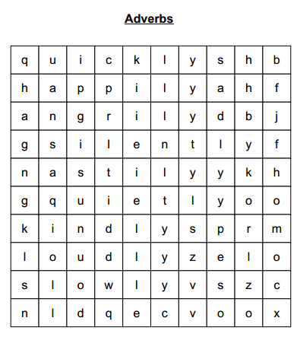
Spot the adverbs in the word search, then choose your 6 favourites and put them in interesting sentences with adjectives.

quickly, slowly, loudly,
quietly, kindly, nastily,
silently, angrily, happily, sadly

Challenge me
WALT recognise adverbs and use them in full sentences.
Spot the adverbs in the word search, then choose your 8 favourites and put them in interesting sentences with connectives and new punctuation.
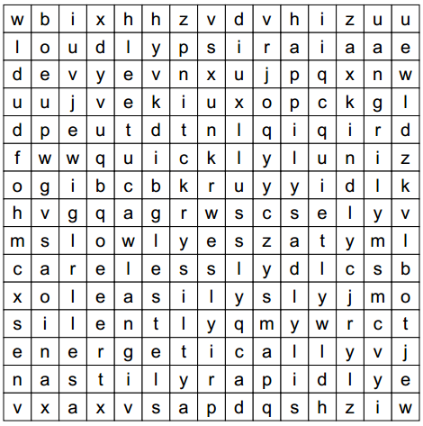

quickly, slowly, quietly,
loudly, happily, sadly,
silently, easily, angrily,
energetically, rapidly, kindly,
nastily, carelessly

27.4.20 – PSHRE – Living in the Wider World – Rights and Responsibilities
WALT: understand how we can contribute to the life of our school and home.
At school, in our classrooms, we have rules to help everyone know how to behave. This makes the classroom a better place for everyone.
Rules keep us safe and help us all to learn.

Now that we are spending much more time in our own homes, what rules could we write to make home a great place to be?
Here are some rules we have in my house:
- Make your bed
- Put your plate in the dishwasher
- Tidy away your own belongings
- Practise your times tables before playing on the tablet
What things could you do at home to help it to be a happy place?
Maybe you could agree on some chores that you could do each day to help the household.

Task: Design a list of rules for you home like the ones we have in the classroom. Decorate you rules to be bright and colourful.
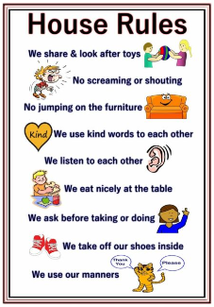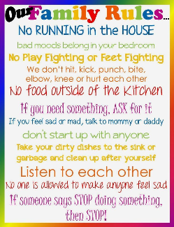
27.4.20 – Music
FRIENDSHIP SONGS
We Go Together (from Grease soundtrack)
Here is another song about friendship to listen to.
https://www.youtube.com/watch?v=ZUrxG8APyiI
Listen to ‘Your Imagination’ again and sing along.
Perhaps you could learn to sing the song.
How is it similar or different to last week’s song?
Then think about these questions:
Does this song tell a story? Perhaps the words tell a story or perhaps the music creates a story in your imagination.
What is that story?
What can you hear? Drums, bass, piano, electric guitar, saxophones and a full chorus of male and female voices.
How does the music make you feel? Music brings many emotions along with it and often each person feels something different. Perhaps share with each other how the music makes you feel.
What did you like about the song? It doesn't matter if you like or don't like a song or a piece of music. Think about the reasons why you do or don't.
Fast Facts Information about the song:
● The musical 'Grease' was first released in 1978 and is still very popular today
(perhaps watch the film when you are older as it isn’t suitable for children in Year 2)
● The musical is set in an American High School in the 1950s.
● 'We Go Together' is a song from the musical.
● The song is sung by the two main characters Danny and Sandy, and all of their friends.
● The song is about being together forever - Danny and Sandy want to be together forever!

