Dear Puffins, Owls and Wrens!

It’s our last week of Home Learning packs! Even though it’s been a long time since we’ve seen each other, it also seem as though the time has flown by and it’s almost the summer holidays!
How are you all? We hope you are all well.
Please find the next week’s Home Learning pack attached to this letter. Have a go, have fun and try your best when completing the activities. We are very proud of you for continuing to complete home learning tasks and trying so hard with your learning. If you have any questions about any of the lessons/tasks, please just let us know. We are here to help.
We hope you will enjoy these new activities 😊 and let us know how you got on. We love seeing your work and hearing about what you get up to each week.
Don’t forget to have fun and stay safe.
Reminder:
July is the National Picnic Month!
July is also a plastic free month!
Plastic Free July is a global movement that helps millions of people be part of the solution to plastic pollution so we can have cleaner streets, oceans, and beautiful communities.
For more information visit https://www.plasticfreejuly.org/

Have a lovely summer break from home learning packs and lessons. Enjoy the weather and time with your families. We are really looking forward to seeing you back in school in September!

Take care, look after yourselves and your families and keep smiling

We miss you all,
Mrs. Cox, Mrs. Milligan, Mrs. Jochacy and Mrs. Athanasiou xxxx

Year 1 Phonics activities – Summer 2 – Week 7 and Year 1 spellings

Session 1 - Monday 13th July 2020  Warm up activity – read and write tricky words and Year 1 Common Exception Words  Tricky words: different  Year 1 Common Exception Words: go, so, by, my  After reading all of the words, cover one word and write it on a piece of paper. Check the spelling and try another word. | Session 1 - Main activity  To know different pronunciations for one grapheme.  u = 'oo' in pull  u = long u in unicorn  in unicorn  u = short 'u'  in up/under/ umbrella  Stretch and blend these words. How many different phonemes for the ‘u’ grapheme can you hear?  fun full unit  up pull unicorn  bus push human  under awful pudding  us put bush  sudden pulley
Session 2 - Tuesday 14th July 2020  Warm up activity  https://www.youtube.com/watch?v=ri4u0TjAZ38  While watching the clip try to write down all of the tricky words included in the song.  At the end of the clip see if you can write a sentence using one or more of the tricky words you have written down. | Session 2 - Main activity  Have a go at sorting these ‘u’ words.  https://central.espresso.co.uk/espresso/primary_uk/subject/module/activity/item819920/grade1/module63427/index.html
Session 3 - Wednesday 15th July 2020  Warm up activity  Recap all of phase 5 phonemes:  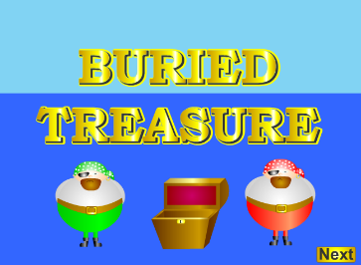  https://www.phonicsplay.co.uk/resources/phase/2/buried-treasure | Session 3 - Main activity  To know different pronunciations for one grapheme.  ow  in owl  ow  in window  Practise reading and then spelling these ‘ow’ words, using sound buttons and sound lines:  Brown, slow, growl, bowl  Now challenge yourself and write as many  ow – owl and ow – arrow  words as possible in 1 minute!
Session 4 - Thursday 16th July 2020  Warm up activity  Recap - To know alternative pronunciations for grapheme c: ‘c’ or ‘s’  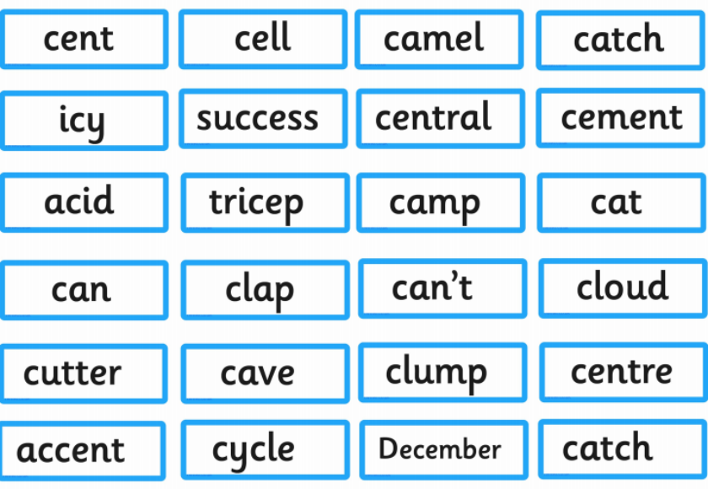 | Session 4 - Main activity  Divide a piece of paper into two columns, one ‘ow’ the other ‘ou’. Sort the words below into the correct column.  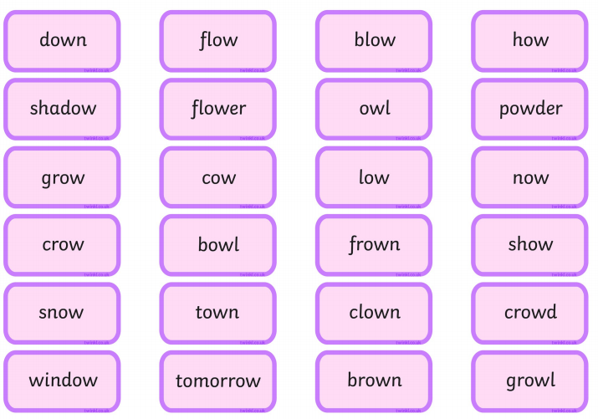
Session 5 - Friday 17th July 2020  Warm up activity  Sing alphabet songs and recap phase 5 phonemes, using flash cards. | Session 5 – Main activity  Can you make up sentences using these words?  different, go, so, by, my  Write them down. Make sure you use a capital letter to start and a full-stop to end each sentence.

Year 1 English Activities – Summer 2 Week 7
This week’s English will be based around the book ‘The Lighthouse Keeper’s Lunch’ by Ronda and David Armitage. If you have the book at home, read it either on your own or to a grown up.
If you don’t have the book you can watch the video here...
https://www.youtube.com/watch?v=1evkeM9O3RY
Before reading/ watching the video, look at the book cover:
What are the names of the authors?
What do you think this book is going to be about?
How do you know?
Once you read the book:
Who are the main characters?
Monday  13th July | Can you retell the story? Try to use time connectives.  Think about what happened in the beginning, in the middle and at the end of the story.  Now, have a think who is your favourite character? Can you use ‘because’ to give your reason why? Write down your answer.
Tuesday  14th July | Write two sentences using adjectives and connectives to describe a picture.  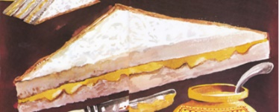  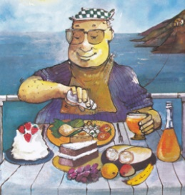  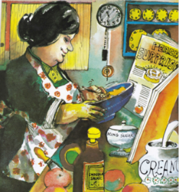  Remember to think about your sentence and then say it to yourself before writing it down. Then re-read your sentence to ensure it makes sense!  adjective - an adjective is a word that describes an animal, person, thing, or thought. Adjectives include words that describe what something looks like and what it feels like to touch, taste, or smell.  connective – joining word that is used to link phrases within a sentence, for example: and, next, because, also, so, then, but, later
Wednesday 15th July | 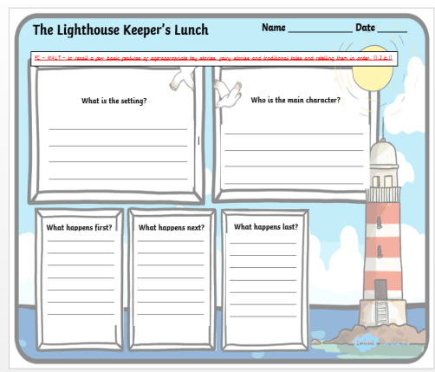  Complete the book review/ordering the story on a piece of paper using/answering the questions on the above sheet.
Thursday 16th July | Can you answer these questions about the story:  Where was Mr and Mrs Grinling’s little white cottage?  Which word describes Mr Grinling as a hard worker?  Why did some ships toot at night?  What was the plan which stopped the seagulls from eating Mr Grinling’s lunch?
Friday 17th July | WOW writing  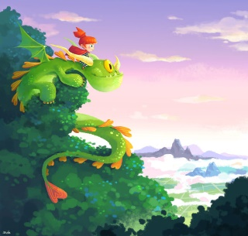  Choose a picture. You can write anything you want about it!  You must remember:  - Full stops  - Capital letters  - Finger spaces  - Re-read your writing to check it makes sense

Year 1 Maths Activities – Summer 2 week 7
This week we are:
- Continuing to begin to understand multiplication, division and doubling through grouping and sharing small quantities.

Monday 13th July 2020
What does the word ‘double’ mean’?
Which representation shows doubling? How do you know?
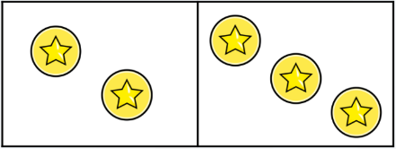
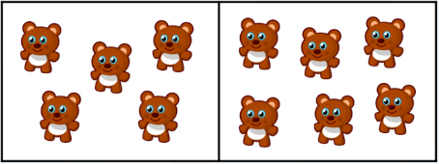

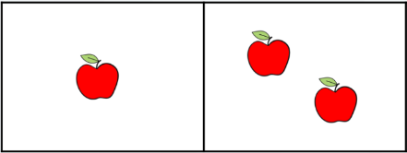

https://www.youtube.com/watch?v=8jOzhiACB68
Listen to the song and try to join in.

Activity:
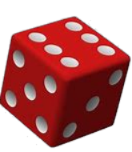
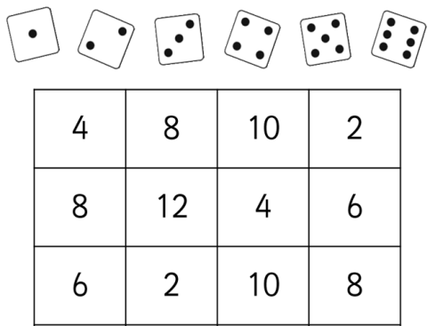
Double the number that you roll on your die. Colour in the box that matches. If there are no boxes to colour, roll again until all boxes are coloured in.

Challenge:
Practise doubling to 20.

Tuesday 14th July 2020

Activity:
Solve each task. You can use counters or other small objects to help you. Group them for each task and draw around your groups.
There are 20 apples.
We need 5 in each box.
How many boxes are there?
e.g.

There are 4 boxes.

There are 16 pencils and 4 pupils in the room.
How many pencils will each of them get?
There are 12 lollies.
Each child gets 3 lollies.
How many children are there?
There are 18 cakes.
We need 3 on each plate.
How many plates are there?

Challenge:
Practise counting in 2s, 5s and 10s. Write the sequence of numbers on a whiteboard.

Wednesday 15th July 2020

Share the doughnuts between 2 plates. How many will each plate have? (Use the language ‘one for you, one for me’.

There are 3 buckets on the beach. Jack has 10 shells. Can he share them equally into 3 buckets?

Activity:

Solve these word problems. Draw ‘sharing circles’ and dots to show your answers.

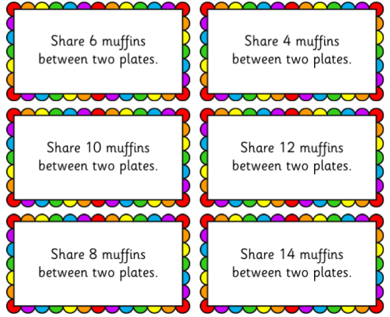
Challenge:
Choose a handful of counters. Can they be shared equally between 3 sharing circles?

Thursday 16th July 2020
Activity:
Here are some maths activities/ problems you can have a go at solving. Try to do these on your own without any resources. Just like you have done Mental Maths quizzes at school.
- 3 + 5=
- 9 - 0=
- 4 +___ = 20
- Add together twelve and six
- 18 – 17 =
- 13 = 5 + ___
- ___ + 4 = 12 + 2
- 12 is one more than ______
- 17-3 = ____ - 2
- 20 – 8 =

Friday 17th July 2020

Year 1 Theme activities – Summer 2 week 7
Date: | Activity:
Monday 13th 2020 | Art  You are going to draw your own lighthouse just like Mr Grinling’s.  You are going to try sketching your own seaside picture. Sketching is a very useful tool in art, it helps us to draw pictures adding detail before we add colour.  Watch a clip showing how to sketch a lighthouse - watch carefully.  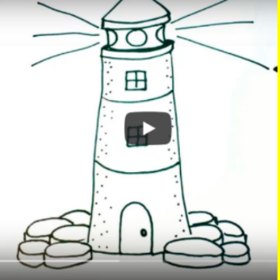  https://www.youtube.com/watch?v=06iZ65pFijU  Once you have drawn your lighthouse you are going to colour it using crayons. You need to think about how you can make strong and soft lines using your crayons.
Tuesday 14th July 2020 | Art  Today, you are going to draw your lighthouse again, but this time you are going to paint it. Watch the clip again to remind you how to draw it.  Once you have drawn the lighthouse, you are going to paint it. Can you remember what the primary colours are? How do you make secondary colours? How can you make tints and shades of your colours? Try and use those in your picture.
Wednesday 15th July 2020 | DT  You will be designing a seaside picnic.  What food would you like to have at a seaside picnic? Create a list.  Have you included something from each of these categories?  - Something healthy  - Something refreshing  - Something savoury  - Something sweet  - Something beach-themed  This is a balanced plate. It helps people understand the different types of foods there are and how much of each type they should eat. What do you notice about how the foods have been sorted? Discuss.
Thursday 16th July 2020 | DT  This is an example of a picnic plate.  Is this picnic a balanced meal? Does this picnic have the right amount of food from each category?  How could I improve it? Write down how you could improve it and explain why you chose the foods in the picnic.
Friday 17thJuly 2020 | DT  Design a balanced picnic and answer the questions. Use Balanced Plate to help you.

