Thursday 25th June 2020
SPaG
Words with the k sound spelt ch
Write each word in your spelling list using two different colours. Write the constants in one colour and the vowels in another colour.
echo
echo
chorus
character
scheme
chemist
stomach
orchestra
technology

Word of the Day –

Definition ____________________________________________
_____________________________________________________
_____________________________________________________
Used it in a sentence: ____________________________________________________
_________________________________________________________________________
Word Class: ____________________________________________________
Synonyms

English
What do the terrible tricks the Twits have played on each other so far tell you about the Twits?

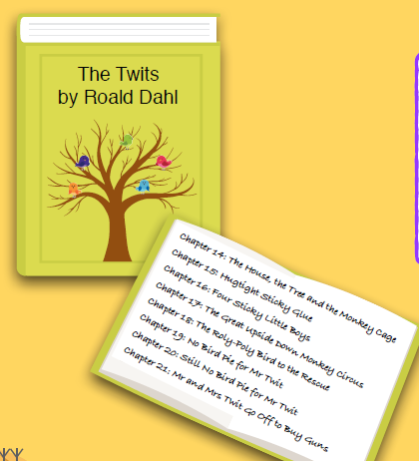
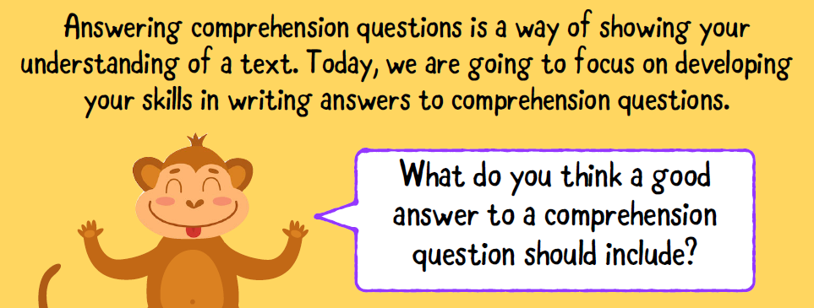
Now sit back and enjoy the next 8 chapters of The Twits.

As you have read lots today there is no written task! Well done

Maths
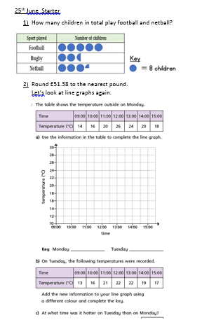
Science
To stay alive and healthy, you and all other living things need certain conditions that let them carry out the 7 life processes:
- Food and water
- Space to move, grow and have young
- Air or oxygen
- Shelter or safety
These are the basic needs that are shared by all living things.
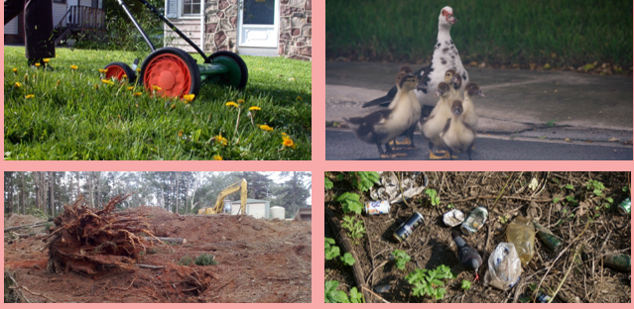
A habitat is a place where animals and plants live, where they can find everything they need to stay alive. A habitat can be as big as an ocean or as small as a rock. Plants and animals rely on their environment to give them everything they need. When habitats change it can be very dangerous to the plants and animals that live there. Even small changes can be dangerous.
TASK: What dangers can you see in these pictures?

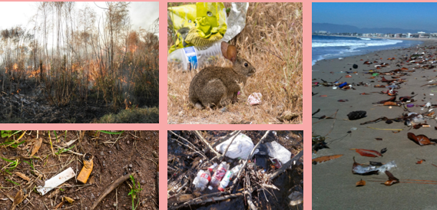

TASK 2: Go into your garden or local park, what habitats can you find? Are there any threats and if so what could you do about it? You might like to use a table like the one below to help you set out your work.
Where is the habitat?  What lives there? | What is the danger? | What can be done to help?

