Year 2 Phonics/Spelling Practice – w/c 20.5.20 Wednesday
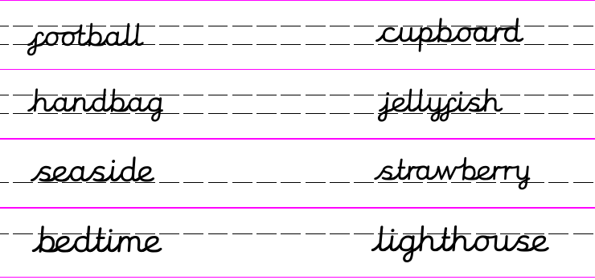

Write the captions for each picture.

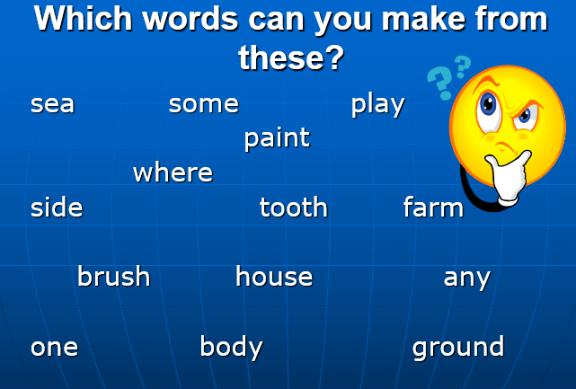
Dictation sentence to practise:
I saw a jellyfish near the lighthouse.

Maths 20.5.20 Subtract 2-digit numbers
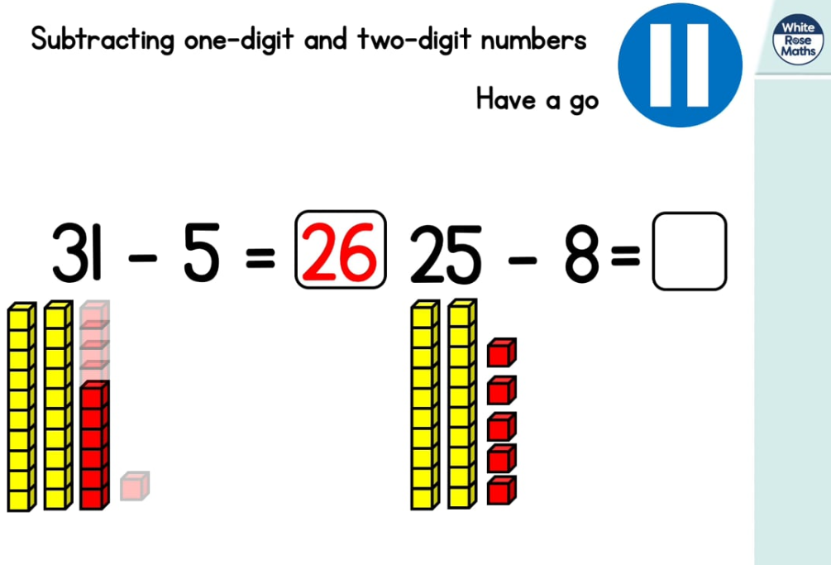
https://whiterosemaths.com/homelearning/year-2/ (week 4 dated w/c 11.5.20 Lesson 3)
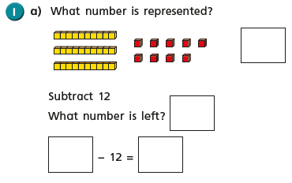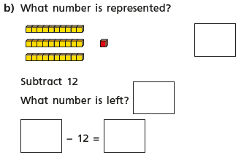

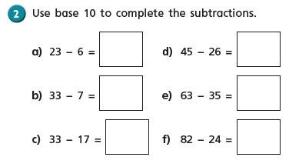
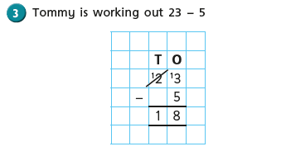
Can you see what Tommy has done? Does he have enough 1s?
He exchanges a 10 for ten 1s.
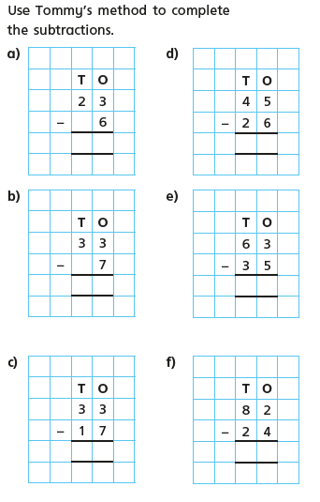
English - Wednesday 20th May 2020
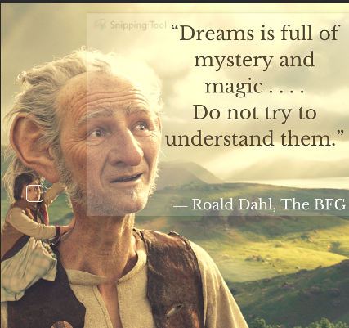
WALT write a diary

Can you believe it is diary day again? Today my diary is from a very special day in our house Mr Johnson’s birthday.

Dear Diary.

What a day! I had very little sleep last night as Drew was outside painting a mural on the back wall for Mr Johnson’s birthday. He has spent most of lockdown building an outdoor kitchen and he finished it yesterday ready for his birthday bash today. She has painted a mural of a pub sign called ‘The Bricklayer’s Arms’ as Mr Johnson is a bricklayer. It looks fantastic but it took her all night as she wanted it to be a surprise when he woke up and I was very worried about her being outside in the cold and dark but she was absolutely fine and finished at seven in the morning. I got up at 8 as Fenella was going to help me decorate the garden. We put up bunting, balloons and Happy Birthday signs and decorated what we call ‘The Birthday Tree’. ‘The Birthday Tree’ began a few years ago on Freddie’s birthday. We decorate it with lots of brightly coloured streamers, it is actually an apple tree on normal days. Everyone in our family apart from Fenella has a birthday in the summer so it gets to be ‘The Birthday Tree’ quite regularly. Once the garden was done we allowed Mr Johnson to get up an open his presents. He was very chuffed with his gifts and loved his birthday balloon and cake from Cakestand and Crumb. It was chocolate with lots of sweets on the top and was made by an ex pupil of mine Hannah. After the present opening we had a big breakfast and pretended we had gone out for it, it was good fun. We then went on a long walk as it was a lovely day and we needed to burn off some of the food we had eaten.
When we got back from the walk we lazed around the garden and facetimed family. At seven o’clock we were going on a virtual trip to some of Mr Johnson’s favourite places. Drew had also painted some pub signs and positioned them around the garden in different areas and we visited some of them for a birthday drink. When we got to one called ‘The Fox and Hounds’ we met up via facetime with Mr and Mrs Hitchings. Mr Hitchings and Mr Johnson have been friends since middle school and this was one of the places they used to go to when they were younger. It was lovely to see them and Mrs Hitchings was wearing some silly sunglasses with birthday candles on. After that we had a really tasty BBQ cooked by Freddie then played some music and danced the night away. Mr Johnson said it was one of the nicest birthdays he’d had and was much more fun than any of us thought possible. We shall remember it for many years. I’m off to bed now as I am in school tomorrow and need to be up early.

Mrs Johnson
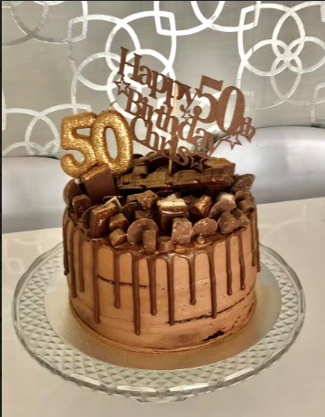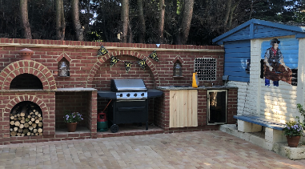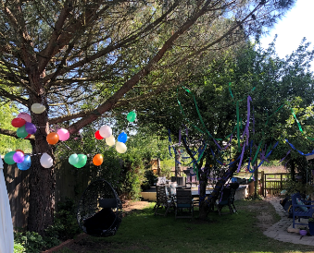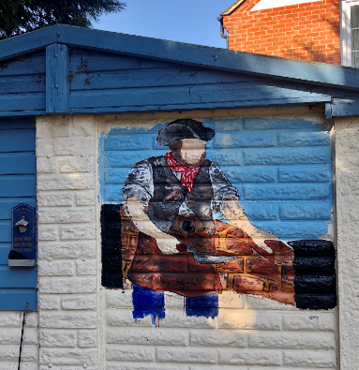

I can share with you the cake, the kitchen, the birthday tree and the mural.

Wednesday 20th May 2020
WALT understand how we can be a good leader and the qualities that we need.

Today is the last week in our R.E topic about leaders. I would like you to look back at all the work we have done and think about what makes a good leader ask yourself these questions.

Who are leaders?
What do they do?
Do they inspire you to be a good leader?
What qualities does a good leader need?

Your task today is to draw you as a leader. When we go back to school we are all going to have to be good leaders and will have to inspire each other under the circumstances we may face.

Can you draw a picture of yourself with sentences or phrases around you saying what will make you a good leader?

Use our previous work to inspire you.

