Friday 3rd July 2020
SPaG
Spellings – Words with the sh sound spelt ch
Create a word search using the words in your spelling list. Write the spelling words in the grid below. Words can go forwards, backwards, up, down and diagonally. Finish by filling in the remaining spaces with random letters.
chef
chute
chalet
machine
brochure
parachute
ricochet
moustache

Word of the Day – ease

Definition ____________________________________________
_____________________________________________________
_____________________________________________________
Used it in a sentence: ____________________________________________________
_________________________________________________________________________
Word Class: ____________________________________________________
Synonyms

English
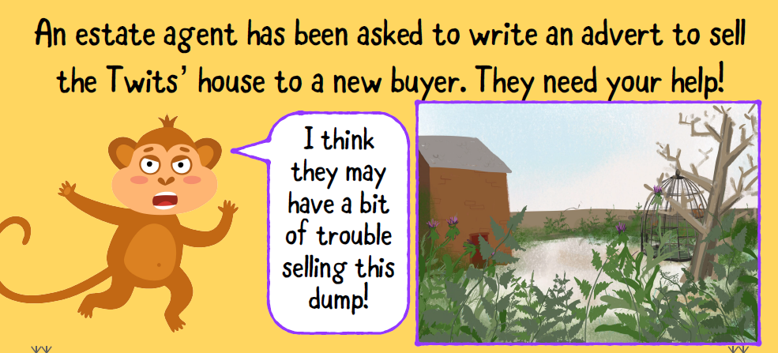
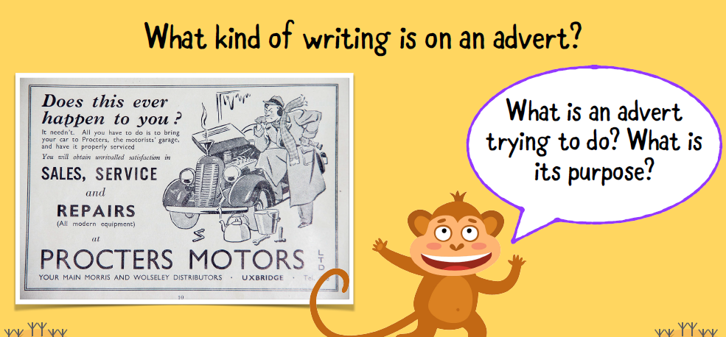
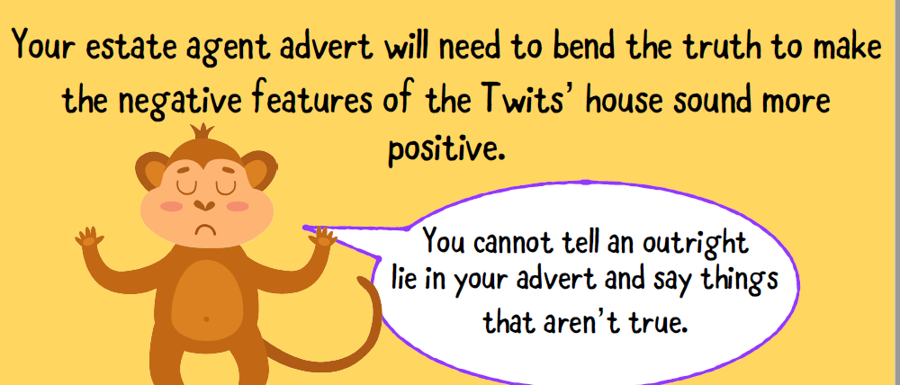
Task
Use the questions in the boxes to help you write an advert to sell the Twits’ house. Think carefully about how you can use language to help your writing become more persuasive.
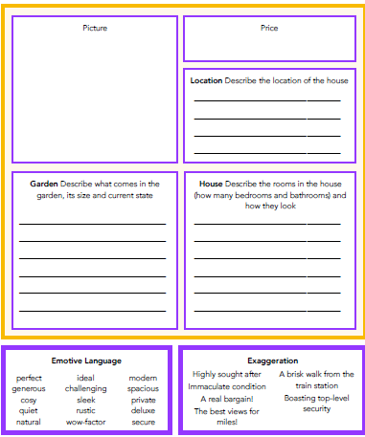

Maths
Use < or > in between these numbers:
- 345 354
- 0.7 1.2
- 2.4 4.2
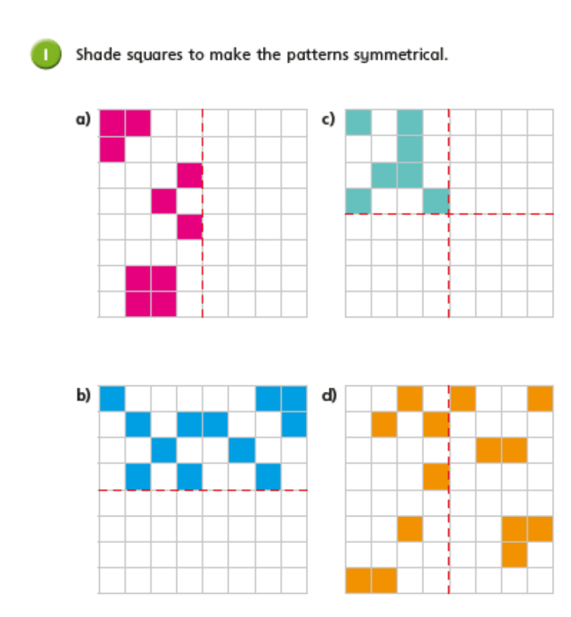
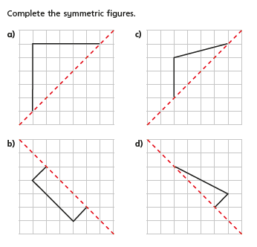

PSHCE wellbeing journal
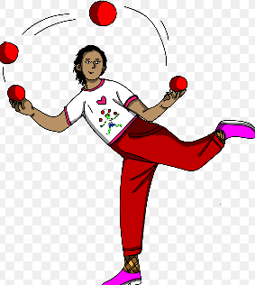  How I feel  Learn a new skill to impress your friends when you return to school.  Which new skills have you learned?  How long have you spent practicing today? | 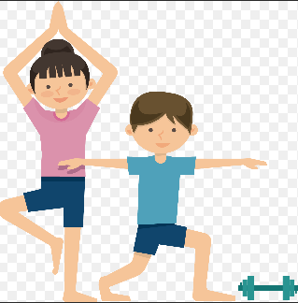  How I move  Help people who you live with by completing three tasks that use your muscles (carrying shopping bags, hanging the washing up…). These should involve movements such as lifting, standing, carrying, pushing or pulling.  What activities did you complete? Which muscles did you use?
How I sleep  Try to keep to a routine and try to go to sleep the same time as a school night so you can get up early and enjoy outdoor activity. Morning sunlight helps you to produce your sleep hormones you need for later in the evening. 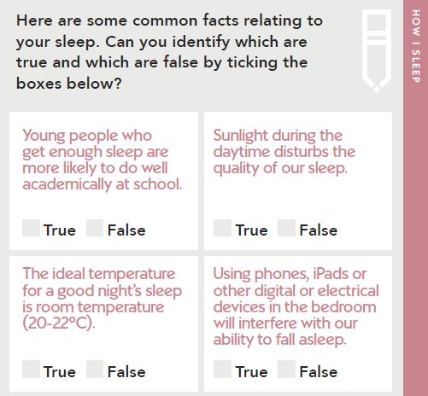 | How I eat  Try to eat vitamin packed fruit and veg to boost your immune system and stay healthy – aim for a variety of colours each day.  Did you eat a full rainbow of colours today? Did you miss any colours out? Can you include these tomorrow?

