Friday 10th July 2020
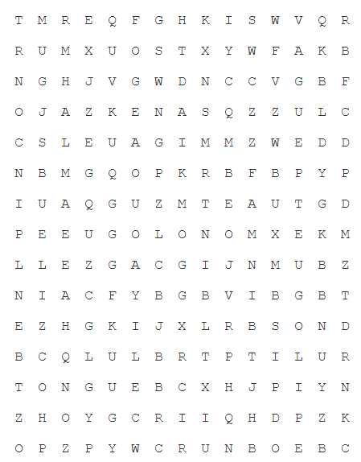
SPaG
Words spelt with a g sound spelt gue
league
tongue
vague
plague
meringue
synagogue
epilogue
monologue

Word of the Day – pardon

Definition ____________________________________________
_____________________________________________________
_____________________________________________________
Used it in a sentence: ____________________________________________________
_________________________________________________________________________
Word Class: ____________________________________________________
Synonyms

English
In preparation for next week’s English today you need to re-read Chapter 15: Hugtight Sticky Glue and Chapter 16: Four Sticky Little Boys. Below are some VIPER questions for you to answer.

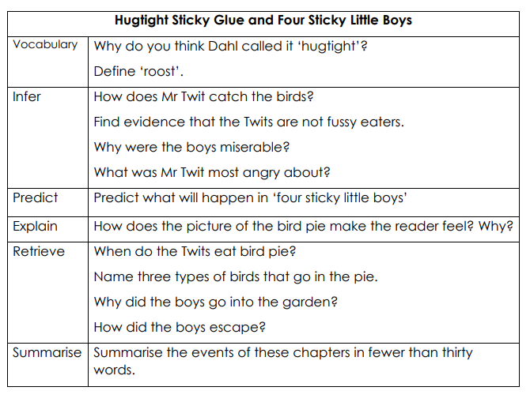

Maths
- 549 ÷ 3 =
- 644 ÷ 4 =
- 999 ÷ 9 =
Use the video from yesterday if you want a reminder about solving problems with money.
https://vimeo.com/430337938

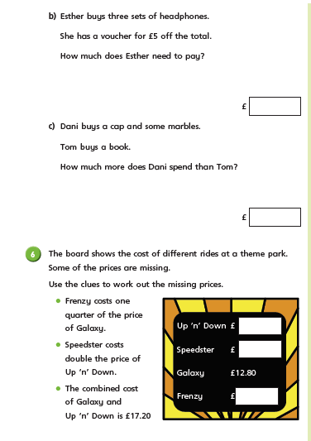

PSHCE wellbeing journal
How I feel  Think of three good things which made you happy today. | How I move  Make up an exercise or dance routine  to your favourite song and teach it to  friends by making a video. Challenge your grownups to join in… can they keep up!?
How I sleep  Spend time to rearrange your bedroom to  de-clutter and make the best environment you can in order to play, exercise and sleep well.  Which items did you tidy up or what  did you change in your room? Did  you sleep better after doing this? | How I eat  Think of new ways to drink enough water  every day by adding ingredients which are low in sugar but high in vitamin C and other nutrients. Examples could include lemon slices, fresh mint, ginger.  