Year 2 Phonics/Spelling Practice – Wednesday 3.6.20.
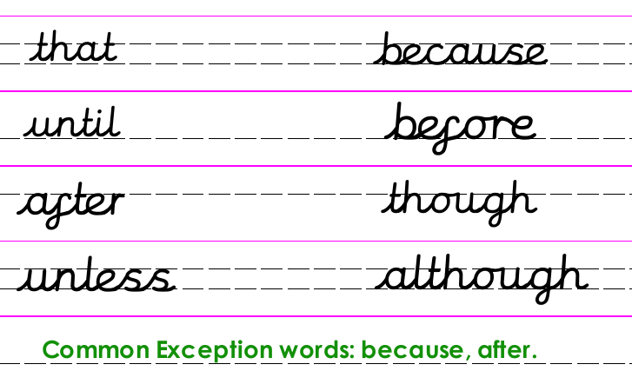

The correct spelling for some words is difficult to remember, but we use them a lot. Do you know a way to remember how to spell ‘because’?
Design and make a poster to remind yourself how to spell ‘because’ or if you know it well already, choose one of the other conjunctions instead. You could always email a photo of it to your teacher too!
Copy and complete the sentences:
I like school because …
My favourite food is ______________ because…
My favourite animal is ___________ because …

3.6.20 Maths
The 2 times table
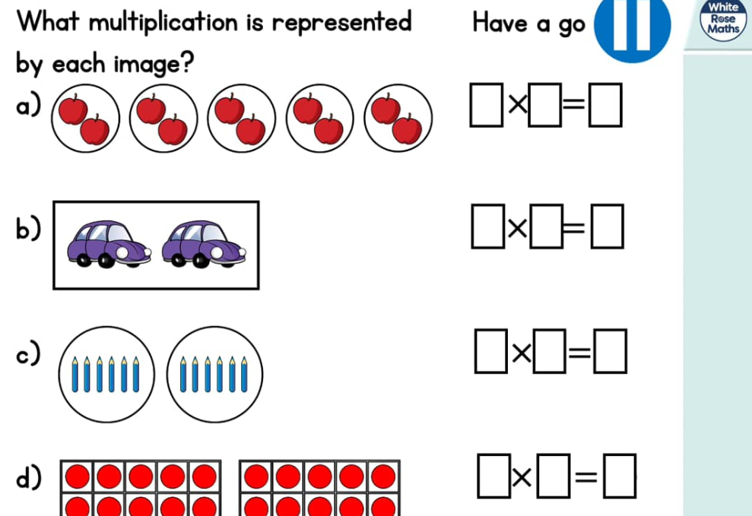
https://whiterosemaths.com/homelearning/year-2/ (Week 5 W/C 18.5.20)
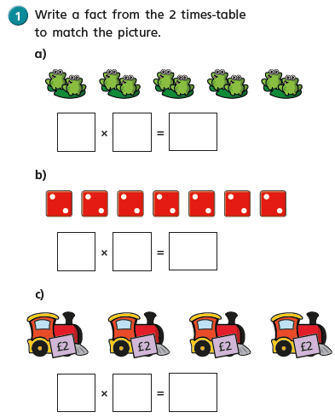
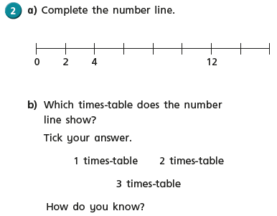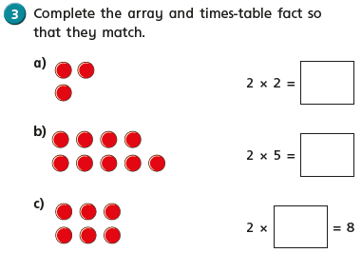

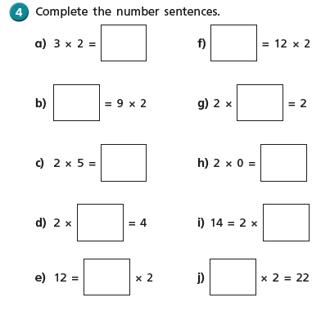
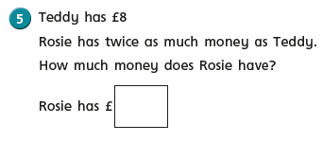

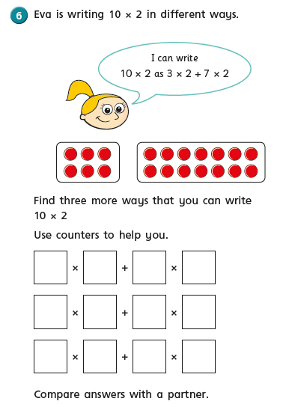

English Wednesday 3rd June 2020
Good Morning, today is Wednesday and we all know that it is diary writing day.

Dear Diary
Another beautiful, sunny day in Box End today. I was quite excited when I woke at seven, the sun was shining through the curtains and the sky was a bright, azure blue. We had decided yesterday, Saturday that we were going to go on a long hike, across the countryside this morning. I had a few jobs to do so I decided to get up early and to get on before we set off. After cleaning floors and watering plants we decided to make bacon sandwiches before we got ready for the hike. I am a vegetarian, so I had Quorn bacon with brown sauce; it was absolutely yummy and went down a treat with my cup of tea.
By 11 o’clock we were almost ready for the hike. We made sure we had got bottles of water and sensible shoes and set off down the road. We have lived in this area for a very long time but have never been down some of the public footpaths just down the road and were keen to discover the beautiful countryside that surrounds us. Before long we were walking alongside a field full of cows. It was so surreal to see them in what seemed like the middle of nowhere. They were so content chewing the cud, enjoying the sunshine. After about half an hour we approached a quiet country lane. I know exactly where we were and so we headed up the lane until we came to another public footpath. We thought we knew where we were heading but were desperate to walk alongside some woods we could see on the horizon. We were very lucky as the path took us there. We were quite shocked to come across a sign that said ‘Welcome to Kempston Woods’. Mr Johnson has lived in Kempston for most of his life and had never known there were woods there! I used to keep horses in Kempston Wood End, (which is where we were) and I had never made the connection that there were woods here. We felt quite silly but were very keen to explore the woods. They were beautiful! It was getting quite warm by now but walking under the canopy of the trees was blissful. The shade offered welcome coolness and there was even a slight cooling breeze.
After exploring the woods for some forty minutes we came back out on a path that led us over fields and back to the roads. We knew where we were now. Stagsden Hill, which was about half an hours walk from home. By now my feet were beginning to rub and I was glad to be heading home.
We had, had a lovely walk and explored some beautiful countryside that was right on our doorstep. We both agreed how lucky we were and how we must aim to get out and discover more of our local area.
What a lovely day we had had!

Mrs Johnson
Wednesday 3rd June 2020
WALT some people can change the world.
In R.E this term we will be investigating ‘The Good News that Christians believe Jesus brought to the world.
We could all do with some good news at the minute! We are going to start this topic by thinking about people or professions which can change the world. Once you start thinking you may find it is not necessarily the people you first thought of.
Can you read the story from the bible about one of Jesus’s ‘word changers’, Matthew the tax collector?
Watch one of these animated versions on YouTube just put in Matthew the tax collector into your search engine.
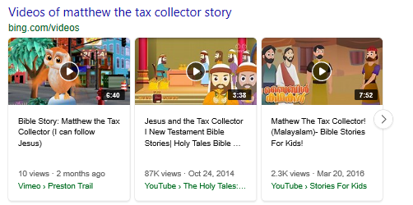
Task
Write a list of people/professions that could help change the world, think of people who help us, help the environment, help government…………….
