Tuesday 28th April 2020
English
SPaG
Spellings - The I sound spelt y elsewhere that at the end of the word

myth
Egypt
gym
pyramid
mystery
symbol
physical
synonym

Write each of your spelling words forward and backwards.
Word of the Day – vast

Definition ____________________________________________
_____________________________________________________
_____________________________________________________
Used it in a sentence: ____________________________________________________
_________________________________________________________________________
Word Class: ____________________________________________________
Synonyms

English – Persuasive Letter – Read the letter below
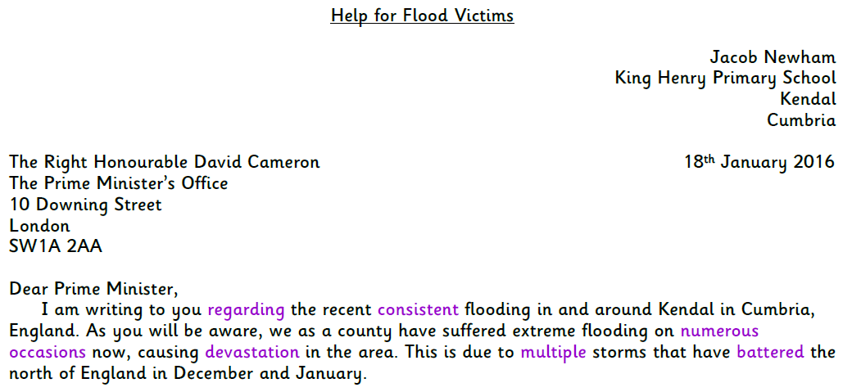
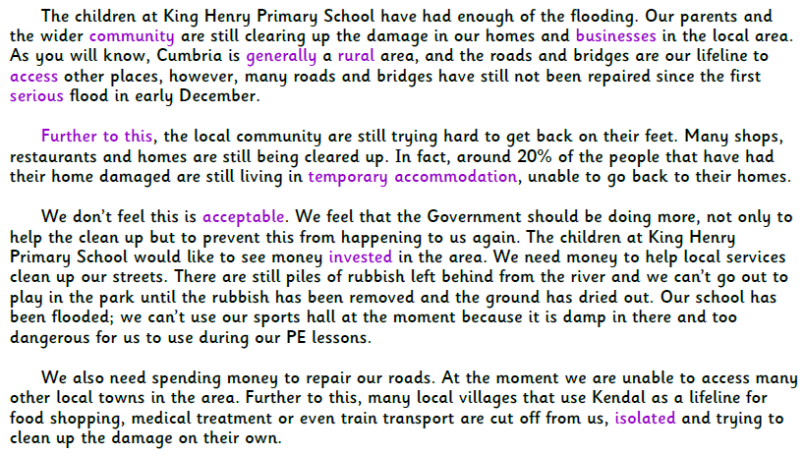
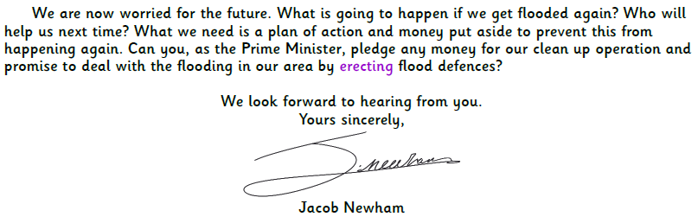
Look at the format carefully as tomorrow you will plan your own persuasive letter. Today answer the following questions using the letter above.
What is the meaning of isolated?
Is the text written in a formal or informal style? How do you know?
What do you predict the prime minister will do after receiving this letter?
Explain what the flooding has done in Kendal.
Who is the recipient of the letter?
Summarise what you think Jacob Newman thinks the government should do about the flooding in Kendal in two sentences.

Maths
- 56 + 22 + 87 =
- 101 x 4 x 2 =
- Write the shaded squares as a) hundredths b) hundredths as a decimal fraction.
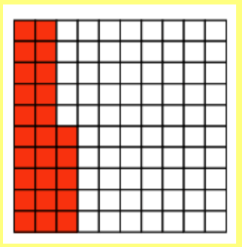

The area of this shape is 6 squares.
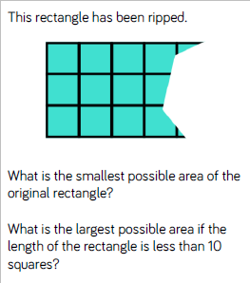
- 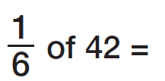
- How many days in April?
- How many days in a leap year?
- 99 – 12 =
- 217 + 105 = (work this out mentally)
- 3,406 + 237 =

Geography
A compass is an instrument used for navigation and orientation that shows direction relative to the geographic "points". Usually, a diagram called a compass rose shows the directions north, south, east, and west on the compass face as abbreviated initials.
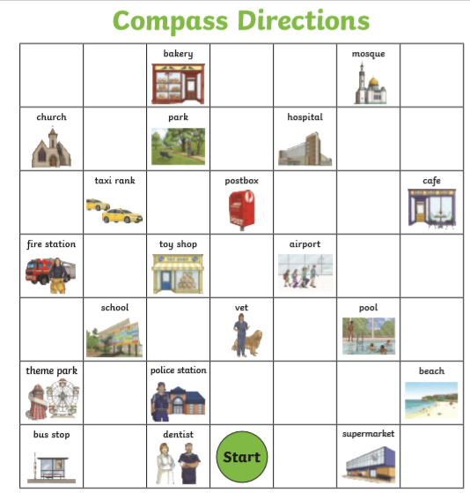
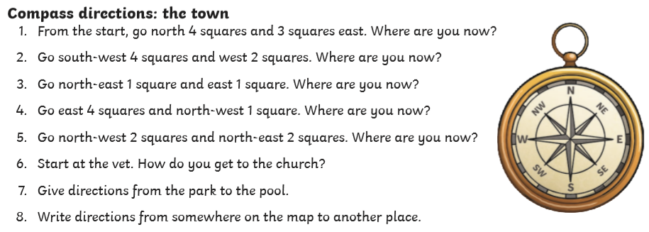
Challenge: could you make your own compass rose?

