Tuesday 5th April 2020
English
SPaG
Spellings - The u sounds spelt ou.
Practise your spellings – try making a fortune teller to help practise the words.
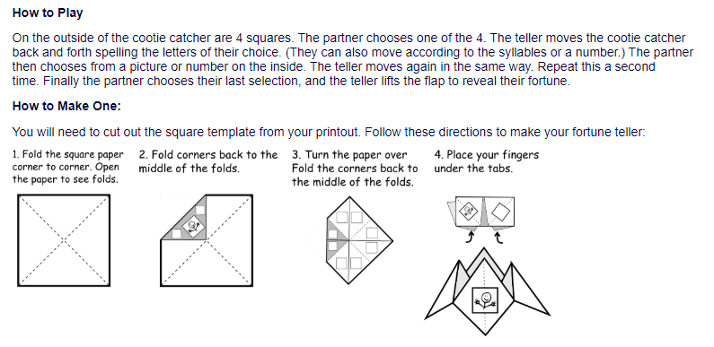
young
touch
double
county
trouble
cousin
encourage
flourish

Word of the Day – appeal

Definition ____________________________________________
_____________________________________________________
_____________________________________________________
Used it in a sentence: ____________________________________________________
_________________________________________________________________________
Word Class: ____________________________________________________
Synonyms

English – Vipers –
Listen to ‘The Egyptian Cinderella’ again. https://youtu.be/kqrnP7Julxw
Have you noticed any themes that appear in the story? (Examples of themes perseverance, friendship, acceptance, responsibility, kindness, honesty, jealousy, courage, compassion, overcoming obstacles, love, hope, isolation, journey, good vs evil, escape etc) Can you identify this theme in other
stories you have read?
Task - Answer questions on The Egyptian Cinderella. Select either MP, FC or CM for each viper.

Text Title: The Egyptian Cinderella
MP - What are chores?
FC - Find and copy a word that means covered in a thin layer of gold or gold paint.
CM - Can you find an example of a simile in the text?
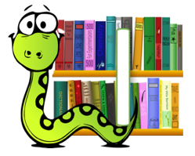 | MP - What might the servant girls be thinking and feeling when the master gave Rhodopis rose-red slippers?  FC - How do you know Amasis is bored of holding court?  CM - Why do you think the servant girls said nothing to Amasis about who owned the rose-red slipper?
 | Do you think Rhodopis will be a kind and caring queen? Explain your answer using evidence from the story.
MP – Explain why Rhodopis bowed her head when she saw the falcon.
FC – Explain how Rhodopis was different to the servant girls.
CM - Explain what holding court means.

MP – At the start of the story who took Rhodopis?
FC / CM- What did Rhodopis do when she saw the Pharaoh coming?

 | Write a summary of the story in three sentences.

Maths – Mental
Last year Blue Peter started at 4:20pm and finished 45 minutes later. What time did it finish?
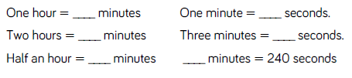

Maths – Main Lesson
Watch: Converting tenths to decimals
https://www.bbc.co.uk/bitesize/clips/zr6pvcw
Write 1/10 as a decimal.
Write 3/10 as a decimal.
Write 7/10 as a decimal.

Watch: Arranging numbers with decimal place
https://www.bbc.co.uk/bitesize/clips/zh6pvcw

Arrange the following decimal numbers on the number line:
3.4 3.7 3.9 4.1 4.5 4.9

3 4 5

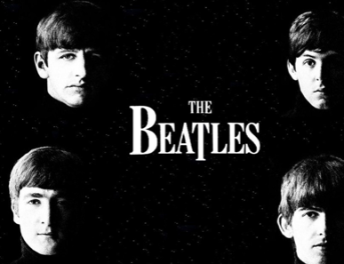
Music
We thought you might like to try listening to some music at home.
Listen to a recording of Blackbird by the Beatles – when you first listen try not to watch a video with it so that you can create your own pictures in your head.
https://www.youtube.com/watch?v=EoAgiYRM0EE
Listen carefully. Perhaps close your eyes. Use your imagination as you enjoy the music. You might see colours, words, pictures, or encounter lots of different feelings. Play the music again. Move to the music or sit down to listen with closed eyes. What instruments can you hear? Perhaps use a piece of paper or Ipad/tablet to make notes, draw, write down any words that spring to your mind. You might want to create your own listening map - a visual representation of what you hear. (But you don’t have to!)
Questions to think about whilst you listen.
Does this song tell a story? Perhaps the words tell a story or perhaps the music creates a story in your imagination. What is that story?
What can you hear? Keyboard, guitar, voice, bongo drums. Some backing vocals and strings as the song progresses
How does the music make you feel? Music brings many emotions along with it and often each person feels something different. Perhaps share with someone how the music makes you feel.
What did you like about the song? It doesn't matter if you like or don't like a song or a piece of music. Think about the reasons why you do or don't.
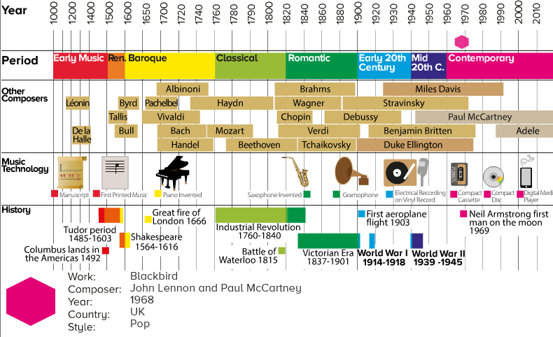
How old to you think the music is?
What does the song make you think of?

