Year 2 Phonics/Spelling Practice – Tuesday 30.6.20.
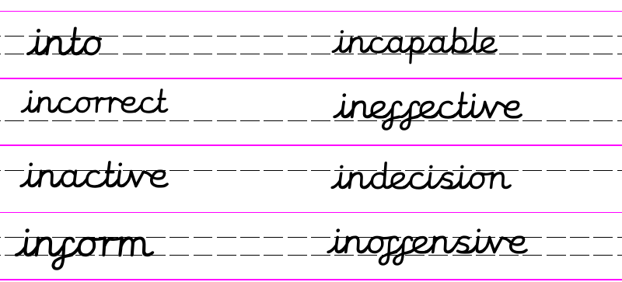

Practise: Today you could use the game hangman to practise spelling our in- words.
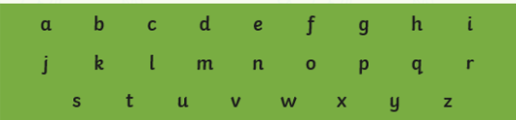
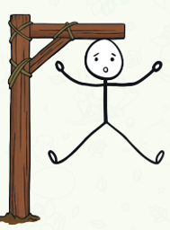

Dictation:
Ask someone to read out the sentence below so that you can write it down – try not to look until after you’ve written it. Check your punctuation and spelling.
Her indecision made her ineffective at school\

Maths 30.6.20
Compare Lengths
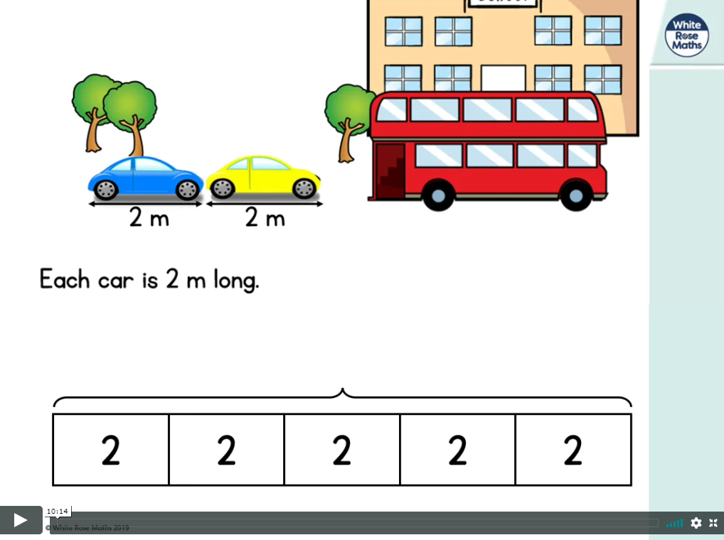
https://whiterosemaths.com/homelearning/year-2/ (week 9 w/c 22.6.20)
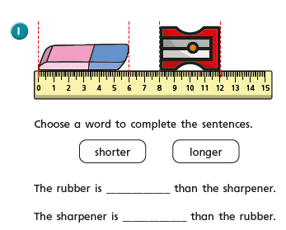
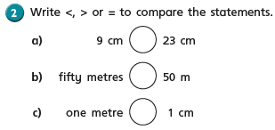
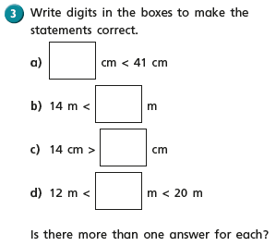
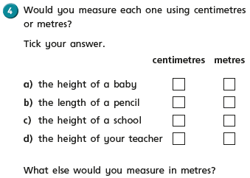

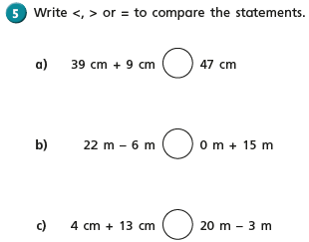
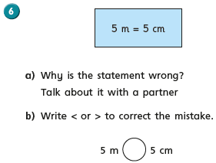

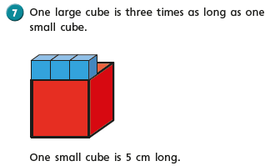
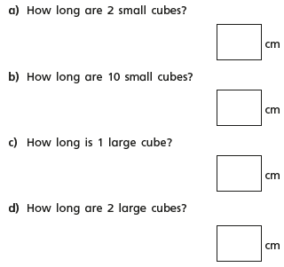
English - Tuesday 30th June 2020
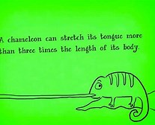 Fun fact of the day!
WALT write a short letter.
Good morning. How did you get on yesterday spending all that imaginary money you would have had as the richest person in England?
Today I have another task for you. I have been wondering all day what on earth the Duke of Hampshire would want with the ‘Ladderless Window Cleaning Company’. What do you predict he has written to our lovely little window cleaning company? Do you think he has good news? Bad new? Will the three friends’ prayers be answered and will there be food on their tables tonight?
You are going to write a letter as the Duke of Hampshire. I want to know what you think he is writing to the ‘Ladderless Window Cleaning Company’. It can be anything, use your imaginations. Your letter doesn’t need to be very long but I would like it to be set out in letter format.
e.g.

Your address and date should be to the left of the page.
Hampshire Court
Hampshire
HA1 23B
Date 9th June 2020

Dear Ladderless Window Cleaning Company
……………………………………………………………………………………………………..
………………………………………………………………………………………………………

Yours sincerely
The Duke of Hampshire.
I can’t wait to see your predictions, make them as imaginative and exciting as possible.

30.6.20 Geography – Map Skills Lesson 4:
WALT: use aerial photos to identify physical and human features of a locality.

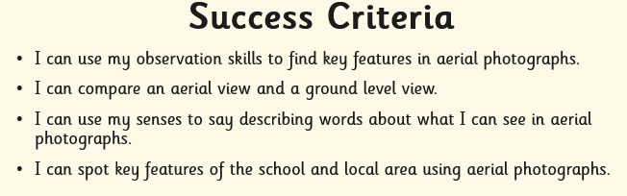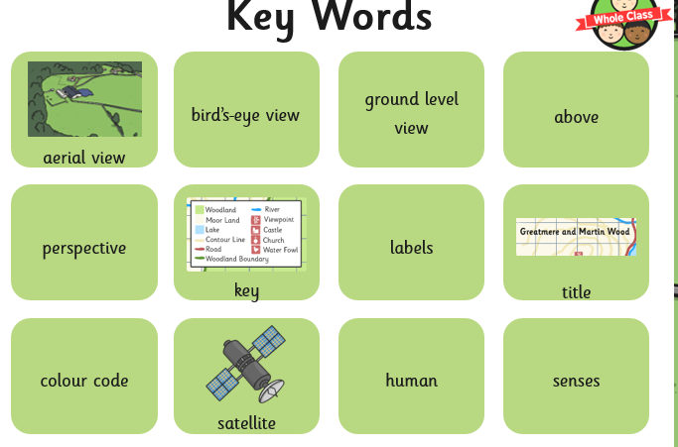
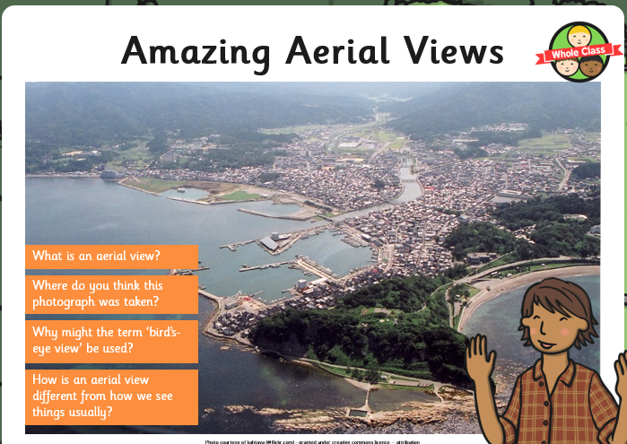
Here is an Aerial view of the area surrounding Russell Lower School.

- Describe what you can see in the picture.
- What can you see in this picture that you cannot see when you are looking from on the ground/are actually at the school?
- Which features are manmade (human) and which are not (physical)?

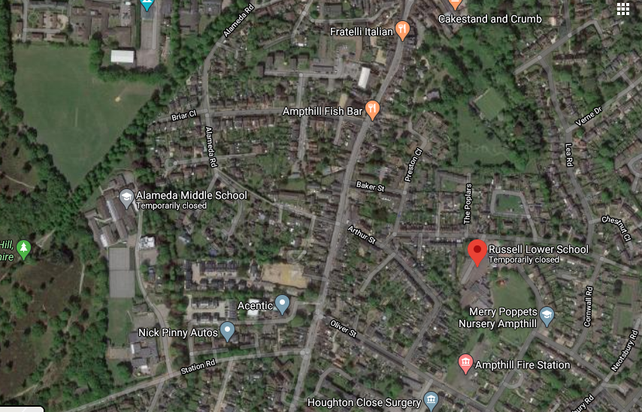

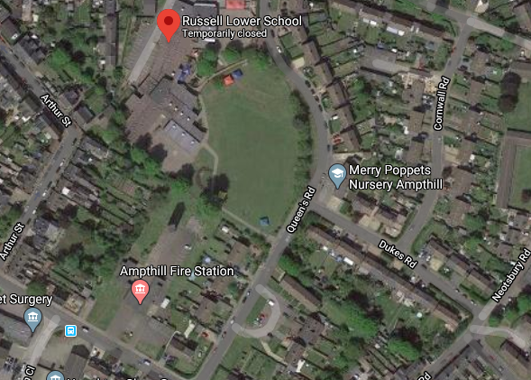
This photo has been zoomed in so that you can look more closely.

Try finding your house on Google Maps – Satellite view.

