Year 2 Phonics/Spelling Practice – Tuesday 23.6.20.
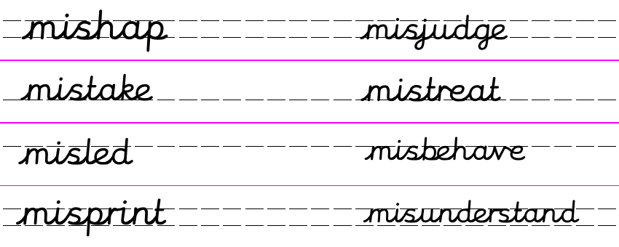
Practise: Today we’ll use the game hangman to practise our mis- spellings. Perhaps you can play with someone at home.
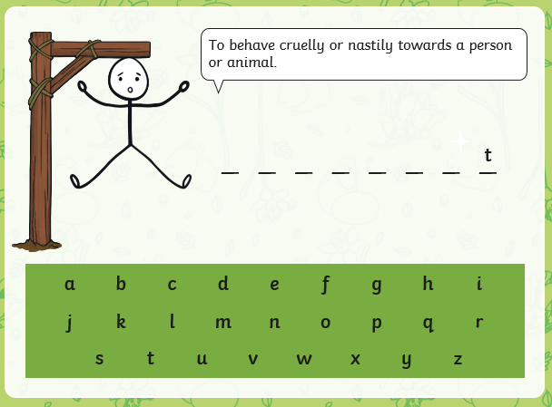

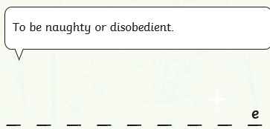
Here’s one more….
Now the play the game with some of the other words which begin with the prefix mis-
Dictation:
Ask someone to read out the sentence below so that you can write it down – try not to look until after you’ve written it. Check your punctuation and spelling.
I must not misbehave and mistreat the dog.
Maths 23.6.20
Count faces, edges and vertices on 3-d shapes
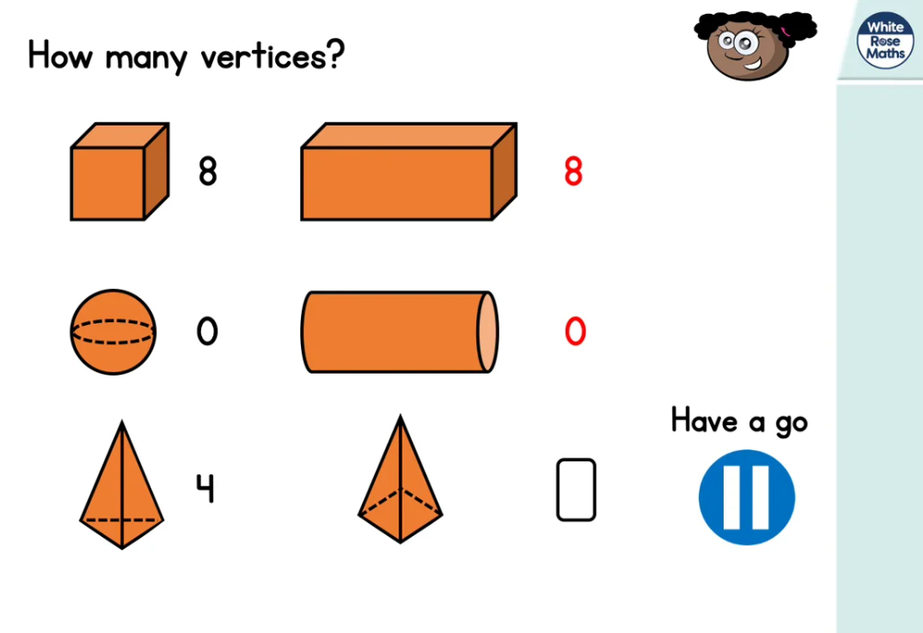
https://whiterosemaths.com/homelearning/year-2/ (Week 8 W/C 15.6.20)
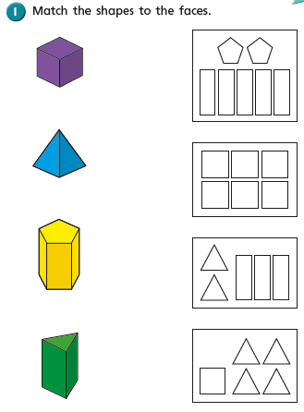
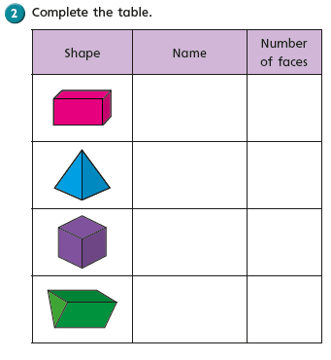

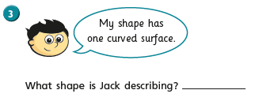
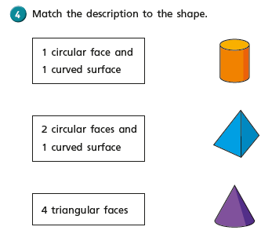
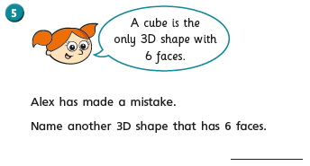

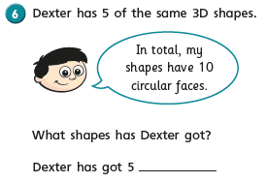
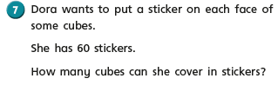

Tuesday 23rd June 2020 Fact of the day: A snail breathes through its foot.
WALT write information texts.

Last week I mentioned that I didn’t know very much about Pelicans. So this week I thought it would be nice if we could find out more about the animals we have met so far in the story and produce an information text about them.

Who are the animals we have met so far?

Giraffe, Pelican and a Monkey.
Today we will start our report by finding out about pelicans but first let’s remind ourselves what is an information text.

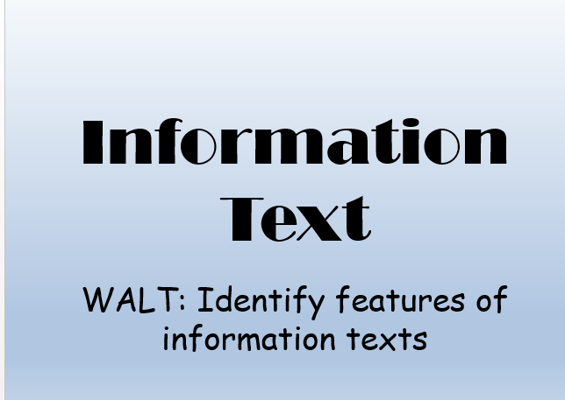
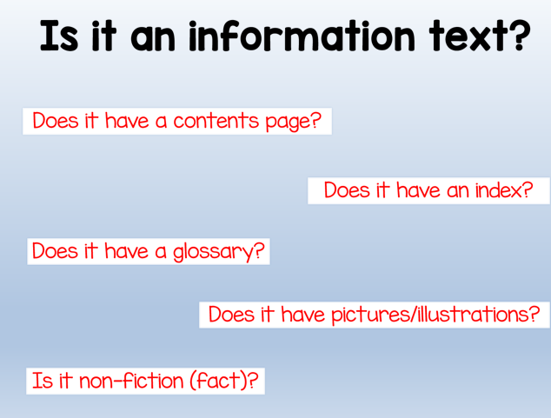
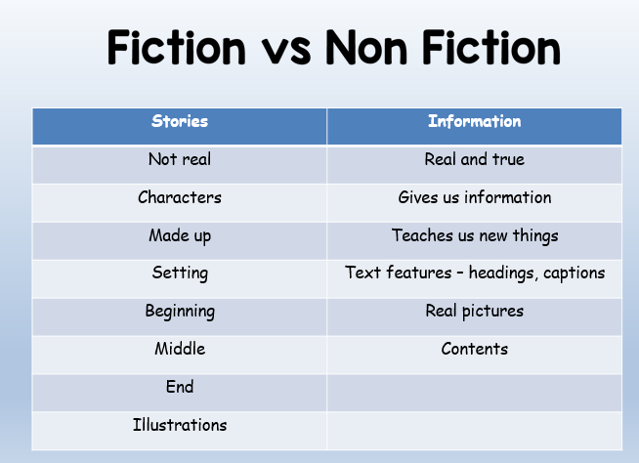
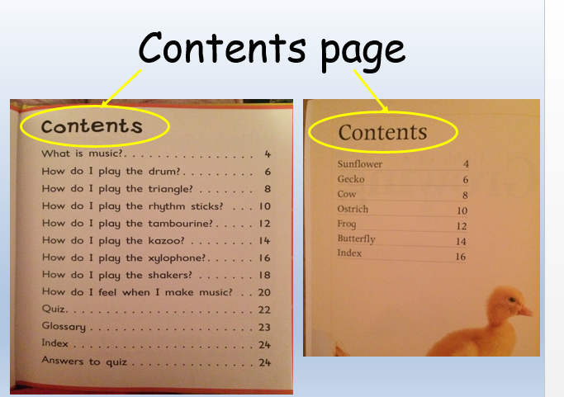
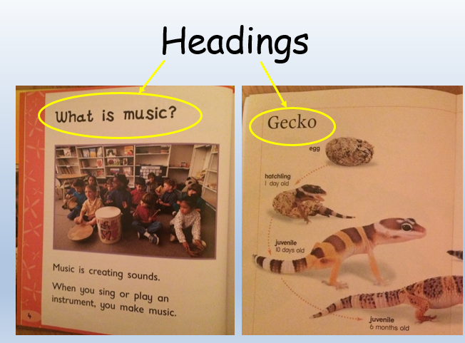
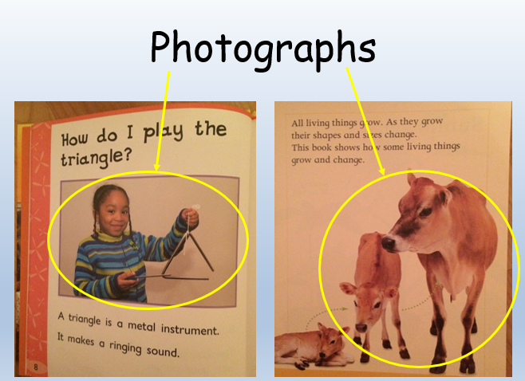
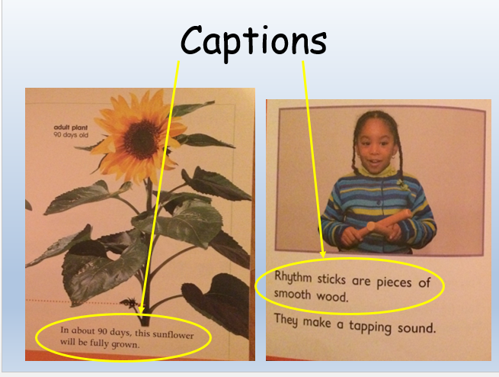
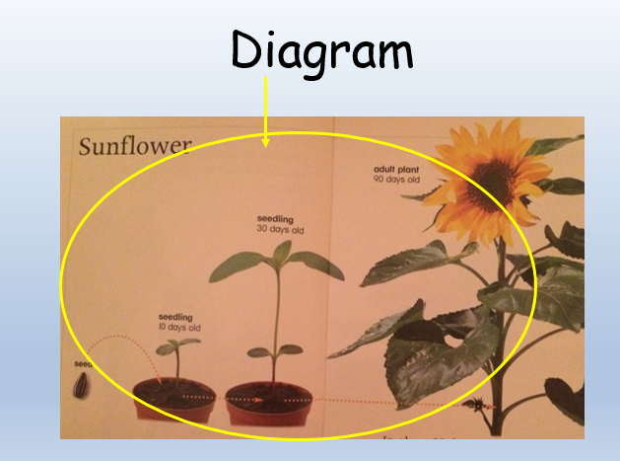
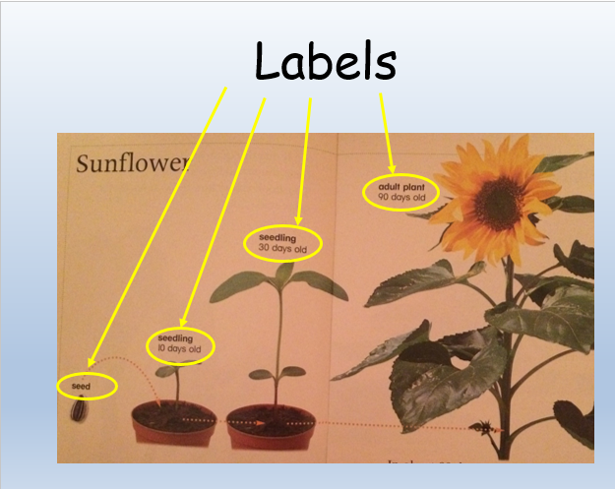
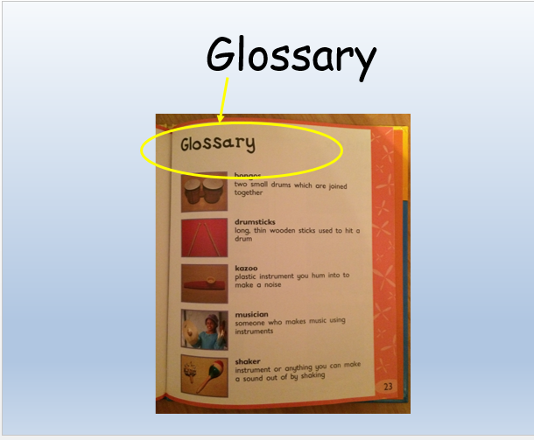
These are some of the features of information texts that you could include this week in your writing about Pelicans, Giraffe and Monkeys.

I have included below a link for a ppt on pelicans. I will go through this in my daily english video on loom but you can also access the link. I would suggest you watch it
twice and write down any facts you have learnt. You can then put them on to the sheet attached or start to create your own sheet. Remember to include headings, captions, drawings with labels and facts about Pelicans.

Link to pelican ppt.

https://www.bing.com/videos/search?q=pelicans+for+children&&view=detail&mid=7AFD820CFC1E26A1D1477AFD820CFC1E26A1D147&&FORM=VRDGAR&ru=%2Fvideos%2Fsearch%3Fq%3Dpelicans%2520for%2520children%26qs%3Dn%26form%3DQBVRMH%26sp%3D-1%26pq%3Dpelicans%2520for%2520children%26sc%3D0-21%26sk%3D%26cvid%3DB92CA6CEE84F42728A58E216852ACFC0

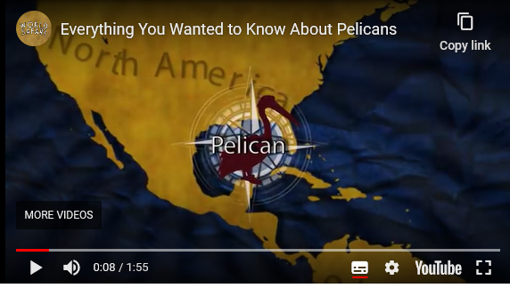

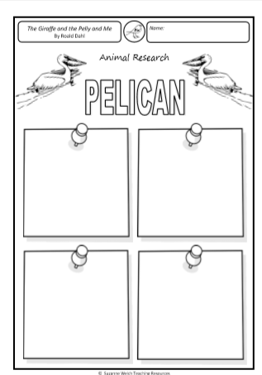

23.6.20 Geography
WALT: use a UK map or atlas to locate and identify the four countries and capital cities of the UK, and its surrounding seas
Online resources and videos available at: BBC Bitesize - Let’s Explore the UK
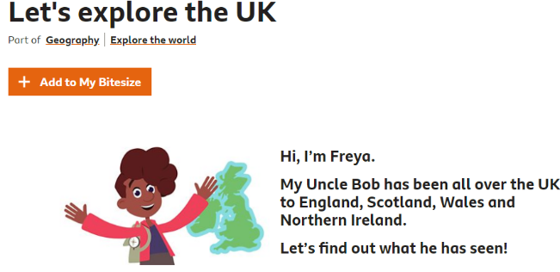
https://www.bbc.co.uk/bitesize/topics/zyhp34j/articles/z4v3jhv

Do your own research and find out more about the capital cities of the four countries of the UK.
