Tuesday 12th May 2020
English
SPaG
Spellings – Suffix - ous
Write each word in your spelling list forwards and backwards
joyous
dangerous
hazardous
poisonous
riotous
mountainous
momentous
scandalous

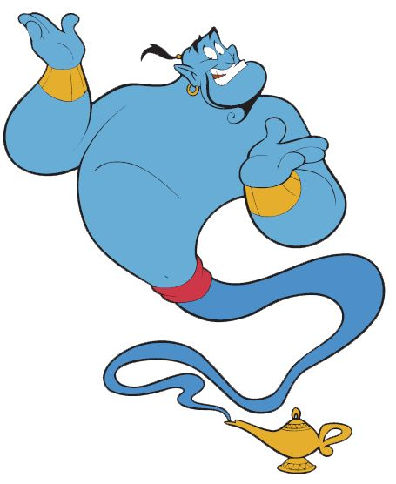
Word of the Day – accelerated

Definition ____________________________________________
_____________________________________________________
_____________________________________________________
Used it in a sentence: ____________________________________________________
_________________________________________________________________________
Word Class: ____________________________________________________
Synonyms

English
Task – use your story map / board and write your own traditional fairy tale with an Egyptian twist.
Pay particular attention to the descriptions of characters and setting as
you tell the story.
Once you have finished used the check list below to make your story even better.

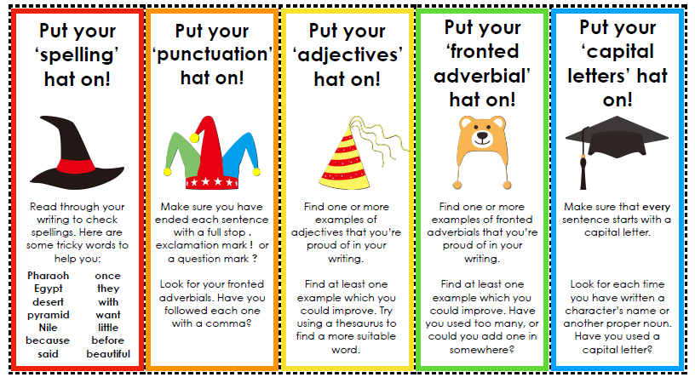
Remember you can ask a grown up at home to send a photograph of your completed story and send it to your class teacher via email.
Maths – Mental
Write in the missing < or > signs for each pair of numbers.

1. 264 _____ 254

2. 328 ____ 431

3. 1536 _____ 1523

4. 6550 ______ 6350

Maths – Main Lesson
Watch this video about rounding: You know all about this, it is just a reminder.
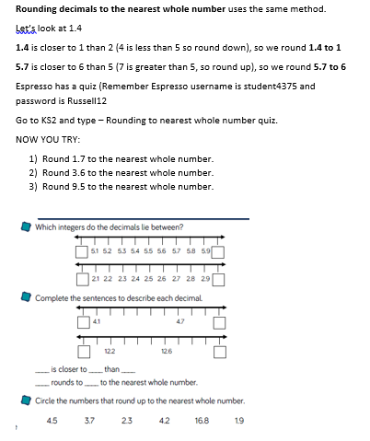
https://www.bbc.co.uk/bitesize/topics/zh8dmp3/articles/zpx2qty

History
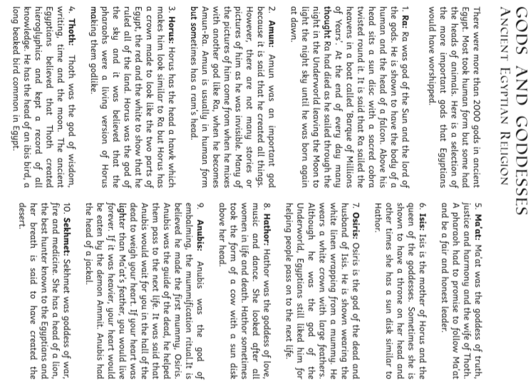
Read the text below and complete the questions about Ancient Egyptian Gods and Goddesses.

- How many Gods were there in Ancient Egypt?
_______________________________________________________________________
- Why are the names of the Gods in bold?
________________________________________________________________________
- What was special about Amun?
_______________________________________________________________________
- What was the name of the first mummy?
________________________________________________________________________
- Who was married to Thoth?
_______________________________________________________________________
- Why do you think pictures are included in the text?
________________________________________________________________________

