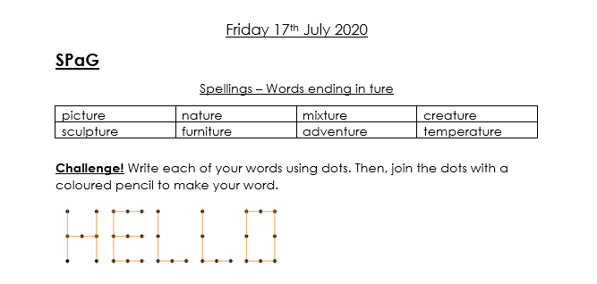

English
Choose one activity from the grid below to complete each day this week.
Write a film or book review. Discuss the plot, characters, whether you enjoyed it and why. | Write a diary entry in the role of your favourite character from one of your favourite books. | Create a new front cover for your favourite book or the book you are currently reading.
Create a poster to advertise your favourite book or film. | Create an acrostic poem that spells out your name. | Find 5 words in the book you are currently reading that you don’t know the meaning of and use a dictionary to find the definition.
Adjective Alphabet Challenge!  Can you come up with an adjective for each letter of the alphabet? | Write a character description for a member of your family. What do they look like? How do they behave? | Write a story involving members of your family. Do they have to defeat a monster? Find something they have lost?
Read this extract from ‘100 Adventures to have Before you Grow Up.’ https://www.lovereading4kids.co.uk/extract/17065/100-Adventures-to-Have-Before-You-Grow-Up-by-Anna-McNuff.html  Write a list of adventures you would like to go on. | Draw a comic strip for the book you have most recently read or for your favourite book. | Write a list of verbs. Play charades with a family member. Can they guess the verb?
Write a letter to a character in a book you have read to find out more about them. | Write on alternative ending for the book you have most recently read or for your favourite book. | Retell a traditional tale from another character’s point of view. E.g. The Three Little Pigs from the wolf’s point of view. Cinderella from the step mothers point of view.

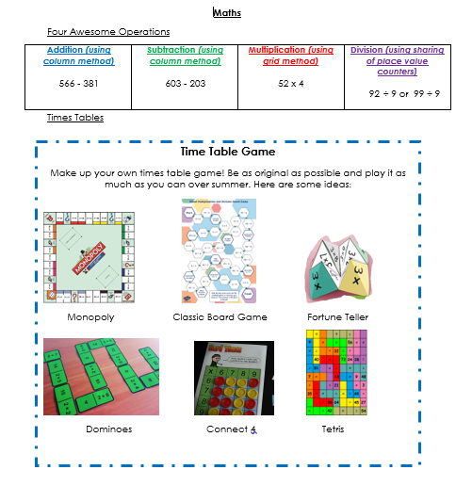

Well done Year 3! You have completed your home learning! Here is a certificate for you and your grown-ups too for being super teachers! We are SO proud of you. Have a wonderful summer! xx
