FS Home Learning Pack
Reading
Please continue to learn the letter sounds in your sound book, learn sight words and read regularly. Enjoy sharing storybooks together.
Read the real/fake words, cut them out and stick them next to the treasure chest (real words) or the bin (fake words).
Writing
Please continue to learn spellings.
Please talk to your child about what they can see in the pictures; this will help them to plan a story or plan sentences to write about the picture. Your child can use their phonic knowledge and spellings to write about the pictures.
Maths
Please use every opportunity to count in real life situations. Write numbers always starting from the top.
Set up a shop and count using real coins. Talk about the number that is 1 less and 1 more than a number.
Fill a container with water and talk about whether it is full, half-full or empty.
Look for 2D shapes (circle, square, triangle, hexagon and rectangle) name them and talk about how many corners and they have.
Look for 3D shapes (cube, cuboid, pyramid, sphere and cylinder) and talk about how many faces and edges they have.
Play hide and seek and talk about where someone hides (under, behind, next to).
Practise number bonds to 10 using your fingers. Put a digit down each time and find all the ways to make 10.

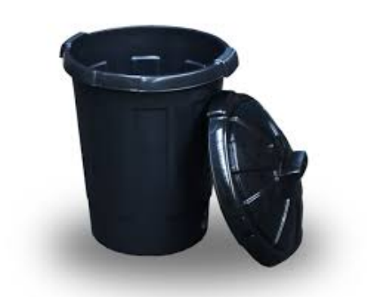

qu ee n | g ai sh
h air | t u v
w o x | z e ff
f l ow er | oi n k
c e th | w i th
h ear | y o ss
w e ll | k i ng
b r oo m | f o zz
ch i ck | r igh t
d or s | l ur j
p oa t | b oo k
sh ar k | m a n ure

WALT: use phonic knowledge to write words which match their spoken sounds.
WALT: write some irregular common words.
WALT: write simple sentences which can be read by me and others.
WALT: spell some words correctly (others are phonetically plausible).
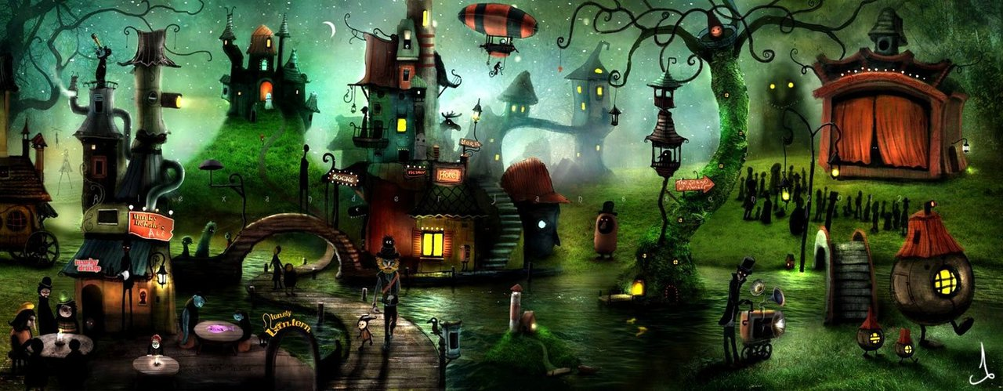

WALT: use phonic knowledge to write words which match their spoken sounds.
WALT: write some irregular common words.
WALT: write simple sentences which can be read by me and others.
WALT: spell some words correctly (others are phonetically plausible).
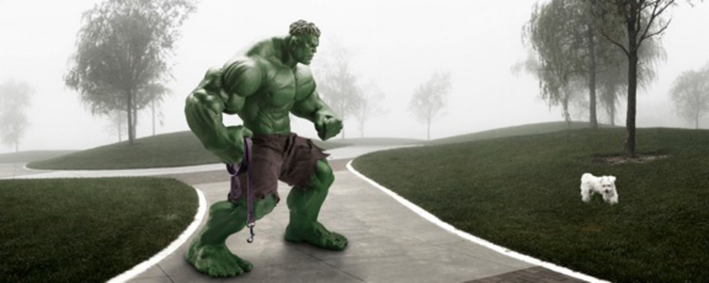

WALT: use phonic knowledge to write words which match their spoken sounds.
WALT: write some irregular common words.
WALT: write simple sentences which can be read by me and others.
WALT: spell some words correctly (others are phonetically plausible).

WALT: use phonic knowledge to write words which match their spoken sounds.
WALT: write some irregular common words.
WALT: write simple sentences which can be read by me and others.
WALT: spell some words correctly (others are phonetically plausible).

Can you fill in the missing numbers?
1 | 2 |  |  |  | 6 |  |  | 9

11 |  | 13 |  |  |  | 17

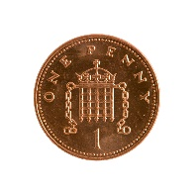
How much is there altogether? You might need to count in 10s, 5s or 2s!
____ p
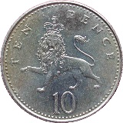

____ p

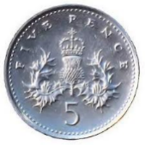
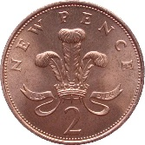
____ p

____ p

1 less | Number | 1 more
 | 6
 | 9
 | 12
 | 18

Colour in ½ of each shape.

How many pennies are in the purse?
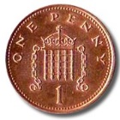

Circle half the pennies in each purse.
Draw a line to the correct label for each bottle.
empty
half full
full

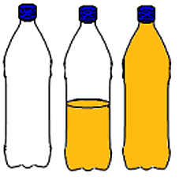

Tick the sentences which are true.
- Breakfast is earlier than lunch.

- A lion is slower than a tortoise.

- Dinner is later than lunch.

Can you name these 2d shapes?

________________ __________________ ____________
Can you name these 3d shapes?
How many faces does each one have?

__________________ ______________ ______________
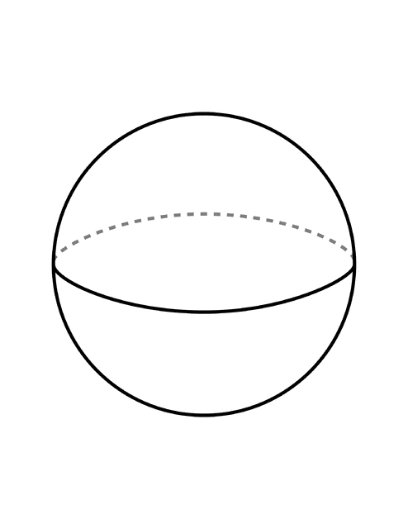
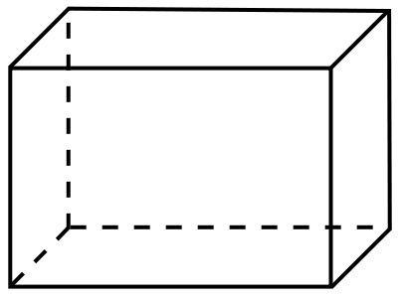
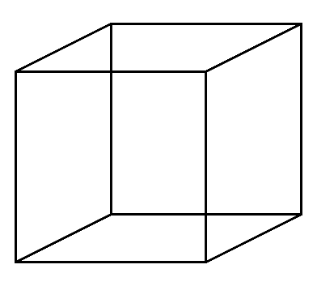

____ faces _____ faces _____ faces

Positional language
Where is the cat?
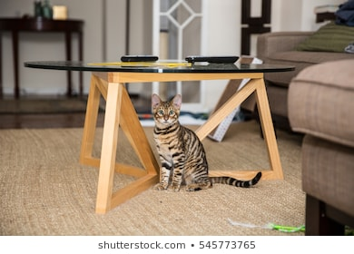

_____________________________
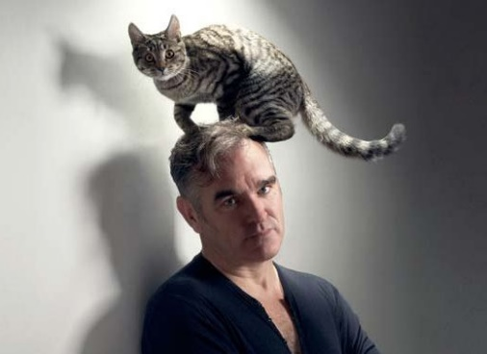

_____________________________

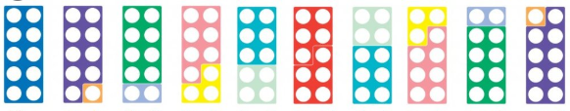
Number bonds to 10.
10 + ____ = 10
9 + ____ = 10
8 + ____ = 10
7 + ____ = 10
6 + ____ = 10
5 + ____ = 10
4 + ____ = 10
3 + ____ = 10
2 + ____ = 10
1 + ____ = 10
0 + ____ = 10

