Year 2 Phonics/Spelling Practice – Wednesday 15.7.20.
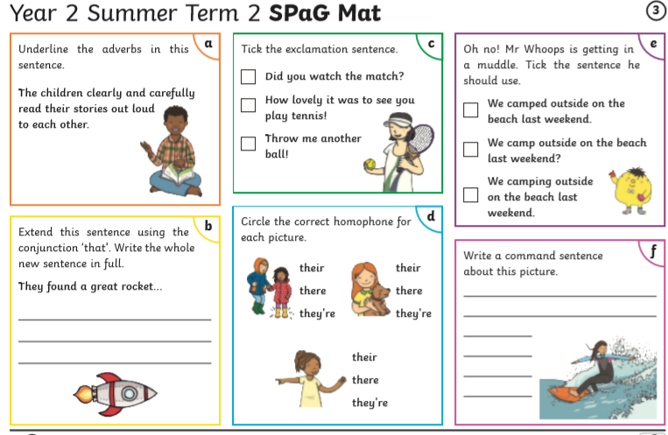
Maths 15.7.20
Time: Hours and days
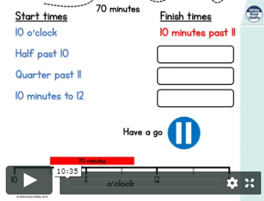
https://whiterosemaths.com/homelearning/year-2/ (Week 12 W/C 13.7.20 Lesson 2)