Writing | Number work | Art and Design /  Design and Technology/History | Science
Create a factsheet/ poster/ collage/ drawing of your favourite seaside or holiday destination (and label) to share with the class.  Research seasides ‘then and now’ and make an interesting fact file or leaflet to share with and teach others about it. | Can you order the jobs a life guard must do during the day on a beach?  Research the jobs they do and link these to times during the day. Can you order the events and the times from morning to evening? Can you draw a clock face/write the digital time to show the time each job is done? | Make an ocean animal habitat.  Research a particular seaside artist and create some art in the same style, using a range of media.  Find seaside images ‘then and now’ and create a collage or montage to show the changes over time. | Explore the different seasides and oceans you have been to and have seen when out and about on holiday. Use pictures you have taken as inspiration for drawings and labels about things you found there. Can you sort them into groups? E.g. shells/rocks/flowers/plants/living/non-living etc.  Draw seaside flowers/plants and label the structure of them.
Create your own word search using seaside and summer time words for your friends to complete. | Create your own seaside board game – this could link to more/less/addition/subtraction/  doubling/ halving. These could then be played in class! | Create a seaside/summer jigsaw puzzle. Draw your favourite seaside scene and then cut it up into pieces – can you put them back together? Can you bring it in to school for a friend to try? | Can you plant a bean or sunflower in different conditions for growing and observe and record the differences and changes over time?  Photograph and label changes observed.
Write a poem about the seaside. Look at books such as – ‘Commotion in the Ocean’ and ‘Seaside Poems’ to give you some inspiration!  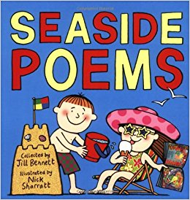 | Create your own seaside in the garden at home, or an ice cream stall inside. Children to label items with prices and use coins to buy different items. Can they work out which coins they need? If they do not have the correct coins can they work out how much change they would get? Take photos to share with the class.  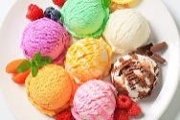 | Complete an observational drawing of your favourite summer time seaside or holiday destination.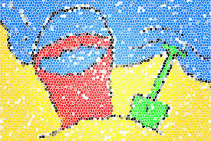 | Homemade ice lollies!  Encourage the children to discuss how a liquid can change into a solid – e.g. using orange juice/squash in liquid form, pour it into an ice lolly mould/ice cube tray and put it into the freezer. Children to predict what will happen and explain why. Children can write about their experiment, take photos, draw pictures etc to share with the class.  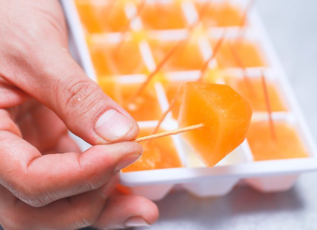
Write a recount of a ‘seaside trip’ you have been on. Or write your own seaside holiday story! | Use junk modelling materials to create a 3D model of the ‘Punch and Judy’ show. Discuss the 3D shapes you have used and their properties.  Alternatively, use junk modelling to make an ice-cream stand and pretend ice-creams to sell. How much will you charge? | Design and create your very own seaside creature! It can have features of a range of different creatures e.g. the fin of a clown fish, the legs of an octopus and the teeth of a shark. Can you make up a name for your new animal? | Seasonal changes.  Can you research what happens in the summer season? What is the weather like, what types of plants and animals are there? Create a fact sheet, collage, poster or model of the 4 different seasons (or you could create just your favourite season).

