Year 2 Phonics/Spelling Practice – w/c 20.4.20 Day 3
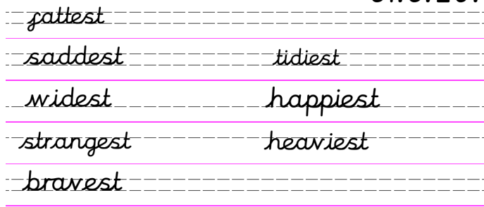
Where a word ends in –e, remove the ‘e’ and then add –est.
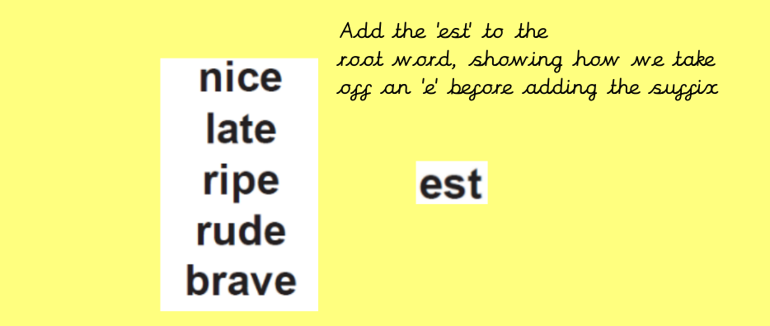

Practise turning these ‘root’ words into superlatives. Ie. Nice nicest
Can you think of any more words that end in –e?

English 22.4.20
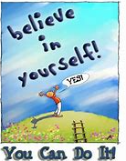
Word of the day – nostalgia
Good morning year 2 today is Diary Writing day! I can’t wait to read what you have been getting up to, we have been so lucky with the Spring Weather. Today I am going to share my diary entry from last week. In the Johnson household we are having a weekly themed Saturday. All our wider family members take part too. On Saturday April 5th we had 80’s day.

Dear Diary
Today is 80’s day! I was a little girl back in the 80’s but by the end of the decade I had met Mr Johnson so we had a lot of memories to share and a love of similar music tastes. I woke up and sent a whatsapp to the rest of the family “Hi de hi campers time to get up.” Hi de hi was a funny television programme back in the 1980’s. I had decorated the house the night before with disco danglers and cardboard cut outs of boom boxes, cassette players and records and other 80’s memorabilia.
Soon the whatsapps were going back and forth between my mum and dad and my sisters, nieces and nephews. We had all agreed to film ourselves doing something funny from the 80’s to cheer each other up. It was hilarious, my son Harry sent us a dance video of him dancing away in his apartment in London. Next up was my sister Julia and niece Robyn they were dressed in 80’s leotards and tights and did an exercise video. I dressed up as Olivia Newton John (an Australian pop star of the time) and did an aerobic video and sang along. Mr Johnson and Freddie dressed up in their 80’s ‘casual’ gear which included Kappa and Fila jumpers, white trainers and jeans. They thought they were really cool!! My parents re-enacted a song by a band called Human League. They dressed up and my mum pretended she was working as a waitress in a cocktail bar… They were brilliant and such good sports as they are in their late 70s.
In the afternoon we had a little break from the shenanigans and watched the ‘Virtual Grand National’. The Grand National is a famous horse race which is run at Aintree in Liverpool. It is one of my favourite days in April. For years we have bought fish and chips and had a sweep stake on the race. This year my nephew James organised a sweep stake for the family and we all paid £2.00 each and had a bet. My Dad won and all the money went to our fabulous NHS. We didn’t have fish and chips but it was still a great afternoon’s entertainment. Instead we had an 80’s inspired tea of prawn cocktail to start, followed by steak and chips and desert was a lemon meringue pie.
In the evening Freddie, Drew and Fenella had a virtual party with their friends which was fun. It was lovely to be able to chat with all their friends on line. They had drinks and nibbles and even an 80’s speciality which was a cheese and pineapple hedgehog.
It was a great day, the sun shone we were all together even if some of us were only at the end of a screen. I can’t wait for next week’s theme day, I wonder if we will have as much fun?
Mrs Johnson
Task
WALT write a diary entry.
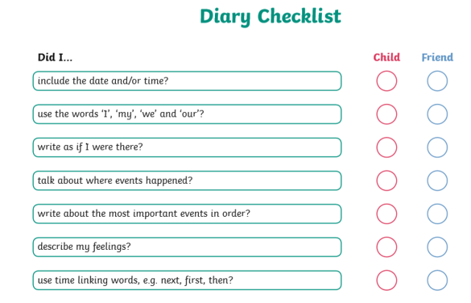

Maths 22.4.20
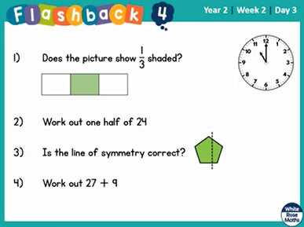
Using a ruler, can you draw a line to match the following measurements?

18cm 22cm 14cm 25cm

11.5cm 25.5cm 30cm 2.5cm

29.5cm 11.7cm 19.3cm 15.1cm

22.4.20 R.E.
WALT understand what inspiration means and why someone inspires us.
In R.E this term we are looking at what makes and inspiring person and which stories inspire people. Inspiration means a feeling of enthusiasm you get from someone or something which gives you hope and new and creative ideas.
Inspiring people and inspirational stories can also help us in how we want to live our life. Inspirational people are people we look up to and admire.
At this moment in time there are so many people in the world who can give us inspiration.
Can you talk to your adult or write down people who inspire you?
What is it that they do that makes you feel like this?
There are so many people who inspire me at the moment. Here is my list..
- You! You all inspire me because I know how well you are doing not being at school, not being in a routine and by doing your bit by staying at home and keeping yourselves and others safe. Well done.

- Captain Tom Moore. You must all have heard about our local hero who has raised over £15 million pounds walking 100 lengths of his garden to raise money for our wonderful NHS. He is a true hero and inspires me so much. He not only served his country in World War 2 but now in these difficult times.

- NHS staff and all the carers out in the world who are putting others first. They are so inspirational. Every day they leave their families at home and go to work so that we can stay safe. What inspirational and wonderful people there are in the world.

These are just a few of the people who inspire me but at the moment they are the ones that stick in my mind the most.

Today’s task is to draw a picture of the person or people who inspire you.
Feeling Confident
Once you have drawn your picture could you write some adjectives to describe them?
Challenge me.
Can you write a paragraph including your adjectives to describe why they are inspirational to you.

