11th February 2021
Keeping in touch 5
Dear Parents and Carers,

Well done! We have all (almost!) made it to half term! This has been the single most extraordinary and challenging half term for all of us, and we have survived by working together. Thank you for ALL your support. Thank you to all of you who have worked tirelessly with your children to ensure they can access and engage productively with their remote learning. Thank you to all of you who have made alternative arrangements to keep your children at home, even though you are key workers. We have almost a quarter of our 423 children in school and, as you know, we simply ran out of space. Thank you for all of your understanding and supportive emails and messages – especially in those early days and weeks when we were all getting to grips with the new technology!

As we look ahead, please do have a lovely, relaxing half term. I know that none of us can do anything very exciting (shame!), but please do rest and take time ‘off’ of school activities to refresh and recharge both the children and yourselves. We are preparing in school for two more weeks of remote learning after half term, and are very hopeful that our children may be allowed back to school from Monday 8th March. We are seriously hoping so! Listen out for the Prime Minister’s announcement on Monday 22nd February and we will be in touch with you as soon as humanly possible thereafter to confirm Russell’s plans.

Parents’ Evening
Thank you for all your support over the two evenings this week. The partnership between home and school has never been more important and we really appreciate everything you are doing to support your child’s continued learning. Thank you for all the wonderful feedback we have collectively received. We really do value the time and effort you have put into thanking us for keeping the Key Worker/Vulnerable bubbles open (mostly!) and for the live lessons in particular.
CHUMS – Shine Bright. Wear Bright. Express Yourself
Thank you for your support last Friday. Lots of us wore very bright attire and raised lots of money for this very worthy cause.
Please don’t forget that CHUMS are also running a ‘creative’ competition, which closes on the 29th March. If you would like your child to join in with this, please find the details attached to last week’s KIT 4 email.

A note from Ampthill Baptist Church
We are very aware of what a difficult time families are having at the moment and would like to show our support for you in some way. If you are interested in receiving a little bag of goodies which will include some craft, and some 'sweet treats' for half term please contact judith@ampthillbaptist.org.uk. We are thinking of you all and praying for our families and schools at this time. Happy holidays!

The PTA FREE half term Magic Show
Please see below for a message from our wonderful PTA:

We appreciate the enormous impact that being locked down is having on our children, parents, carers and teachers.
As half term approaches Russell Lower PTA wanted to do something to try and bring some brightness and fun to everyone’s February half term.
So, on Saturday 20th February Skittleman, the family entertainer will perform a virtual magic show for all children at Russell Lower and their families. It’s absolutely FREE! The PTA at Russell Lower School will be funding the show in the hope it brings some much-needed sunshine to our school community during lockdown.
Skittleman is an online comedy magician and member of the prestigious Magic Circle. His show is suitable for ages 2-102 and we think his unique style will bring lots of laughter to homes this half term.
Register for the free Virtual Magic Show by Monday 15th February and provide your contact details to the PTA, so we can send you the Zoom details for the performance. The link is below. If you want to make the performance extra special and support the PTA, we are selling some Magician's Treat Bags and Family Boxes that will be delivered directly to your door to enjoy during the show.
There are two performances on Saturday 20th February:
- Key Stage 1 (Foundation, Years 1 and 2) session: 17:00 - 17:40
- Key Stage 2 (Years 3 and 4) session: 17:50 - 18:30
You will need to register as soon as possible for your preferred time by completing the Google Form below. Each session is tailored to the age group. If you have more than one child at the school and would like to join as a family, pick the session time that works for you. If you would like your children to join separate sessions you will need to complete another registration form.
If you would also like to order a Magician's Treat Bag or Family Box to support the PTA you can do so on this when you register. On offer we have:
A Magician's Treat Bag - £5:00
This includes a small magic set, magic themed colouring sheet, Fruit Shoot, packet of popcorn, packet of sweets and a chocolate.
A Magician's Family Treat Box - £12:00
This includes two small magic sets, two magic wands, magic themed colouring sheets, two large packets of popcorn (sweet and toffee), four chocolate bars, bag of Magic Stars, bag of sweets, three Fruit Shoots, two cans of drink.
Dairy free options are also available.
If you do not complete the form, for safeguarding reasons we will not be able to send you details for the call. Safeguarding measures are being put in place for the Zoom call and your camera will need to be switched on throughout the performance. PTA members will be monitoring the call. Chat on the call will be disabled, participants cannot share their screens and participants will be unable to record. Children need to be supervised by an adult at all times during the performance.
Registration and orders for Treat Bags and Family Boxes need to be placed and payment made by 17:00 on Monday 15th February. Any questions please contact pta@russell-lower.co.uk

Click here to register.

Russell Lower School PTA Bank Details:
Sort code 20-05-74
Account number 30768693

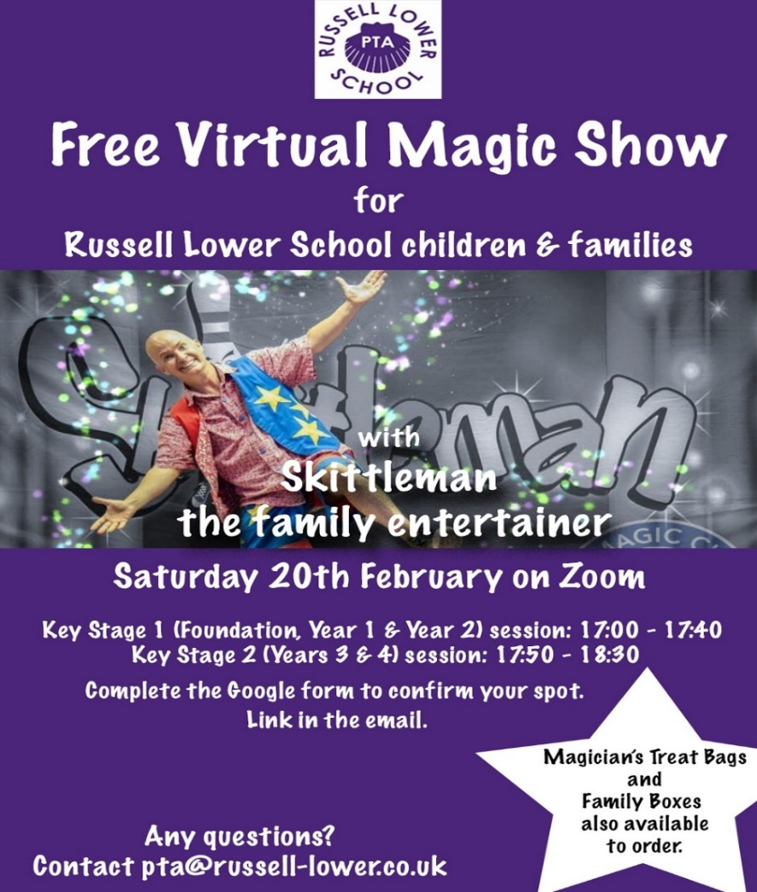
Inspiring Music Opportunity for Year 4
Conductive Music have fantastic news for schools!
Their beloved free After School Clubs are now going to be running until the 31st of March!

Music Production: on BandLab, Mondays and Wednesdays at 4pm, for Y4-8
Musical Video Games: on MakeCode Arcade, Tuesdays and Fridays at 4pm, for Y4-8

All sessions lasting 1 hour, held on Zoom (no cam, no mic, all questions on chat). Students can join at any time as instructions are shared at the beginning.
Find out more here

And finally…
Once again, thank you for all the many different ways you have supported us this half term. We really appreciate the wonderful way parents have worked in partnership with us to do the best we can in these really difficult circumstances. We are really missing all of you (parents and children) that we haven’t seen since December and cannot wait for us all to be back together again soon.

Monday 22nd February (NO INSET DAY) – Spring half term two begins
- Remote Learning and Live lessons resume on Google Classroom (same schedule as this half term) Live lessons at 9:15am, 10am, 11:15am, 1pm
- Key Worker/Vulnerable in school provision resumes 9am – 3:30pm – regrettably, this can only be for those who already have a place. We review our waiting lists at least weekly based on changed needs of parents, and staff availability. We will contact you if a space becomes available. Thank you for your support.
I wish you and your families a very happy, restful and safe half term.
Many thanks and kind regards,
Nicki Walker
Headteacher

