|  |  |  |
| --- | --- | --- |
| Maths Challenges | Literacy Challenges | WOW challenges |
| |  | | --- | | Go on a number hunt inside and outside. Record the numbers that you find and order them. | | Write a list of instructions detailing how to care for a pet – real or imaginary. | Cut a square out of the centre of a piece of card. Use your viewfinder around the house and garden; draw/paint what you can see. |
| Partition a set of objects into two groups and find all the pairs of numbers that make that amount. | Interview someone in your family to find out more about them. | Fill ice cube trays with water and when frozen create your own igloo out of the ice cubes. |
| Use sticks and play dough or Plasticine to create 2D or 3D shapes. | Read and/or watch The Very Hungry Caterpillar story. | * 1. Play Kim’s Game. Find 10 objects; take one away. Can you work out which object is missing? Try 15 or 20. |
| Order the months of the year. Teach your grown-ups the song we sing at school. | Act out the story of The Very Hungry Caterpillar using your favourite foods. | Make a poster to explain the lifecycle of a butterfly- use The Very Hungry Caterpillar book. |
| Look at pictures of butterflies- they are symmetrical. Make your own symmetrical butterfly using shapes and colours. | Make a food diary; write down all the food you eat each day just like in The Hungry Caterpillar story. | Go on a butterfly hunt in your garden or at the park and see if you can name the different flowers the butterflies enjoy landing on. |

[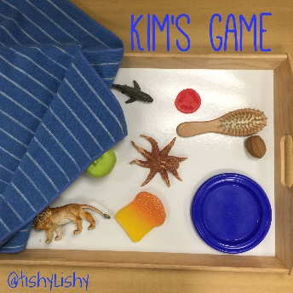](https://www.google.co.uk/url?sa=i&url=https://www.pinterest.com/pin/497929302545728415/&psig=AOvVaw1qSIsWaxclAp-jJ-a9rTZ8&ust=1589279912206000&source=images&cd=vfe&ved=0CAIQjRxqFwoTCPj2kP7Nq-kCFQAAAAAdAAAAABAD)

