Monday 22nd June 2020 – English
SPaG
Words with the k sound spelt ch
echo - __________________________________________________________________
chorus - ___________________________________________________________________
character - _______________________________________________________________
scheme - _________________________________________________________________
chemist - _________________________________________________________________
stomach - ________________________________________________________________
orchestra - ______________________________________________________________
technology - _____________________________________________________________

Look up the meaning of each of these words in a dictionary so you understand what each word means.
Word of the Day – hostile
Definition ____________________________________________
_____________________________________________________
_____________________________________________________
Used it in a sentence: ____________________________________________________
_________________________________________________________________________
Word Class: ____________________________________________________

Synonyms

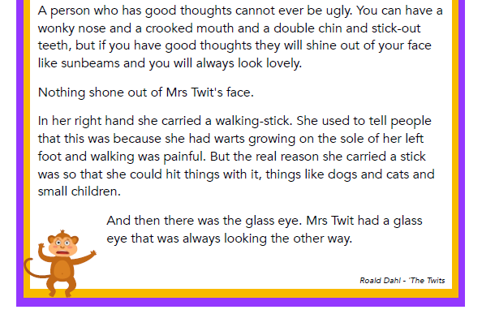
English - See loom intro video first. – Link - https://www.loom.com/share/6e6ab07f4fcb4b0f919c251872f3c54a

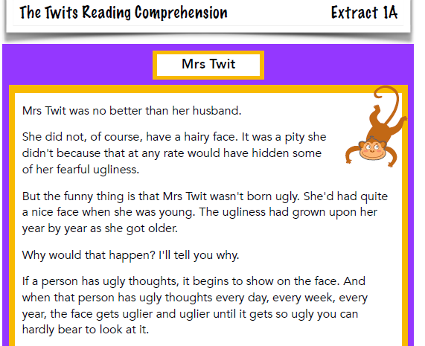
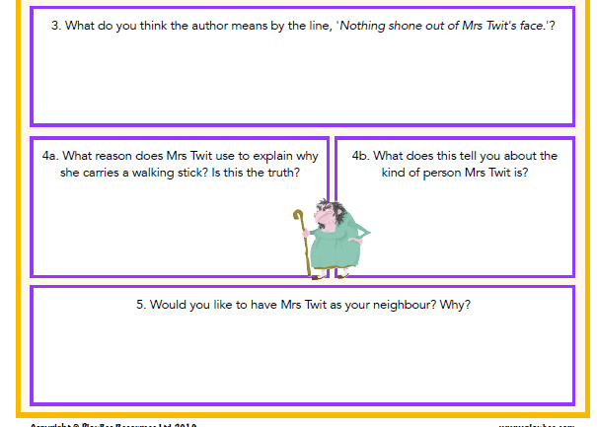
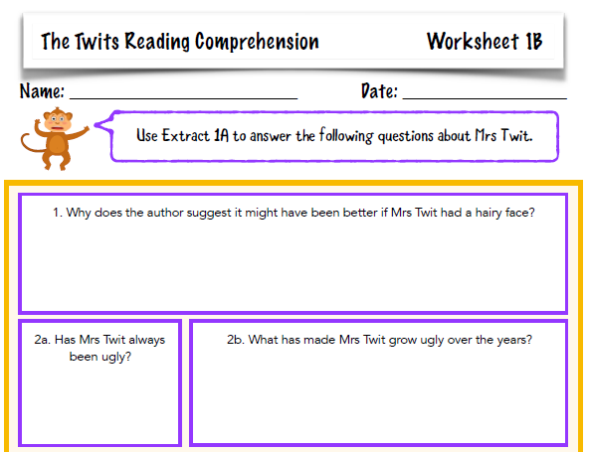
Maths
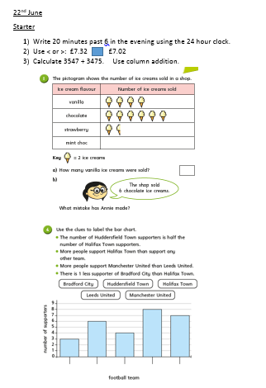
- PSHCE
Yesterday was father’s day 2020 have a read of the text below and answer these questions:
- When is father’s day celebrated in the UK?
- Who tried to get an official day started to honour all fathers?
- Find and copy a word which means outraged or angered.
- What is the official flower of father’s day?
- Explain in your own words what the phrase ‘father figure’ means.
- What is father’s day called in Germany?
- Explain what is meant by ‘…Father’s day is the fifth largest card sending holiday.
- What did you learn from this text that you didn’t know before?
