Year 2 Phonics/Spelling Practice – Friday 26.6.20.
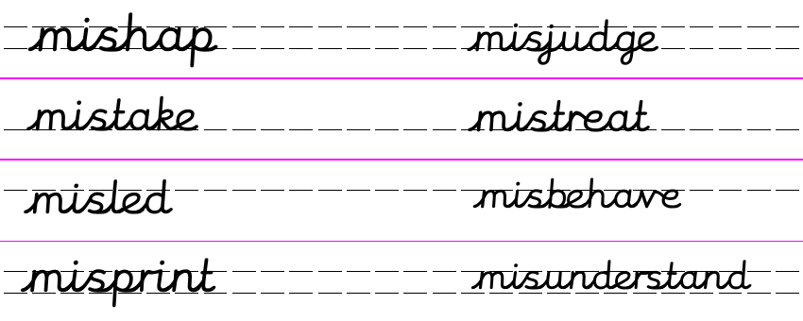
Today we’ll practise what we’ve learned this week:
Here are some more words starting with mis-. Use a dictionary, an adult or the internet to find out the meaning of any words you don’t know.
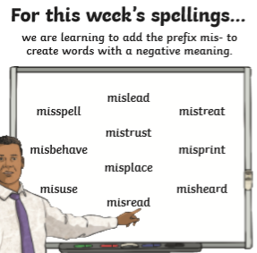
Sentence writing practise:
Use 2 of the words above to write a sentence of your own.
Can you write 3 sentences?
Maths 26.6.20
Making patterns with shape
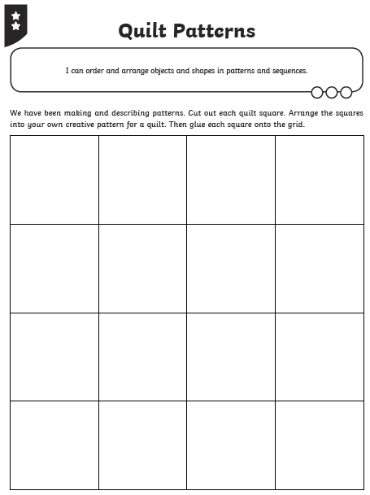
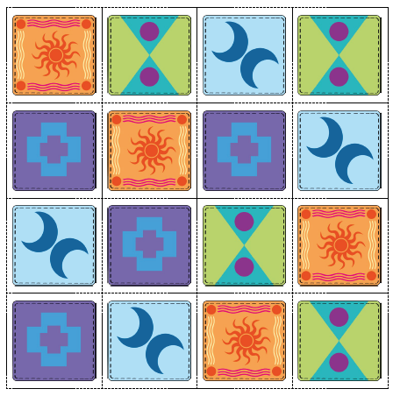
Friday 26th June 2020 Fun fact of the day: Caterpillars have about four thousand muscles
WALT write an information text.

Well done, you have made it to Friday! What fantastic work you have been producing this week. Today we are going to finish our information text of.
You should have written three sheets, one about each animal. Today we are going to produce a front page, a contents page and a glossary. The front page will be part of this week’s art lesson so you have plenty of time to finish it. I would suggest perhaps looking at the front cover of the book and trying to copy it or perhaps if you can print out photographs putting them on the front cover. Don’t forget to say by ……………………..

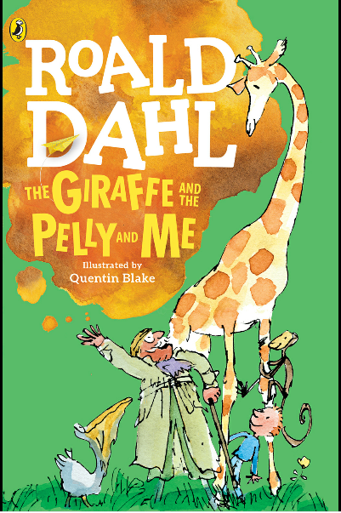

Let’s remind ourselves of what a contents page looks like.

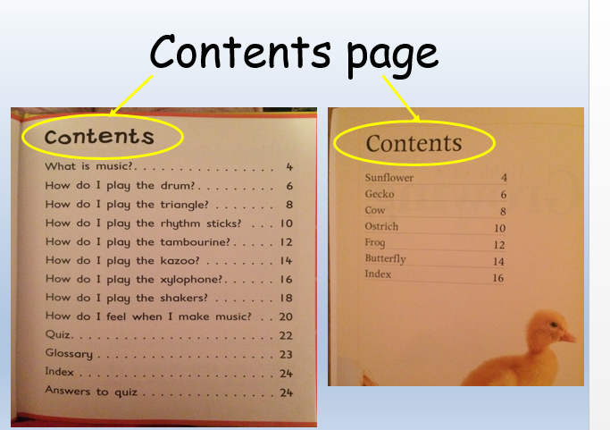
and a glossary….

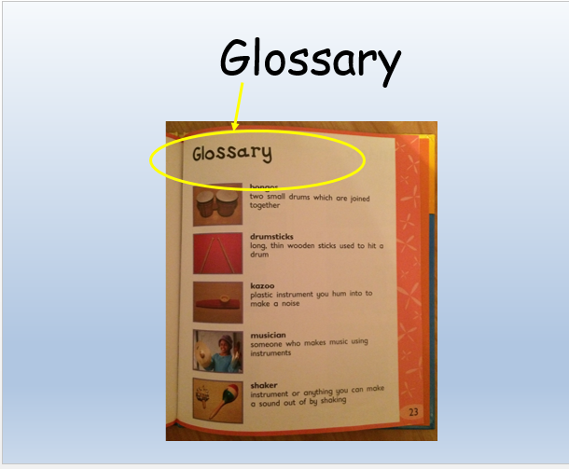

Have fun and I can’t wait to see the finished document. I hope you have enjoyed writing this non-fiction information booklet.

Next week we will be continuing the story of The Giraffe,The Pelly and Me.
26.6.20
Science: Last Friday we looked at a whole variety of different habitats.
Today we are going to look at a micro habitat? What does ‘micro’ usually mean? Micro means ‘extremely small’.
