Year 2 Phonics/Spelling Practice – w/c 4.5.20 Monday
This week we will be learning words which have the ‘ness’ or ‘ment’ suffix.
Practise writing your new spelling words each day using your best Russell handwriting.
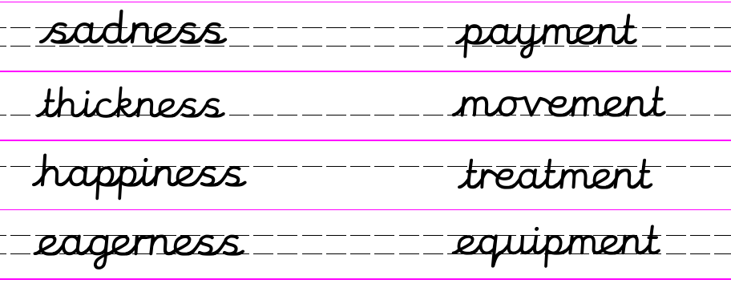 The suffix -ness changes an adjective (describing word) to a noun (naming word) and means 'the state of being'.
ie. Happiness = the state of being happy.
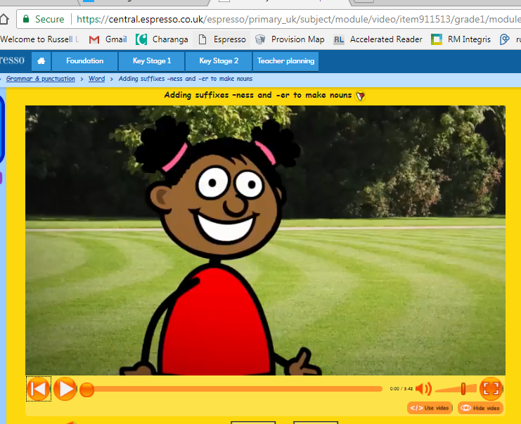
Sadness = the state of being sad.

If you have access to Espresso – watch this short video about how to use the suffix –ness.
https://central.espresso.co.uk/espresso/primary_uk/subject/module/video/item911513/grade1/module910304/collection910337/section911510/index.html?source=search-al l-all-all-all&source-keywords=suffix%20ness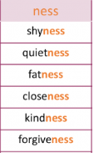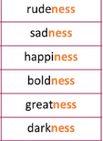Here are some more words ending in –ness. Can you read them out loud?

Maths 4.5.20
This week we are going to be working on addition and subtraction, + and -.
Before we start we need to remind ourselves of the value of each digit in a 2-digit and 3-digit number, so that are calculations are accurate.

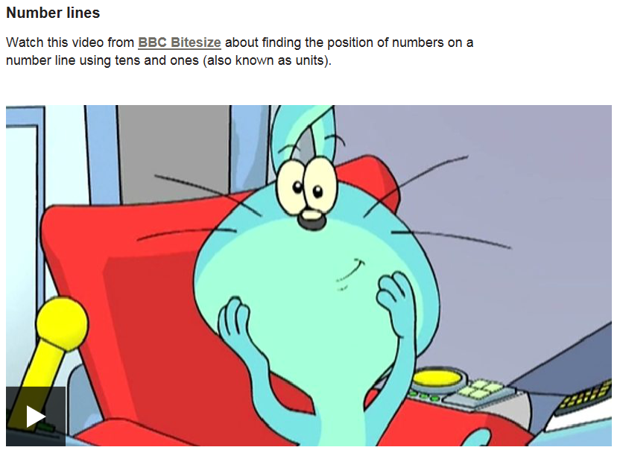
Watch this video to revisit place value in a 2-digit and 3-digit number.

https://www.bbc.co.uk/bitesize/articles/z7cthbk

Draw 1s, 10s and 100s to represent the following numbers:
Remember: 100 = 10 = I 1=
C

62 = IIIIII 39 = 41=
C
C

17 = 68 = 28 =

82 = 33 = 80 =

124 = 258 = 709 =
English - Monday 4th May 2020
Inspirational quote of the day! 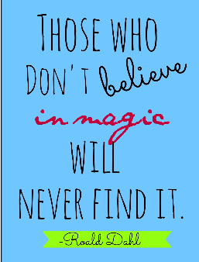
Good Morning, year 2. How are you all getting on? This week is a short week as on Friday we have a bank holiday. It is a special bank holiday this year as we are remembering VE day. VE day stands for Victory in Europe Day which happened in 1945. Which was 75 years ago.

Today we are going to continue to look at the story of A New Home for Hermit Crab by Eric Carle and answer some VIPER style questions about it. Don’t forget you can find the story of Hermit Crab on youtube.
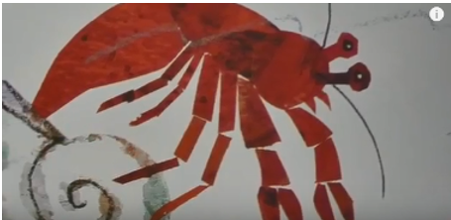

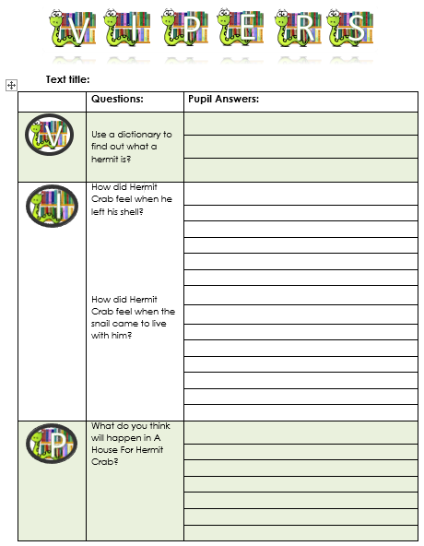

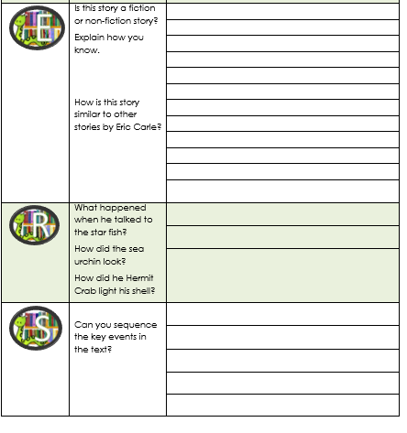

PSHRE 4.5.20
WALT: to understand how rules help us.
What would happen if we had no rules?
Would school or home be a nice place to be for children?
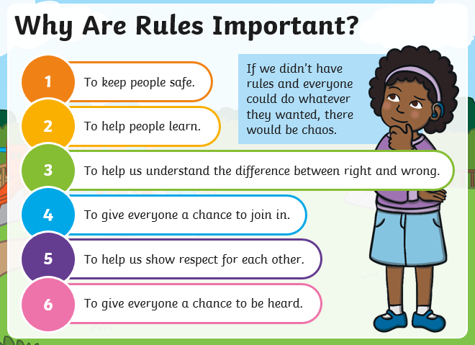
Think about what might happen if a certain rule didn’t exist. For example:
Rule: We always tidy up after ourselves.
Consequence: Our homes and our classrooms would be very untidy and we would be able to find anything.
Can you now think of the consequences if these rules didn’t exist?
Rule: We use our indoor voices. Consequence?
Rule: We look after our equipment. Consequence?
Rule: We listen to each other. Consequence?
Rule: We always try our best. Consequence?

Music 4.5.20 FRIENDSHIP SONGS
Listen to another song about Friendship – You Give A Little Love from the film, Bugsy Malone.
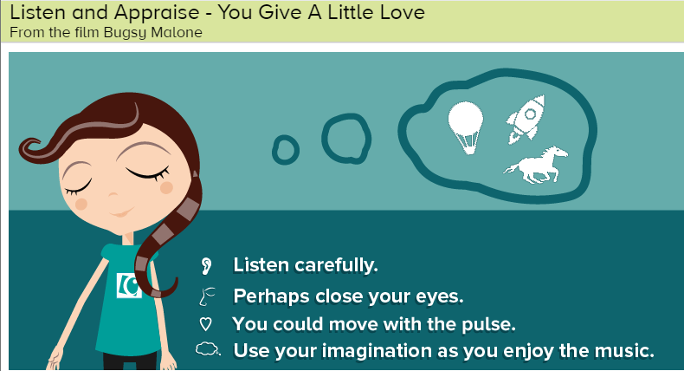
Word of the day: Tempo – can you remember what it means? (speed of the music)
https://www.youtube.com/watch?v=pY-D5Hkd86I
After listening to the song, think about these questions:
● Does this song tell a story? Perhaps the words tell a story or perhaps the music creates a story in your imagination. What is that story?
● What can you hear? Piano, bass, drums, banjo, male vocals and backing vocals. The tempo doesn't stay the same during this song, it gets faster.
● How does the music make you feel? Music brings many emotions along with it and often each person feels something different. Perhaps share with someone how the music makes you feel.
● What did you like about the song? It doesn't matter if you like or don't like a song or a piece of music. Think about the reasons why you do or don't.
Fast Facts Information about the song:
● 'You Give A Little Love' is from the musical film 'Bugsy Malone'.
● This film starred only child actors.
● The film is set in New York and Chicago in the 1920s and 30s.
● 'You Give A Little Love' is about friendship and treating the world and each other with love and respect and then that love and respect will come back to you.

