Year 2 Phonics/Spelling Practice – w/c 22.5.20 Friday
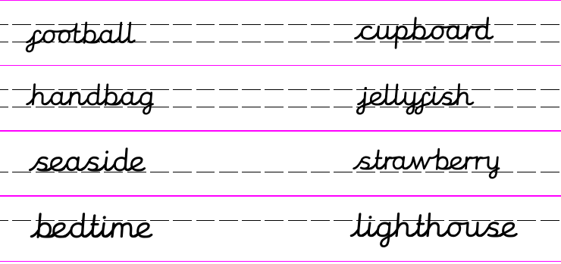
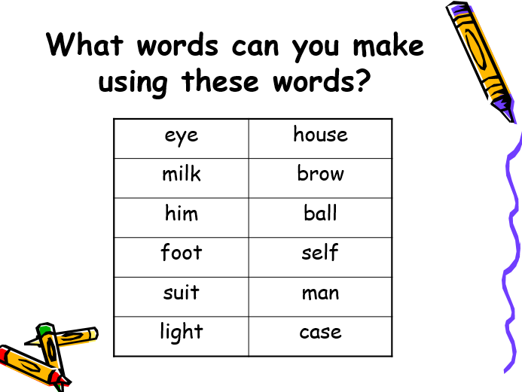
Now choose some of the words which you might find useful and practise writing them using Russell writing in two different colours.
ie. toothbrush, farmhouse, seaside.
Can you then put these word into a sentence of your own?
Challenge: Explain to your grown up what a compound noun is.
A compound noun is…
Dictation sentence to practise:
The milkman put a football in the suitcase.

Maths 22.5.20
Hit the Button – Number bonds to 100
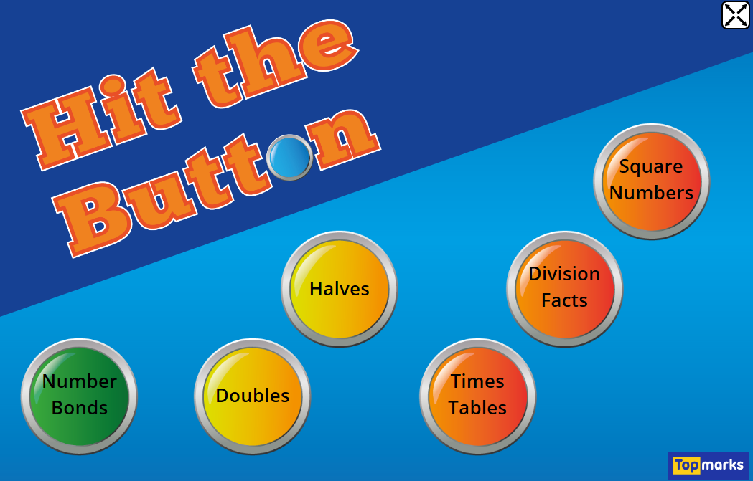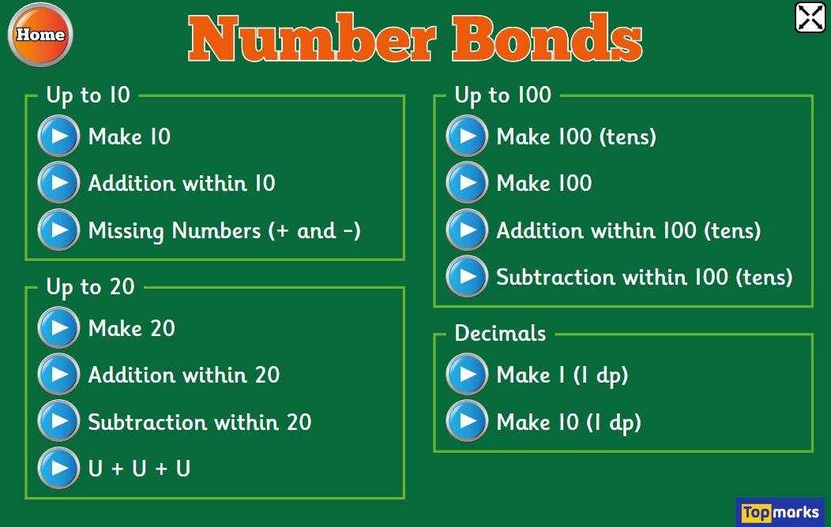
If you can, use Hit the Button to practise number bonds to make 100
https://www.topmarks.co.uk/maths-games/hit-the-button
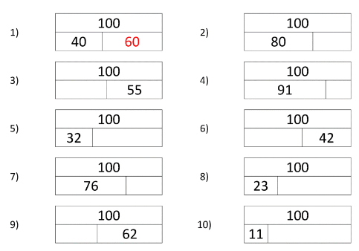

English - Friday 22nd May 2020
WALT design a new tail for Mr Fox or a new machine for The Three Farmers.
I have copied the story for those of you who don’t have access to YouTube. If you can get on YouTube there are lots of videos of people telling the story.
Please read the next two chapters or ask an adult to read them to you.
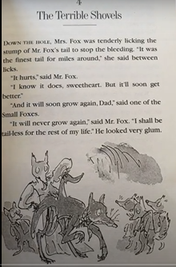

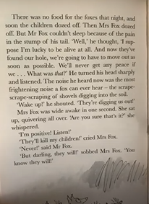

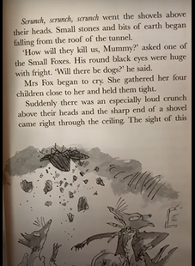
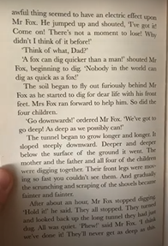

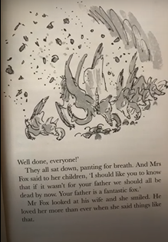
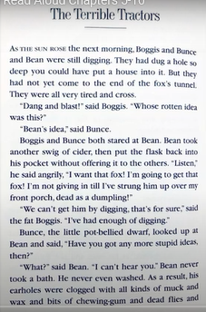

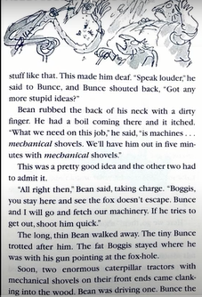

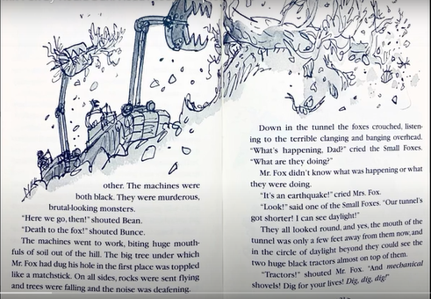

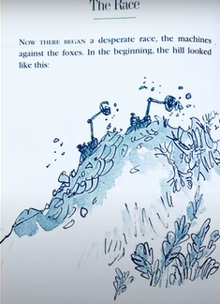
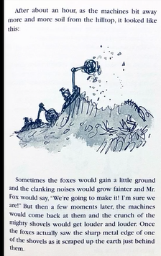

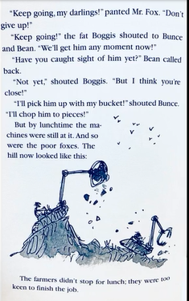

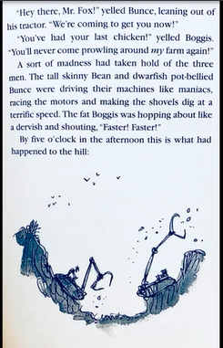

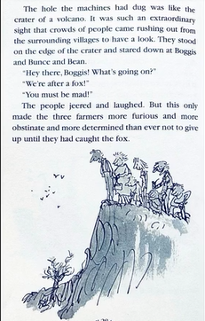

Today’s task is to use your imagination and design and label either a new tail for Mr Fox, one with special features that will help him defeat the farmers or a new machine that will enable the farmers to catch Mr Fox.

Draw and label your picture.

Have a lovely half term. If you can read/listen via YouTube to the rest of the story. There is also a movie which is very good too if you have it or can get hold of a copy. It really is a ‘fantastic’ book.

22.5.20 Science

WALT: Observe and describe how seeds and bulbs grow into mature plants.
So far we have looked at how we can grow plats from both seeds and bulbs. Today we are going to look at the life cycle of a sunflower.
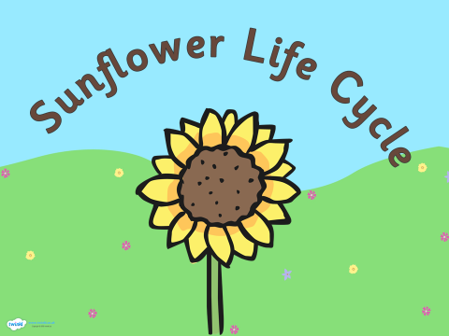
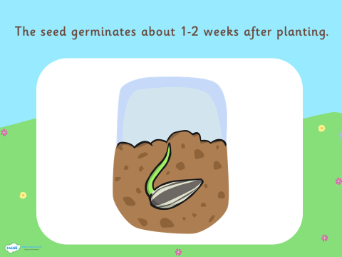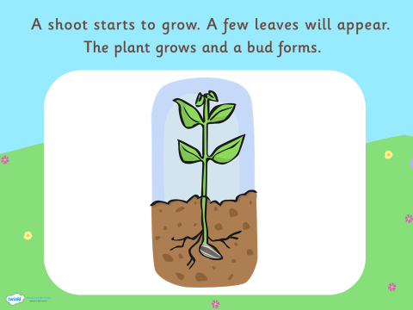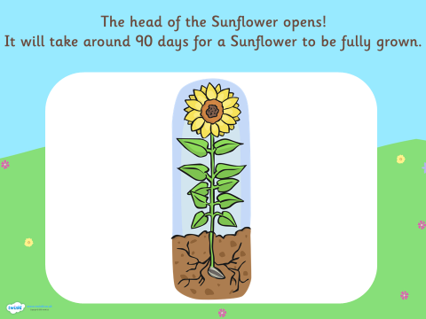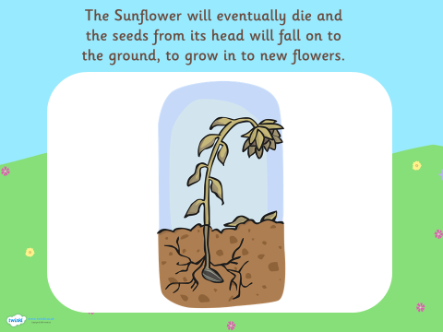

Can you draw OR cut and stick the pictures to shoe the life cycle of the sunflower?

