Sports Premium 2014-2015
What is the Sports Premium?
The Government is providing additional funding for the next 2 academic years 2013 to 2014 and 2014 to 2015 to improve provision of physical education (PE) and sport in primary schools. This funding has been provided jointly by the Departments for Education, Health and Culture, Media and Sport. This funding is ring-fenced and therefore can only be spent on provision of PE and sport in schools.
Each school will receive £8000, plus £5 for each pupil in years 1 – 6.
The total that Russell Lower will receive this year, is £9050. We have a carry-over from last year of £3070.90. This was allocated to be spent on new equipment for our extended hall once our build work in complete in Summer 2015. Giving us a total of £12,120.90
Schools must spend the additional funding on improving their provision of sport and PE, but have the freedom to choose how they do this.
Possible uses of the funding include:
- Hiring specialist PE teachers or qualified sports coaches to work alongside Primary teachers when teaching PE
- New or additional Change4Life sports clubs
- Paying for professional development opportunities in PE/sport
- Paying cover to realise teachers to attend professional development opportunities in PE/sport
- Running sports competitions or increasing participation in school games
- Buying quality assured professional development modules or materials for PE/sport
- Providing places for pupils on after school sports clubs
How do we intend to spend the funding?
At Russell Lower we intend to use the sports premium funding to:
Provision | Estimated Cost | Link to aims of the funding
- Join the Redborne School Sport Partnership (SSP). This provides support for local schools including professional development for teachers and entry into all local school festival and transition events. | £2000 | Continued professional development opportunities, greater access to festivals for children
- Contribute towards the payment of specialist sports coaches brought in to cover KS2 PPA sessions. KS2 teachers are expected to attend at least one hour session each half term to aid towards professional development. | £720 (6 one hour sessions for each of the four KS2 teachers.) | Staff acquiring new ideas and strategies to use within their own lessons.  To increase the quality of initial teacher training in PE and sport, and to promote PE specialisation in the primary level workforce
- Use these coaches to provide a wider variety of afterschool sports clubs. A KS1 and KS2 club in the Spring 1 and Spring 2 terms will be funded by the school in order to encourage uptake. This was then extended to the Summer term due to the impact. | £720 (club of KS1 and KS2, 20 places for each)  £800 | To encourage greater take-up of our extra curriculum sports clubs.
- Tennis coaching for year 2. CPD for teachers. | £420 | Teachers to develop their knowledge around the teaching of tennis through ‘peer teaching’ with a tennis coach.
- Tag rugby resources. | £42.00 | To ensure children are fully ‘kitted out’ for the tag rugby festival – ongoing resources to be used.
- 2X lunch staff sent on ‘The Outdoor Classroom – Playpals’. | £60 pp | To help increase the range of activities offered during the lunch period.
- Year 3 staff member sent on multiskills course. | £36 | Continued professional development
- PE coordinator to attend PE conference. | £120 | Continued professional development
- Introduce KS1 activity club at lunchtime and after school as part of after school club to increase pupil activity | £249.99 | Increase participation levels in healthy activity of pupils
- Resources bought for KS2 children to encourage greater activity during lunchtimes. | £131.24 | Increase participation levels in healthy activity of pupils
- Trolley to hold equipment for break and lunchtime use so Young Leaders are able to monitor. | £221.45 | Increase participation levels in healthy activity of pupils  Include PE as a tool for whole school improvement
- Young Leader tabards. | £74.25 | Include PE as a tool for whole school improvement  Increase participation levels in healthy activity of pupils
- Yr4 Bikeability course paid for all who were interested. | £140 | Include PE as a tool for whole school improvement  Increase participation levels in healthy activity of pupils
- Equipment bought to support school netball club. | £187.82 | Include PE as a tool for whole school improvement  Increase participation levels in healthy activity of pupils
- Equipment bought to develop dance | £73.15 | Equipment needed to support teaching
- Equipment bought to develop Athletics provision | £660.50 | Equipment needed to support teaching
- Equipment bought to develop cricket provision | £19.13 | Equipment needed to support teaching
- New mat trolley | £301.90 | Equipment needed to support teaching
- Skipping workshop for all children | £557 | Include PE as a tool for whole school improvement  to improve the quality of existing PE teaching through continuing professional  Increase participation levels in healthy activity of pupils
- Sports day certificates bought for each child. | £54.25 | Include PE as a tool for whole school improvement
TOTAL | £7,648.68
Carry over | £4472.22 | To be used to develop the outside space.

When considering the spend we kept in mind the four over-arching aims of the Primary PE and Sport Premium funding which are:
- to improve the quality of existing PE teaching through continuing professional learning in PE for generalists, so that all primary pupils improve their health, skills and physical literacy, and have broader exposure to a range of sports
- to increase participation levels in competitive sport and healthy activity of pupils, and maintain these into adolescence
- to increase the quality of initial teacher training in PE and sport, and to promote PE specialisation in the primary level workforce
- for schools to understand and value the benefits of high quality PE and sport, including its use as a tool for whole school improvement

Impact

Point above/pictures | Details | Impact/Anticipate Impact
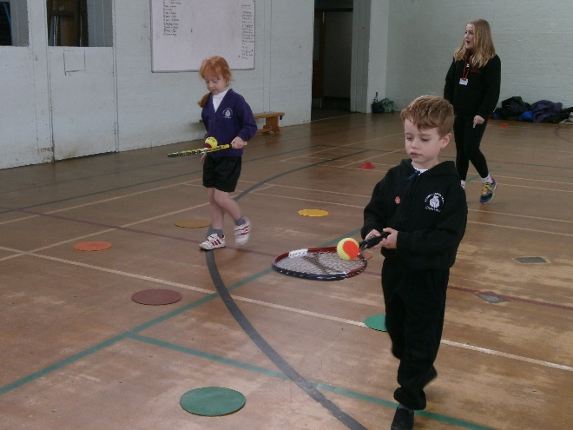  1 | Through signing up to the RSSP all children who were on role at the beginning of the academic year were signed up to take part in at least one sports festival/transition event.  CPD opportunities are also offered throughout the year. | Pupils who attend the festivals are awarded a certificate and these are presented in our whole school assemblies in order to raise the profile of PE.  There is a large emphasis placed on the fact that the children are representing their school and to do their best, but the main message portrayed is for the children to enjoy themselves and have fun.  Gym CPD for staff.  3 members of staff attended other CPD opportunities.
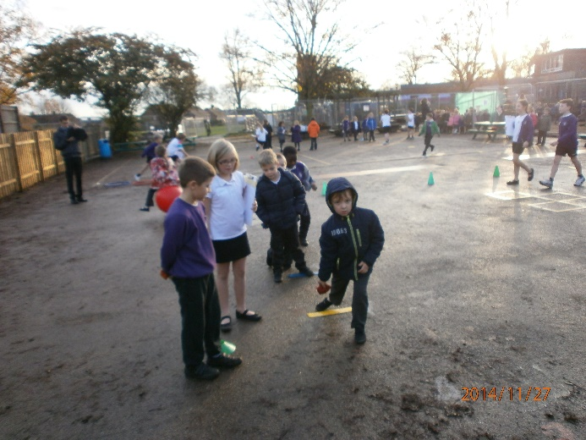  1 | Through signing up to the RSSP we have also accessed the Year 4 Leadership Programme where members of the Redborne Partnership have trained selected year 4s on how to become good sports leaders. This was carried out in an afternoon sessions where an hour was spent training the selected Year 4s, they were then given the opportunity to put their new training to the test by working with a class of Year 1s. | 12 children tool part in the Leadership Programme which during the training focussed on values such as self-esteem, honesty and friendship. The Young Leaders will continue to be encouraged and supported to achieve their Leadership Award which will help to develop their own self-esteem and confidence in the area.
2 | KS2 staff have been asked to spend a one hour session each half term spectating the delivery of PE sessions to their class via the bought-in sports coaches covering PPA. | Staff have made notes on their observations and have been introduced to new ideas and ways of working with PE lessons.  High quality PE lessons consistently delivered  Progression of skills across the school are well planned for.
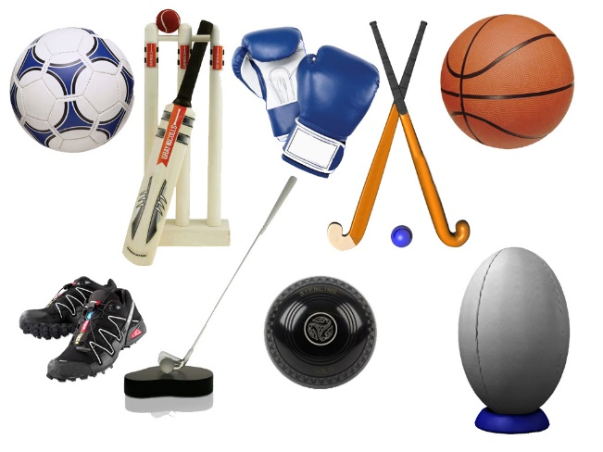  3 | After noting that there was quite low uptake for the extra-curricular sports clubs offered after school it was decided that the school would finance these via the sports premium. | Personal finance is not a barrier to attending clubs.  Since the school has been funding the clubs the uptake has at least doubled and tripled in some cases. We are now becoming over-subscribed. These extra-curricular clubs provide opportunity for the pupils to develop their skills in various sports beyond the curriculum content. Due to the build work happening this year we have had to limit our clubs but we are hoping to offer a much broader range and many more next academic year. Priority is given to PP, overweight children and children who have not attended a club.
5 | We have bought in tennis coaching for year 2 for the Summer term as they are now the only year group not receiving specialist coaching as part of their ppa. | This will be an opportunity for staff CPD as staff will be expected to remain with their class during the sessions.  The staff felt that through being present during the sessions it better equipped them to teach the lessons them self and they felt more self-confident.
6 | The purchase of additional tag rugby resource was made in order to ensure that children were fully equipped to attend a tag rugby festival. | Ensuring that children were fully equipped when entering a tag rugby festival. Self-esteem and confidence when representing their school.
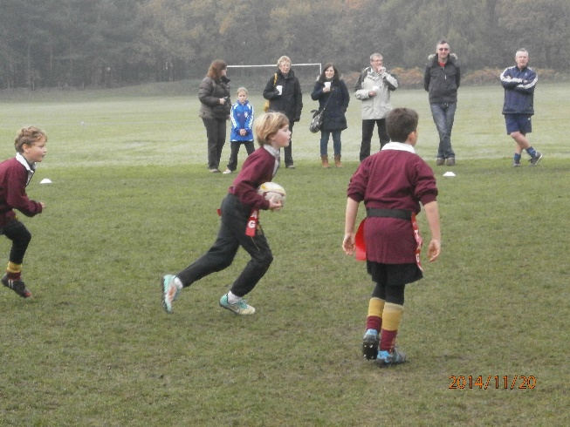  7 | Two members of the lunchtime staff were sent on an outdoor play course to encourage greater activity at lunchtimes. | The staff now appear to be engaging with the children more during this time and encouraging games and physical activity.
8 | A staff member was sent on course to do with multi-skills teaching as she felt this was an area that required improvement. | She reported that the course was very useful and had taught her new ideas to try during her teaching.
9 | PE co-ordinator to attend the PE conference in March 2015. | Acquiring up to date knowledge.  Attended workshops on sports premium, kwik cricket and children’s yoga.
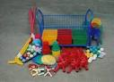  10 | We have bought into resources to provide a KS1 activity club at lunchtimes and to be used as part of after school club to increase pupil activity. During lunchtime this is to be delivered by a specific member of staff who has been identified as being responsible for ‘games’ during this time. | Children are more active at lunchtimes and are involved in organised games to help increase health.  To be evidence more in the future - questionnaire, lunch staff to monitor.
11 | Resources were bought for KS2 to encourage greater activity during lunchtimes. The PE coordinator has spoken to the Young Leaders in the school and they are going to organise a range of activities and games that children can take part in during the Summer term. | Children are more active at lunchtimes and are involved in organised games to help increase health.  To be evidenced more in the future – questionnaire, lunch staff to monitor.
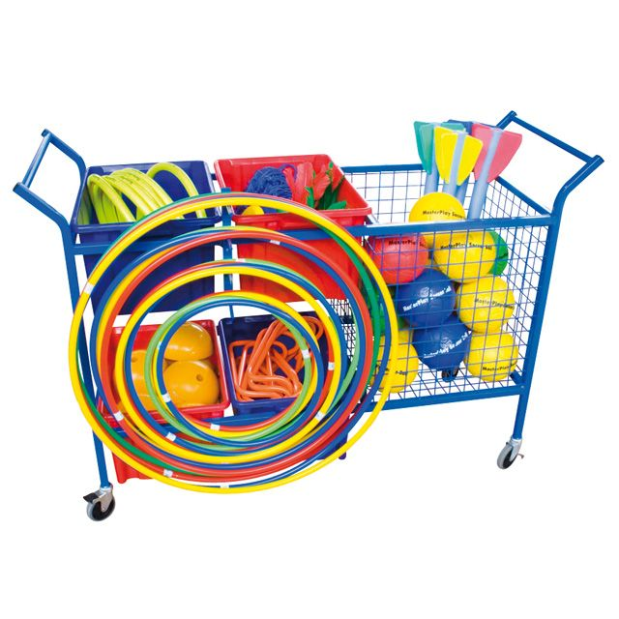  12 | A storage trolley is to be ordered so that equipment can be stored neatly and can be handled by the children. | This was ordered to encourage the children/Young Leaders can take more responsibility and ownership over the use of the equipment.
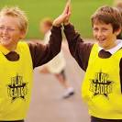  13 | Purchase of Young Leader Tabards so that leaders can be recognised on the playground. | Leaders to feel that they have a recognised role to play in the organisation of games at break and lunch times.
14 | Bikeability for all year 4 children who expressed interest. | To develop the skills of riding a bike and safety issues surrounding this.
15 | Equipment bought to support school netball club. | Ensuring that children were fully equipped when entering netball tournaments. Self-esteem and confidence when representing their school.
16 | Equipment bought to develop dance | Teachers having the equipment they need in order to teach effectively.
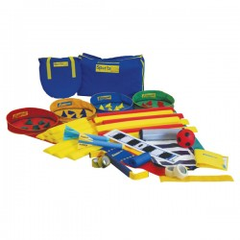  17 | Equipment bought to develop Athletics provision | Teachers having the equipment they need in order to teach effectively.
18 | Equipment bought to develop cricket provision | Teachers having the equipment they need in order to teach effectively.
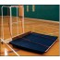  19 | New mat trolley | Teachers having the equipment they need in order to teach effectively. Health and safety.
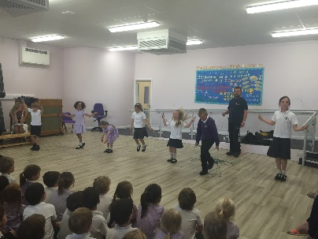  20 | Skipping workshop for all children  Skipping workshop for all lunchtime staff who wished to attend | All children involved in a healthy activity to help promote physical activity. A skipping zone has now been set up on the field during break times.  Following the workshop the lunch staff immediately set up a ‘skipping zone’ and interacted with the children to develop and enjoy skipping skills.

