Year 2 Phonics/Spelling Practice w/c 12.5.20 Tuesday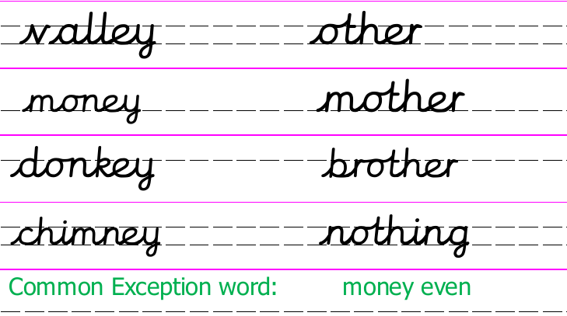
Here are some more –ey words. Write a caption word for each.
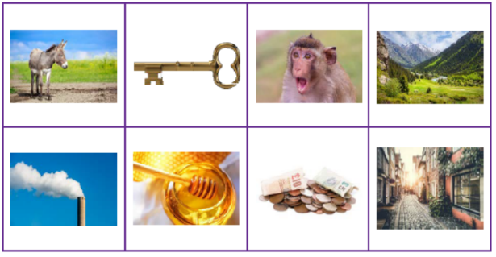
Dictation:
Ask someone to read out the sentence below so that you can write it down – try not to look until after you’ve written it. Check your punctuation and spelling.
We found the key to the donkey and monkey pens.

Word bank:
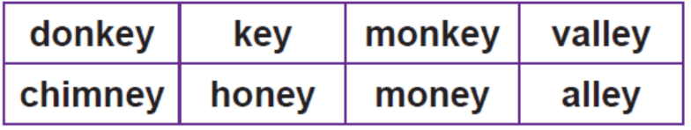
Maths 12.5.20
Watch the video and copy and complete the questions below.
https://whiterosemaths.com/homelearning/year-2/
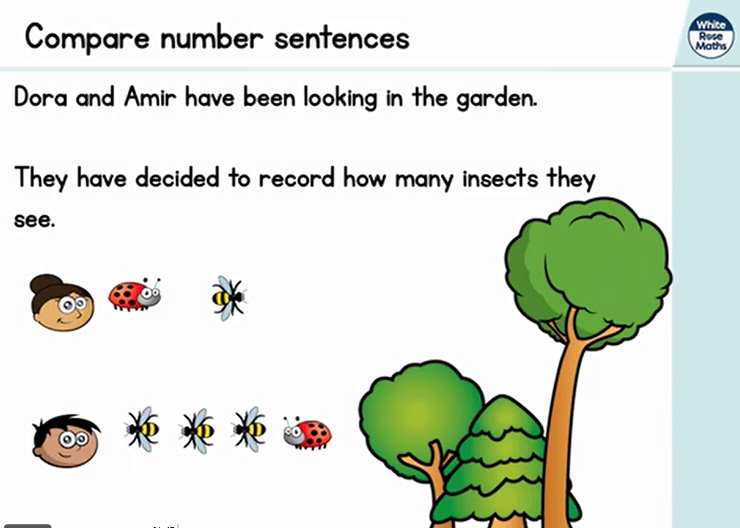
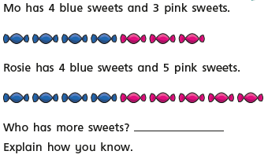
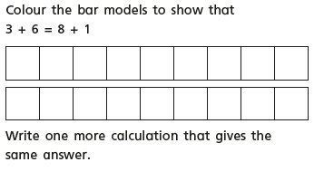
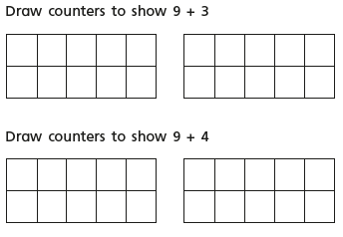
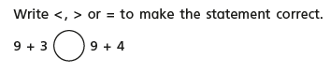
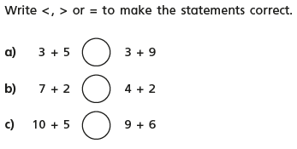

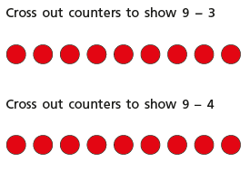
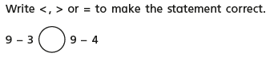
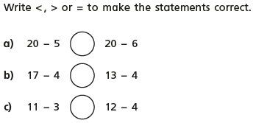

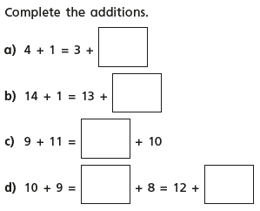
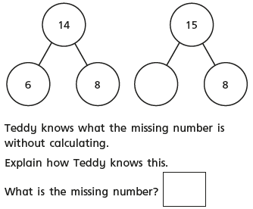
Tuesday 12th May 2020 - English Word of the week ‘Victory’.

Quote of the day –
Good Morning, year 2, Happy Tuesday.
WALT use two nouns to make compound nouns e.g Super man – Superman

Adults information to help you.
- This step focuses on forming compound nouns using two existing nouns, e.g. hairbrush.
- Children will make compound nouns by joining two existing nouns. The compound noun created has a similar meaning, e.g. superman.
- In this step, children will make compound nouns by joining two existing nouns. Sometimes, the compound noun created has a similar meaning, e.g. hairbrush.
- There are exceptions to this when two nouns are joined and the meaning is not the same. A strawberry, for example, is not a berry made from straw.

Starter
Can you circle all the nouns. (Remember what a noun is? A name, a place, an object).
Table running slowly house England earth tall apple
Task
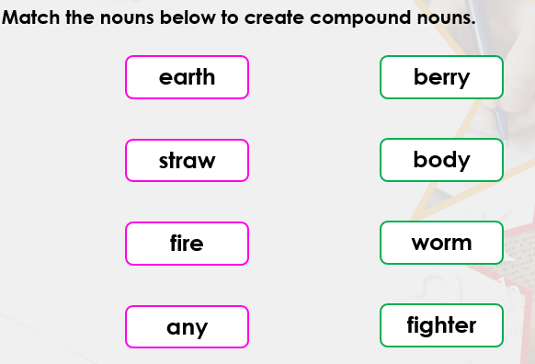
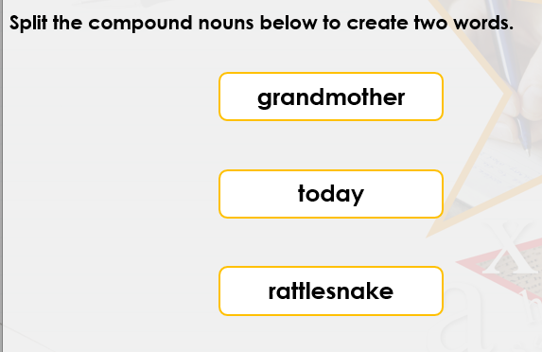

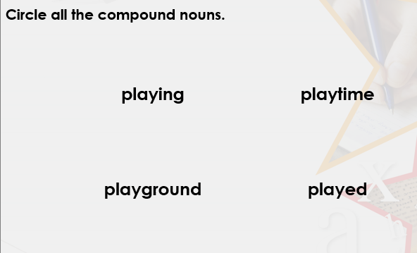

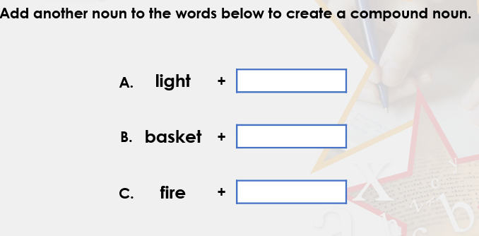

Challenge
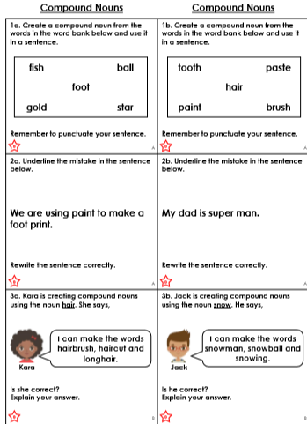

History - Tuesday 12th May 2020
WALT understand the significance of historical events in our locality.
Word of the day community.

How did you get on with last week’s task? Your historical evidence is now beginning to build up and will be a fantastic primary resource for historians in the future as well as something you will be able to share with family and friends.

Today’s tasks are to write down all the things you are doing to keep busy whilst you are at home. I know you have been doing your home learning packs but what else have you been up to.

I try to get my school work done in the mornings. I get up early and sit at my kitchen table till lunch time. Every day Mr Johnson and I go on a long walk around the fields opposite us. It was something we never used to do as Mr Johnson wasn’t too fond of a walk but now it is something we really enjoy. It has been lovely to see different vegetation growing over the past six weeks, we would never have noticed the changes before. I have also kept busy cooking, so much so I ordered a new cookery book from a restaurant called Mildred’s which is in London. I was inspired by a friend to cook from it and we have tried lots of new recipes. I have spent a lot of time in the garden too. We tried to grow some plants from seed which hasn’t been that successful but some have grown. I had an old patio table and chairs which had rusted and were ready for the tip but have managed to restore them using some paint I found in the garage. Make do and Mend is my new slogan! So what have you been doing to keep busy?

Task.

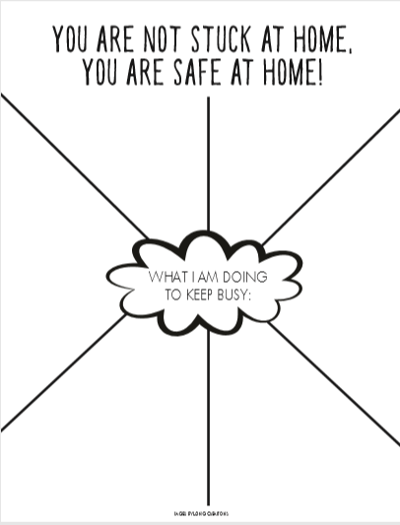

Extra task

