Tuesday 23rd June 2020
English
SPaG
Practise your spellings – try making a fortune teller to help practise the words.
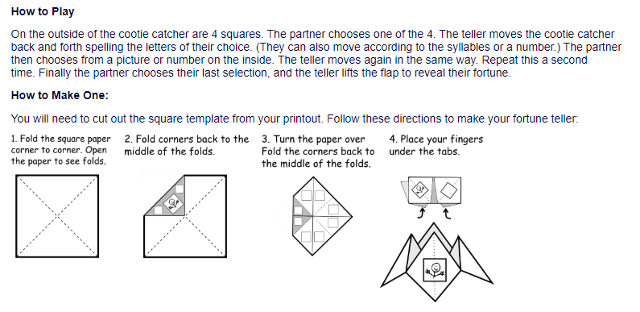
Words with the k sound spelt ch
echo
chorus
character
scheme
chemist
stomach
orchestra
technology

Word of the Day – coax

Definition ____________________________________________
_____________________________________________________
_____________________________________________________
Used it in a sentence: ____________________________________________________
_________________________________________________________________________
Word Class: ____________________________________________________
Synonyms

English
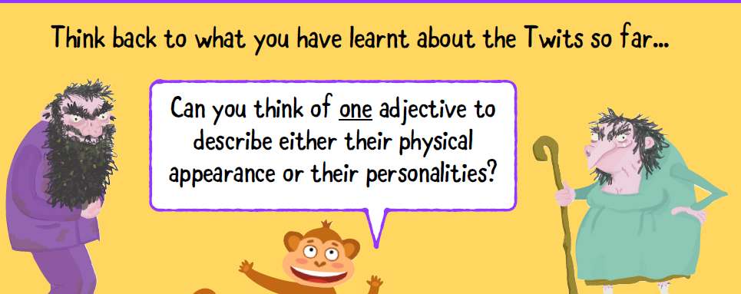
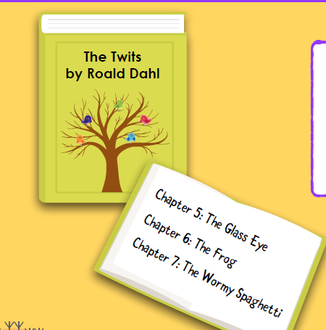

Find somewhere where you like to read, in a comfy armchair, in the garden etc and read the next three chapters.
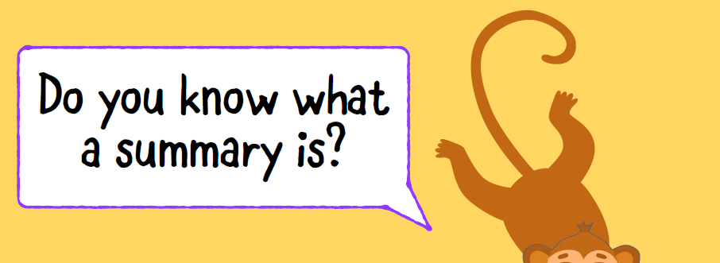

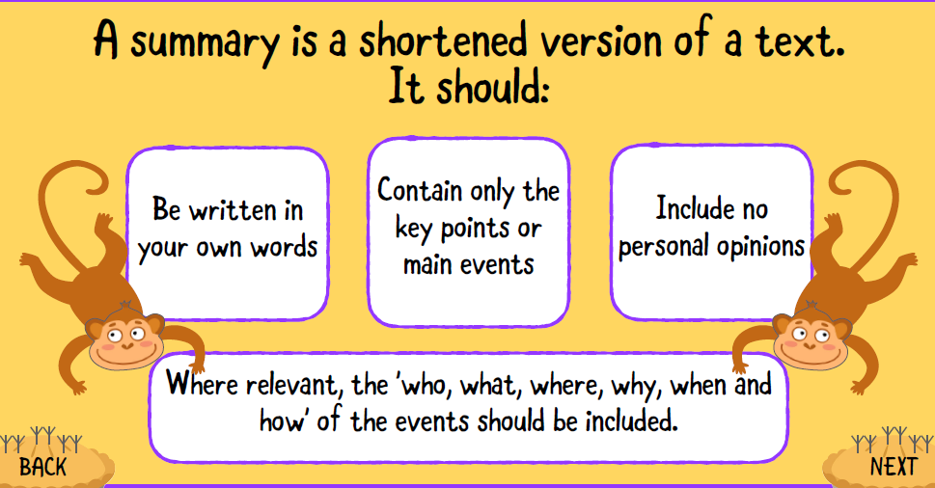

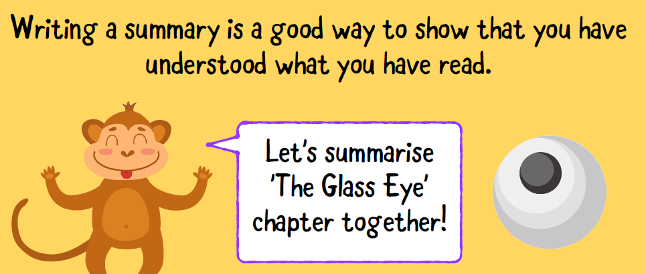
Using a table like the one below helps you sort your thoughts
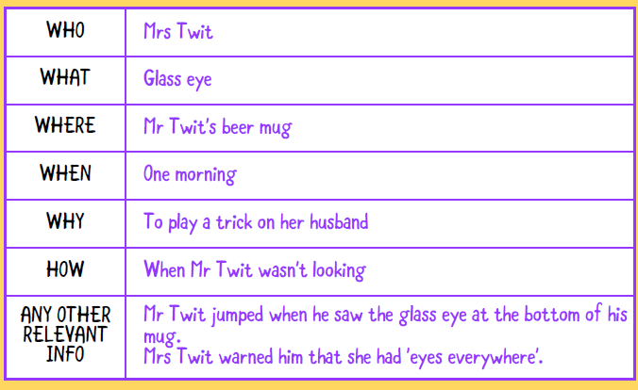

Below is my summery – remember a summery shouldn’t contain any personal opinion.

One morning, Mrs Twit decided to play a trick on her husband. She took out her glass eye and dropped it into Mr Twit's beer mug when he wasn't looking. Mr Twit jumped when he saw it at the
bottom of his mug. Mrs Twit warned him that she had 'eyes everywhere'.

Task – use a table like the one above to plan your own summery of either Chapter 6: The Frog or Chapter or 7: The Wormy Spaghetti and then write a short summary.

Maths
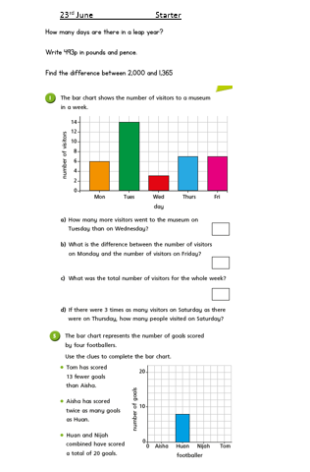

Music
What do you think the answers to these questions might be? Read the information below to find out more.
- What similarities might there be between our modern music and music from the Ancient Egyptian era?
- How many Egyptian instruments can you name?
- Paintings and hieroglyphics do not help us learn about Ancient Egyptian music. True or false?
- Ancient Egyptians thought music was an invention. True or false?
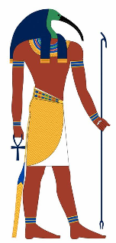  Ancient Egyptians believed that the Gods invented music. The Gods were called Thoth and Ihy. | 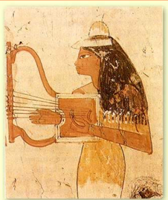  We can make inferences about the instruments used in Egypt by looking at ancient paintings.
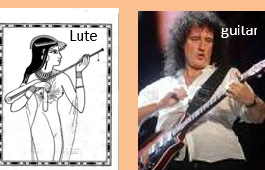  There are actually quite a few similarities between many Egyptian instruments and those used today by modern pop stars. The lute and the guitar shown below are both stringed instruments which are plucked or strummed to produce a sound. | 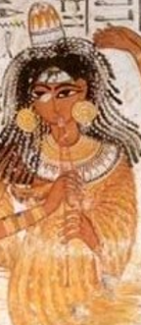  Ancient Egyptians probably would have played the harp as shown above, a lute (shown to the left), trumpets, drums, bells and many more. Can you figure out which instrument the lady is playing in this picture?
Task: Listen to some traditional Egyptian music think about how it makes you feel, do you like it? Listen carefully, which instruments can you hear? (search ‘traditional Egyptian music’ on you tube or follow this link: https://www.youtube.com/watch?v=GI6dOS5ncFc&safe=active )
What next? You could try some guided mindfulness meditation if you find the music relaxing, click here: https://www.youtube.com/watch?v=DV_kZtSGzyY&safe=active

