SWIFTS, SWANS & DOVES - AUTUMN 2020 – 2nd half term
CELEBRATIONS
Personal Social and Emotional Development  - Circle Games  - Value - Peace  - Getting on and falling out activities and stories  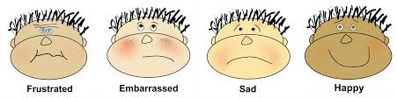  - Feelings |  | Communication and language  - Listening attentively  - Expressing themselves effectively showing awareness of listeners’ needs when sharing Learning Logs and Show and Tell items  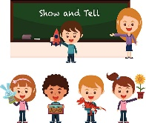  - Using language in role play situations e.g. Castle (Swifts), Post Office (Doves), Toy Shop (Swans) |  | Physical Development  - Firework and autumn dances  - Giant strides and fairy steps dance.  - Using tools effectively including pencils for writing  - Body Management activities  - Dressing and going to the toilet independently  - Handwriting patterns and names  - Writing cursive letters
Literacy  - Listening to nursery rhymes, a pantomime, The Owl who was Afraid of the Dark, Rama and Sita, the Nativity and other stories  - Looking at books independently  - Continuing a rhyming string  - Hearing and saying initial sounds in words  - Segmenting sounds in simple words and blending them together  - Sounding and naming the letters of the alphabet  - Writing our name and other words using cursive style  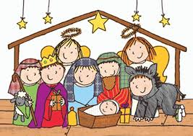  - Writing labels and captions | Mathematics  - Representing 1, 2 and 3  - Comparing 1, 2 and 3  - Counting on and back – one more and one less  - Composition of 1, 2 and 3  - Circles and triangles  - Printing circles and triangles using the flat faces of 3D shapes  - Spatial awareness – using positional language  - Count and subitise 4 and 5 objects using a 5 frame  - Squares and rectangles  - Night and day – order key routines and use language to describe when events happen  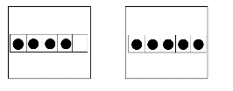 |  | Understanding the World  - Observational autumn walk  - Seasonal change  - Find out about the history of bonfire night  - Birthdays  - Diwali  - Story of Rama and Sita  - The seasons  - Use computer programs to create firework pictures and seasonal pictures  - Non-fiction texts about Hinduism  - Why is Christmas special for Christians?  - Nativity story  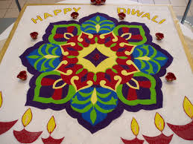  - Christmas traditions around the world |  | Expressive Art and Design  - Music – My Stories  - Painting calendars  - Printing fireworks  - Autumn  - Firework dance  - Giant strides and fairy steps dance.  - Making a clay diva  - Rangoli patterns  - Andy Goldsworthy environmental art work  - Christmas tree decorations  - Wriggly Nativity  - Christmas cards

