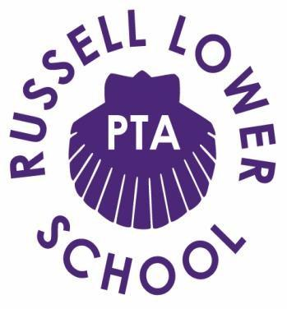

Dear Parents/Carers,

As the Easter holidays fast approach, COVID restrictions will still be in place and we’re aware there’s going to be little open for our children over the school break, so let the PTA lend a hand and help keep them entertained...

Following fantastic feedback, we’re thrilled to announce that SKITTLEMAN IS BACK!

This time hosting a ‘Virtual Family Games Night’ on Saturday 10th April 18:00-20:00

The event will be streamed via Zoom absolutely FREE! The PTA will be covering the cost in the hope it brings Russell families some interactive fun that the whole family will enjoy this Easter.
Register today by completing the Google Form* below.

For those who are new to Skittleman, he is an online comedy magician and family entertainer who used to be a Red Coat. His show is suitable for ages 2-102 and his unique witty style brought lots of laughter to our homes last time around.

If you want to make this Saturday Night show EXTRA special and support the PTA, we are selling some Treat Bags and Boxes. You can place your order in the Google form when registering.
Here’s what’s available:

Treat Bag - £5.00
This includes a pack of playing cards, chocolate bunny, small pack of popcorn, small bag of sweets, a fruit shoot and activity sheet.

Treat Box for 4 - £12.00
This includes a pack of playing cards, pack of dominoes, two large packets of popcorn (sweet and toffee), four chocolate bars, bag of sweets, two fruit shoots, two cans of fizzy drink and activity sheet.

Tipples and Treat Box - £22.00
This includes a pack of playing cards, pack of dominoes, two large packets of popcorn (sweet and toffee), four chocolate bars, bag of sweets, two fruit shoots, two cans of fizzy drink and activity sheet PLUS 1 Large 280ml Cocktail (choice available) and 2 Brewdog IPAs.
We are proud to support local business The Cocktail Company. Freshly made cocktails ready to drink that taste totally delicious, so go on...treat yourself! (Cocktails or beers can be added as an extra to any order). Menu includes:

- Pornstar Martini
- Espresso Martini
- Appletini
- Cosmopolitan
- Bubblegum Martini

Dairy free options are available. Treat box for 5 is also available with an extra fruit shoot and chocolate bar. As school is now open, all bags and boxes will be available for collection on the afternoon of the performance from school.

Register for this free event by 12:00 on Friday 26th March by completing the Google form below. Please make payment for any Treat Bags/Boxes also by 12:00 on Friday 26th March.
Bank details: Russell Lower School PTA. Sort code: 20-05-74. Account number 30768693. Please use your child's last name and class as reference. Once payment is received your order will be placed.

Any questions at all please do contact us at: pta@russell-lower.co.uk.

Click here to register.

Warmest wishes, Russell Lower School PTA

* If you do not complete the google form, due to safeguarding measures we will not be able to send you details for the show. The safety of everyone involved is paramount therefore your camera must be switched on throughout the zoom performance. Chatbox must be disabled and participants cannot share their screens or record the show. PTA members will be monitoring the event to ensure everyone is kept safe throughout. Children need to be supervised by an adult at all times during the performance.
