Day 3 - Week Beginning 13th July 2020 – English
SPaG
Words with the k sound spelt with que
Write each word in your spelling list using 2 different colours. Write the consonants in one colour and the vowels in another colour.

mosque
unique
antique
plaque
cheque
boutique
picturesque
grotesque

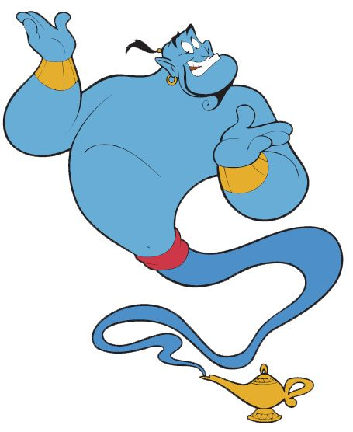
Word of the Day – crave

Definition ____________________________________________
_____________________________________________________
_____________________________________________________
Used it in a sentence: ____________________________________________________
_________________________________________________________________________
Word Class: ____________________________________________________
Synonyms

English
First read the following extract
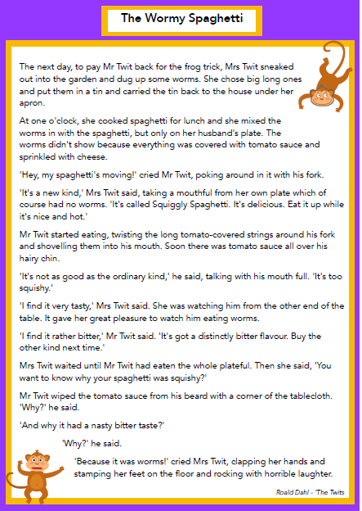

Task
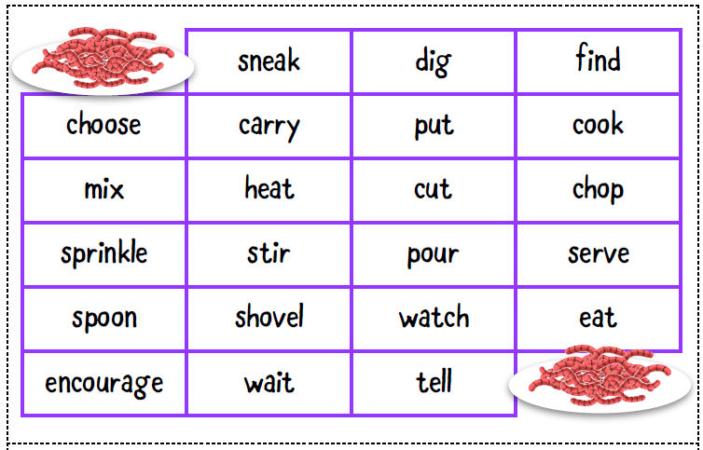
Create a plan for a set of instructions that would be included in a recipe book entitled, ‘Tasty Twit Treats’. Plan a recipe for Wormy Spaghetti featured in the Twits. Use these imperative verbs below will be helpful in your plan

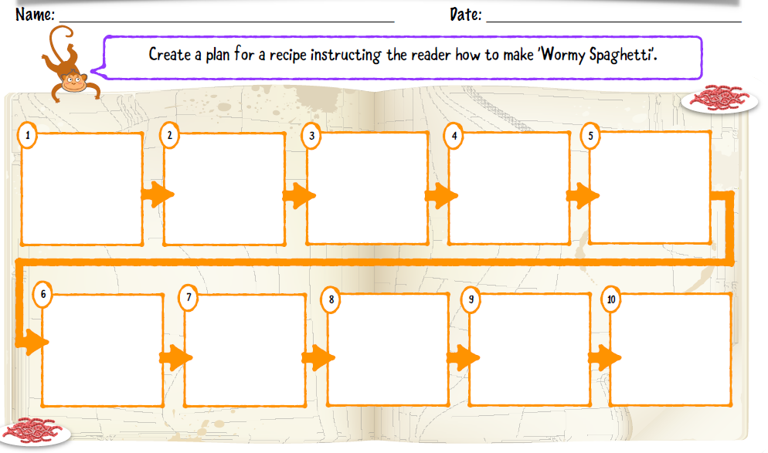

Day 3
Starter
- 432 +777
- 654 – 464
- 124 ÷ 4
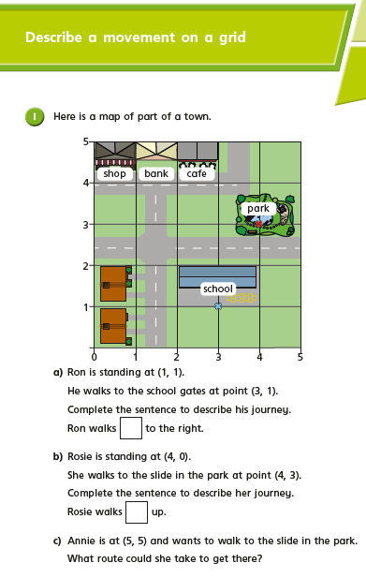
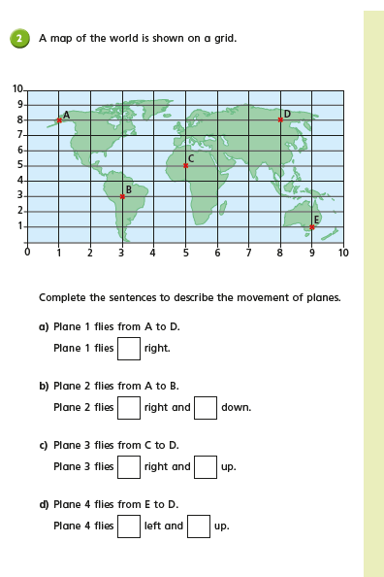

Day 3 –History
Task1 : Listen to Greg Jenner (from horrible histories) give a 15min lesson on Ancient Egypt. Search ‘BBC home school history’ or click here: https://www.bbc.co.uk/sounds/play/m000kgnr
What new facts did you learn?
How did you do in the quiz at the end?
Task 2: Could you create your own quiz about ancient Egypt and send it to a friend?
TASK 3: When we first started this topic you would have filled in a table like the one below. You can now take some time to reflect on all the wonderful new things you have learned and fill in the final column!
