Wednesday 20th May 2020

SPaG

Spellings – Prefix – re

Create a word search using the words in your spelling list. Write the spelling words in the grid below. Words can go forwards, backwards, up, down and diagonally. Finish by filling in the remaining spaces with random letters.

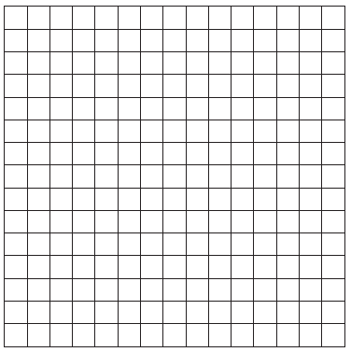redo

refresh

return

reappear

revenge

remember

retrieve

redecorate

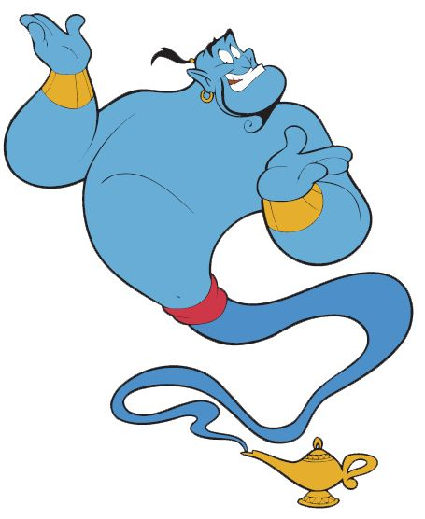

Word of the Day – **address**

**Definition ____________________________________________**

**_____________________________________________________**

_____________________________________________________

**Used it in a sentence: ____________________________________________________**

**_________________________________________________________________________**

**Word Class: ____________________________________________________**

**Synonyms**

**English**



Hopefully you noticed the text doesn’t have any paragraphs! It’s all in one big section, making it hard to read and pretty uninviting!

A paragraph is a section of writing with one or more sentences in it. All the sentences in a paragraph will be about one main point or subject.In a non-fiction text like a biography, a new paragraph is needed when the topic changes or a new, different point is being discussed.

Paragraphs make the text easier to read as it is broken into sections. A new paragraph can be shown by starting a new line and leaving a line between the last paragraph and your new paragraph.

Take another look at the Text you looked at earlier. Can you help spot the places where a new paragraph is needed?

There should be five paragraphs. What subheading would you give each paragraph?

Finally have a look back at your biography from yesterday on Howard Carter and check you are now happy with your paragraphs and their headings – can you make any improvement?

**Maths – Mental**

Find the difference between each pair of numbers.

1. 98 13

2. 15 57

3. 30 76

4. 282 40

5. 120 144

6. 151 191

**Maths – Main Lesson**

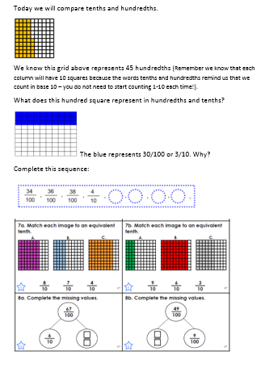

**History**

First, read some information about pyramids. You might like to use the information below **or** listen to the information on the bbc videos linked below. <https://www.bbc.co.uk/bitesize/clips/z849wmn>

Then, record three facts you have learned from the text.

**Just for fun:** You could challenge yourself to make a power point or a video presentation to share with your teacher or a friend ☺

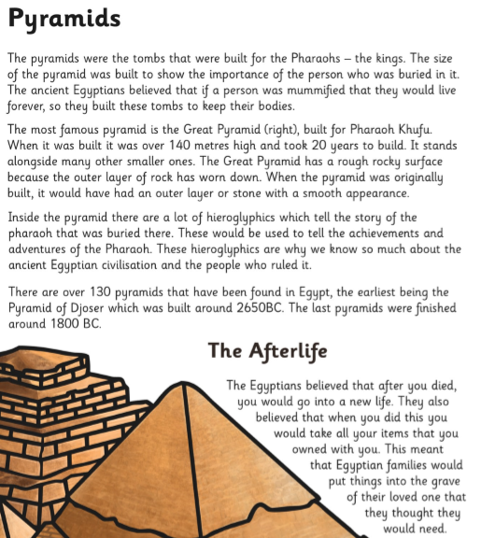

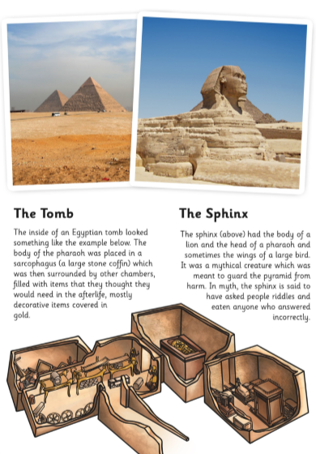

<https://www.bbc.co.uk/bitesize/clips/z849wmn>