Year 2 Phonics/Spelling Practice w/c 5.5.20 Tuesday
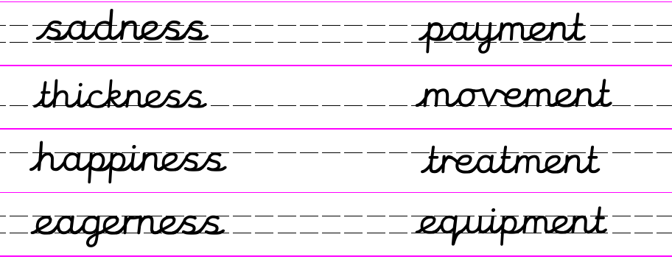
Match up the adjective with its noun ending in –ness.
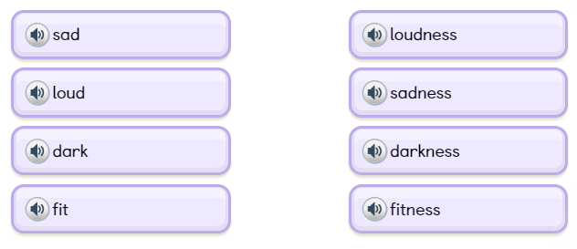
Can you remember the rule about adding a suffix to a word ending in –y? The ‘y’ changes to an ‘I’. Try these.
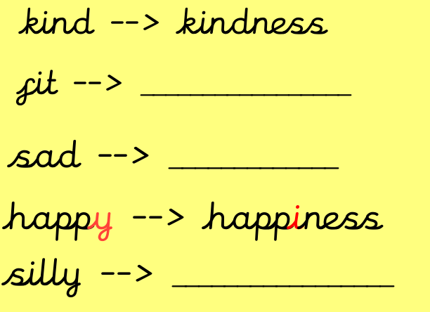
Dictation:
Ask someone to read out the sentence below so that you can write it down – try not to look until after you’ve written it. Check your punctuation and spelling.
It was with happiness that I helped her to forget her sadness.
Maths 5.5.20
Yesterday we revisited representing 2-digit and 3-digit numbers by drawing symbols for 100s, 10s and 1s. Today we will continue to draw the numbers but we will also add the two numbers together. We did lots of this back in the autumn term, e.g:

32 + 10 = 42
III + I = IIII
Copy and complete these additions, drawing the digits to help:
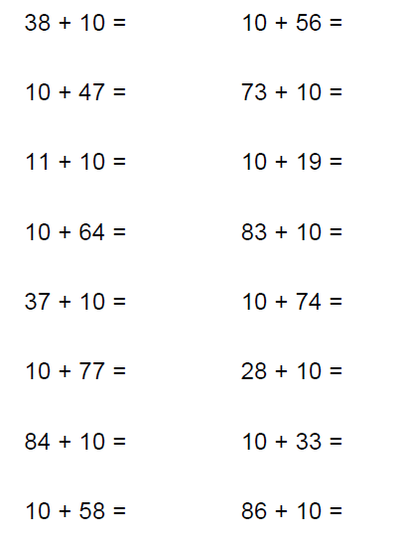
What do you notice about the answer when you are adding 10 to a 2-digit number?
Challenge:
125 + 20 = 229 + 50 = 519 + 90 = 664 + 60 = 789 + 100 =
834 + 120 = 222 + 20 = 610 + 60 = 999 + 90 = 1245 + 80 =
English - Tuesday 5th May 2020 Word of the week ‘summary’
WALT: write a blurb.

Quote of the day –
Good Morning, year 2, Happy Tuesday.
Today we are learning to write a blurb for one of the Eric Carle stories we have read.
Do you know what a blurb is?
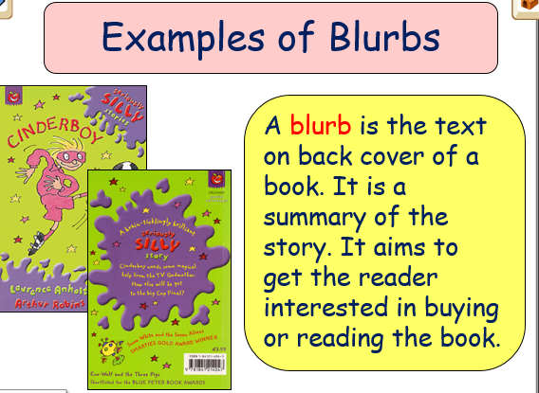
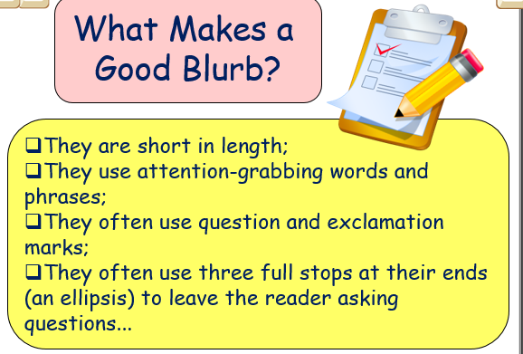

Here is an example of a good blurb.
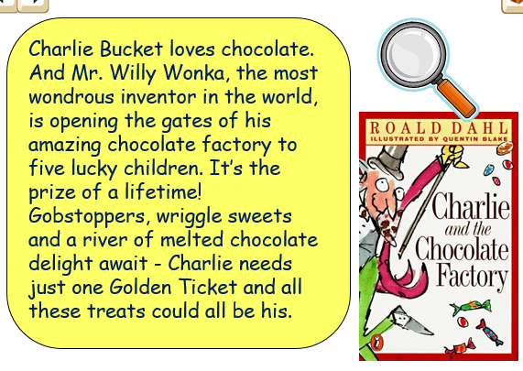

Task
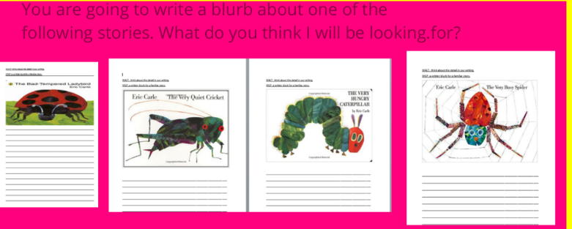

You can chose to write a blurb about any of the stories we have read over the past week.

Have fun, I look forward to reading them.

History 5.5.20
WALT understand the significance of historical events in our locality.
Word of the day community.

How did you get on with last week’s task ‘How I am Feeling’? I am feeling so much better now that I have heard from lots of you and know that you are all doing so well and working hard for your parents learning lots of new skills. Whatever you wrote is now part of history, it is a primary source of historical evidence

I am feeling hopeful and positive that soon we will all be back together at school. I am feeling grateful that my family and friends are all safe. I may not be able to see my parents or my sisters but how fortunate are we to be able to talk or the phone or see each other through facetime. I am feeling thankful that I have a nice home to spend this time in, that the weather has been so nice and I have been able to get outside in the garden. There are so many things to feel thankful for at the moment. I do feel sad that my son Harry is not at home with us at the moment but I know he is working hard and that he too is safe and well. We are all allowed to feel sad at times and worried but we have so much to be happy about too. I cannot wait to be back at school. I am looking forward to seeing all my family and friends and being able to give them a huge hug. I am looking forward to visiting the beach and dipping my toes in the sea.

I want to know how you are feeling. I want to know what you are excited to do when we are out of lockdown. I want to know what you are thankful for and what you have learnt from being at home.

I have attached a copy of a template that you could use but as I said last week you can make up your own or even record your thoughts on the iPad or on a phone.

I look forward to seeing what you have written/recorded as soon as it is possible for us to be back together in school. Have fun! Remember you are living history and this is your chance to create the primary sources that historians will study in years to come.

