Year 2 Phonics/Spelling Practice – Monday 13.7.20.
As it’s the last week of term, this week’s spelling and grammar work will be a little different – we’ll focus on practising some of the things that you have learned this year.

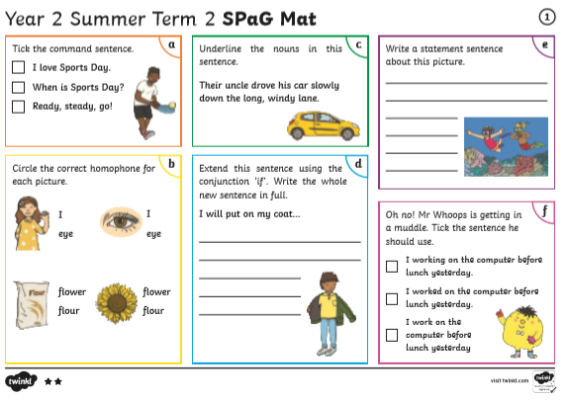
Maths 13.7.20
Time: quarter to and quarter past
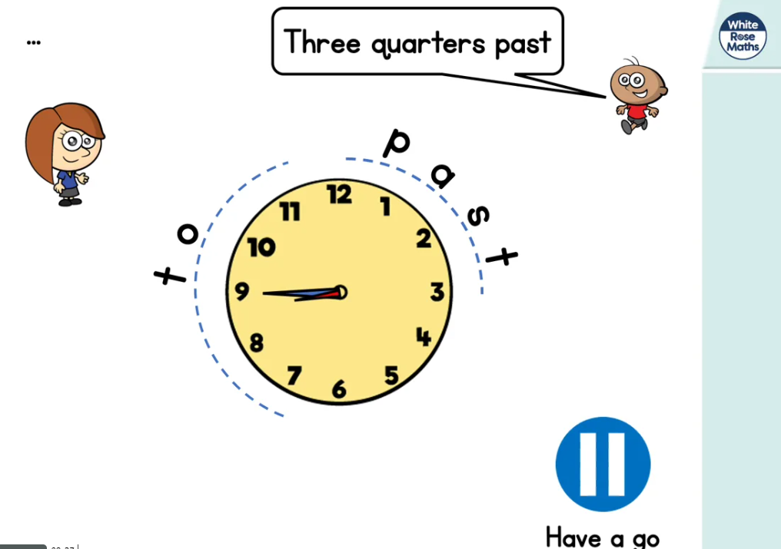
htps://whiterosemaths.com/homelearning/year-2/ (Lesson 4 w/c 6.7.20)
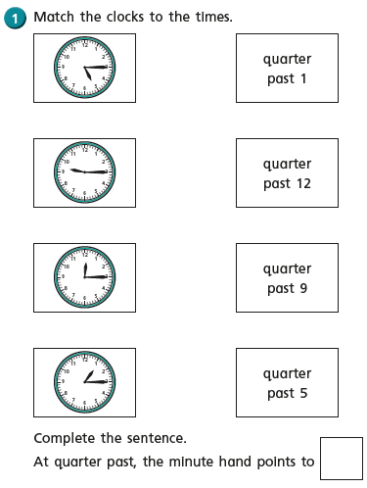
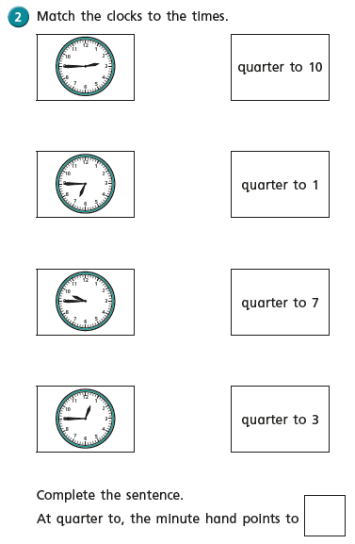
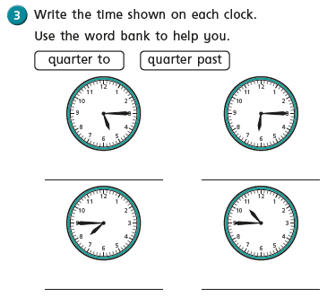
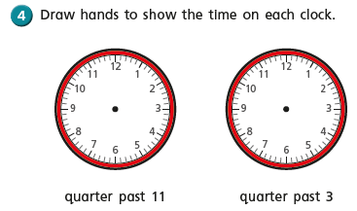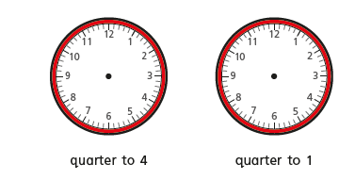
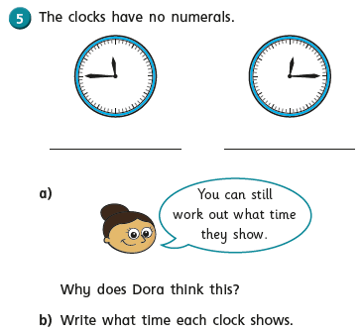

Year 2 Music Summer Term 2 –
Consolidating Year 2 music learning – history of music, musical language.

Week 7
Rewind and Listen Out! Count On Me by Bruno Mars. A listening activity to remember songs, instruments and their sounds.
https://www.youtube.com/watch?v=o8pAIO3CPBY
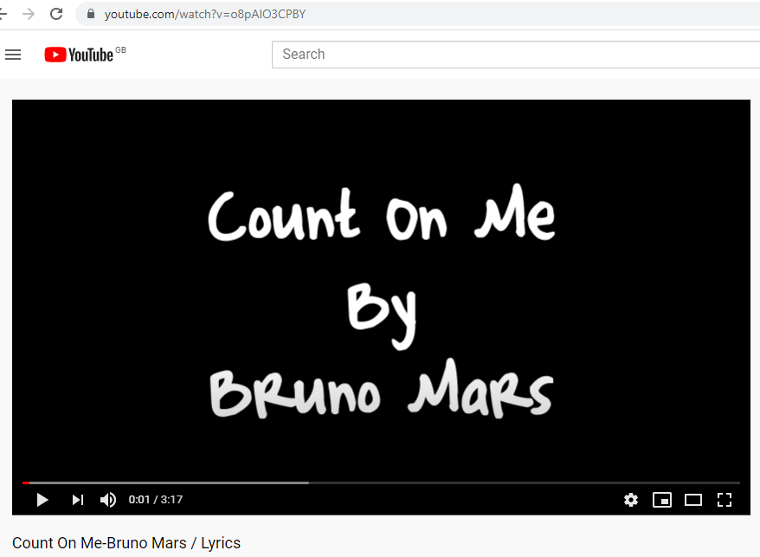
You will all have heard this song earlier in the year. Do you remember it?

“Which of the following can you hear?”
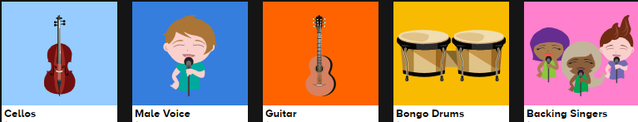
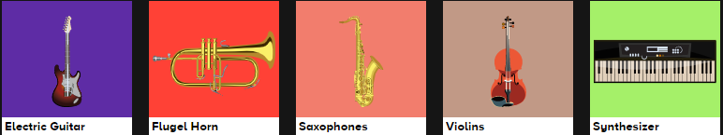
Listen to the song and name the instruments/voices that you can hear.

The answer to the question is: male voice, backing voices, guitar, bongo drums, violins, cellos.
Listen again and see if you can hear them this time.

You can carry out this listening task with any piece of music you like – listen out for familiar instruments.

