Monday 8th June 2020 – English
SPaG
Spellings – Words with a zhuh ending spelt sure

unsure - __________________________________________________________________
leisure - ___________________________________________________________________
measure - _________________________________________________________________
closure - __________________________________________________________________
treasure - _________________________________________________________________
pleasure - _________________________________________________________________
composure - _____________________________________________________________
enclosure - _______________________________________________________________

Look up the meaning of each of these words in a dictionary so you understand what each word means.
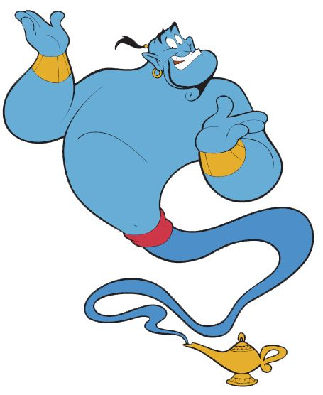
Word of the Day – queasy

Definition ____________________________________________
_____________________________________________________
_____________________________________________________
Used it in a sentence: ____________________________________________________
_________________________________________________________________________
Word Class: ____________________________________________________
Synonyms

English
Today we are going to complete a comprehension on a different type of text - an 'explanation text'. Read the text below and then answer the Viper questions
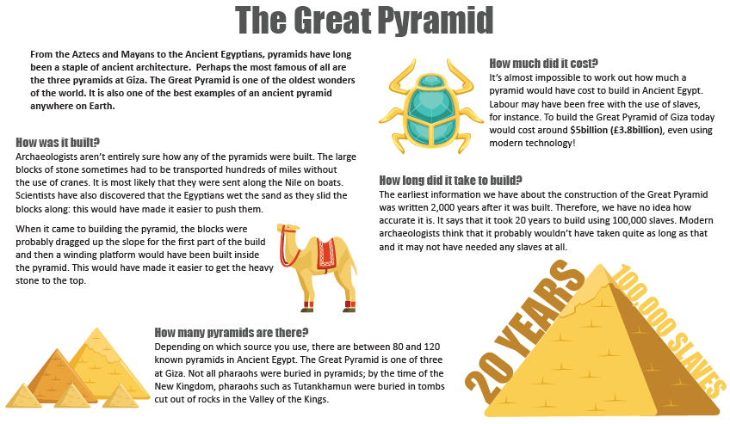

Text Title: The Great Pyramid
MP – What does buried mean?
FC – What does construction mean?
CM – Find a word that tells you that something is important or common.

MP/FC/CM – Why shouldn’t we trust the oldest source of information about the building of the Great Pyramid?
MP/FC – Why don’t you think modern Egyptian kings would be buried in a pyramid?

CM - What do you think impact of modern technology would be if we tried to build a pyramid now?
MP / FC / CM – Explain how the Ancient Egyptians, pyramids have long been a staple of ancient architecture?
MP – How much would the Great Pyramid cost to build today?
FC – If the old stories are true, how many slaves did it take to build the Great Pyramid?
CM – What did the Egyptians do that made it easier to push the blocks of stone?

MP / FC / CM – What had to happen once the stone blocks had been transported along the Nile?

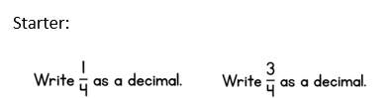
Maths

Main Lesson
Watch this video to remind yourself about money. https://www.bbc.co.uk/bitesize/clips/zk487ty
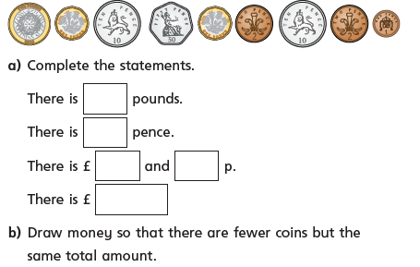
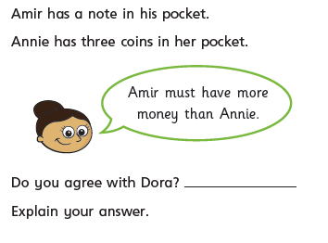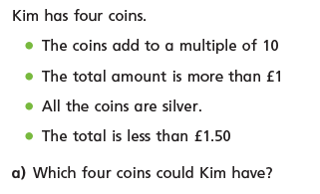

PSHCE (the world around us)
On Saturday 30th May 2020 Elon Musk’s space exploration company, SpaceX launched a new rocket into Space. It's the first time that Nasa astronauts have been sent to space on a rocket owned by the private company, SpaceX. Now Nasa will use SpaceX as a 'taxi' service to send people into space, rather than using their own rockets and if you have lots of money you can even pay to be a passenger!
You can find out more and even watch the launch on cbbc news round: https://www.bbc.co.uk/newsround/52526849
Task: If you were lucky enough to go to into space what would you want to investigate? What would you look forward to most? Write your answers below:
__________________________________________________________________________________
__________________________________________________________________________________
__________________________________________________________________________________
__________________________________________________________________________________
What would you take with you on your journey?
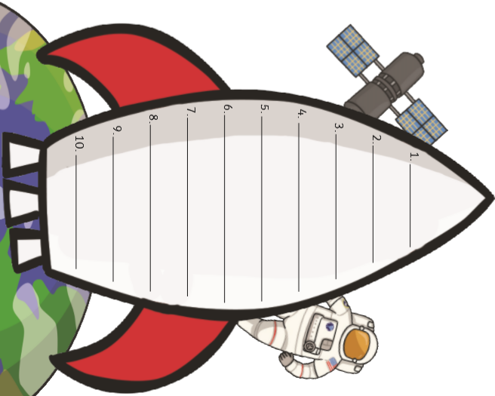

Challenge: The rocket separates several times after its launch, why is this?
What are the different parts called?

