APRIL NEWSLETTER
April 2022
Dear Parents/Carers,
Welcome to our April newsletter and to the very busy, but exciting, summer term at Russell! These newsletters are sent out on a monthly basis to keep you informed about what is happening in school. If you ever want to contribute an ‘article’ or suggest information that should be on the newsletters, I would be delighted to hear about them.
Please note events that are underlined and in italics are new since the previous newsletter.
Friday 29th April – Year 4 children and staff return from Condover Residential trip
Tuesday 3rd May – Back to school after the bank holiday on Monday, PTA sunflower seeds begin to come home and competition begins this week
Wednesday 4th May – 6:30pm, NHS Improving sleep workshop for parents
Tuesday 10th May – Year 4 Bikeability sessions (more info to follow)
Wednesday 11th May – Year 4 Bikeability sessions (more info to follow), Year 3 Celtic Harmony Trip (more info to follow)
Thursday 12th May – Year 4 Cricket festival, Foundation Stage height and weight with school nursing team, 7:30pm PTA meeting
Friday 13th May – Class Photos, deadline for Alameda friendship forms to be back
Monday 16th May – Year 2 assessment week, Foundation Stage Vision Screening
Wednesday 18th May – Foundation Stage Visit to Ampthill Library
Tuesday 24th May – Greenfinch Class to Roald Dahl Museum
Wednesday 25th May – Penguin and Robin Classes to the Roald Dahl museum
Thursday 26th May – Foundation Stage Pirate Day – more information to follow
Friday 27th May – Queen’s Platinum Jubilee Celebrations in school

Half term holiday 30/5 – 3/6 – Premier holiday camp running

Monday 6th June – Year 1 (and some Year 2) Phonics assessment week, National Fieldwork week (Geography) (NO INSET DAY)
Friday 10th June – Quad kids athletics festival for Year 4
Tuesday, Wednesday and Thursday 14th – 16th June, Alameda Class visits after school with parents (more information to follow)
Wednesday 15th June – Greenfinch and Penguin Class to Marston Vale
Thursday 16th June – Robins to Marston Vale, Y3 tennis festival, New Intake Meeting for parents of September 2022 entry children at 6:30pm
Monday 20th June – Friendship letter home for Year 2 and Year 3 children (these two year groups will be the only ones where children are ‘mixed’ into new classes for the following year
Tuesday 21st June – History off the Page visit Year 1
Friday 24th June – Year 2 and 3 friendship letter deadlines
Tuesday 28th June – Big Concert at Russell day (more information to follow)
Wednesday 29th June (am) – Russell Lower School Sports Day Morning, (pm) Ladybirds Sports Day
Thursday 30th June – History off the Page visit Year 1
Monday 4th July – Y2 Cricket festival, 6:30 CLS Governors meeting
Wednesday 6th July – Y3 and 4 girls’ football festival
Friday 8th July – Middle school transition day, Class swap at Russell day, stay and play sessions for new Foundation Stage 2022
Saturday 9th July – PTA Inflatable fun day (more details to follow)
Monday 11th July – 6:30pm Full Governors meeting
Tuesday 12th July – 2:30pm and 6pm – Year 4 performance to parents (tickets and more information to follow)
Wednesday 13th July – Foundation Stage Visit to Herrings Green Farm, Alameda meet the tutor night
Thursday 14th July – 2:30pm and 6pm – Year 1 performance to parents (tickets and more information to follow)
Friday 15th July – End of year school reports home to all
Monday 18th July – 2:30pm onwards – Open afternoon – parents invited in to see children’s books/work and classrooms, parents may take children home when they have finished
Tuesday 19th July – 9:15am Year 4 Leavers’ Assembly (with parents), 1:15 – 3:30pm Year 4 Leavers’ Party (no parents)
Thursday 21st July – last day of school – Break up for summer

Friday 22nd July – Friday 2nd September – Summer holiday – Premier Sports Camps running much of the holiday (Thursday 1st and Friday 2nd September are INSET days)

Monday 5th September – All children (Y1 to 4) back at school, new Foundation Stage children will start later. Home visits continue

More detailed information on the above events will follow in due course
Covid Update:
So far so good – I daren’t even say the word! There are only very low instances of Covid currently in school amongst both staff and children. Long may it continue and thank you so much for your support!

Paperless medical notifications:
Please note that we have now moved to completely paperless medication administration notifications and first aid, or ‘bump’, notes. These will arrive via email. Please do keep your email details up to date in the school office or you may miss important information. Please be assured that for any more significant incidents we will always still call home too. Over the next few weeks, we will also send home data checking sheets so that you can confirm all your details are up to date. Thank you for your support.

Pupil absence:
Thank you for your support in using our preferred method of reporting pupil absence: an email to pupilabsence@russell-lower.co.uk
This is working really well and we now receive the majority of notifications this way (which saves us a lot of time). Thank you again.

Summer term learning:
To help you know what your child is learning about this term, we recently sent home:
1) Summer Theme Webs to show key learning in all subjects
2) Summer Learning Logs to show key learning activities which can be undertaken at home to support, supplement and enhance the learning opportunities at school
These are also on the website, under the curriculum tab, and then the correct year group.
Although we do not require formal homework to be completed at home at Russell, very importantly, we DO ask that you support your child to read to you, aiming for around 4 times a week for about 10 minutes each time please (which should be recorded in the reading diary please) and support them to practice other home learning tasks such as: weekly spellings, Doodle Maths, Phonics and Sight Words, TTRS etc. This is because evidence shows that teaching at school, supplemented with 'little and often' practice at home is the absolute best way to secure progress in key knowledge. At this age, this is fundamental to a child's confidence and future ability to access the curriculum and learning. Thank you in advance for all your support from home.
The website can also provide you with so much more information. Please do have a look. https://www.russell-lower.co.uk/website/curriculum_learning__send/543710
Thank you again. We look forward to working in partnership with you during this term.

Year 4 walking to and from school unaccompanied:
It is wonderful to see our Year 4 children behaving so responsibly when coming to and from school. They are really growing in confidence and maturity! No doubt, the Condover trip will have further accelerated this process too. Please can all Year 4 parents ensure that their contact details and latest walking arrangements are always up to date in the school office. This helps us if we should need to contact you. Thank you again.

Parking, traffic and kindness:
The roads around schools are always very busy, particularly at the start and end of the day. This can make it a stressful and dangerous time too. Please ensure that our Year 4 children who are walking alone are alert to these dangers and have strategies to protect themselves from risks. In addition, can I please ask everyone to park legally and respectfully. All road users are equally entitled to use the areas around the school so can I please request that if you need to speak to someone else about their road use, parking etc. that you do this calmly and respectfully too. Thank you in advance for your support. The well-being and safety of our entire community is absolutely paramount.

September 2022:
Thank you for spreading the message about Russell Lower School in the local community. We are full again for September, with 90 applications for school places in our new Foundation Stage, and we even have a waiting list in 4 different year groups now! Thank you for your total support and commitment. We really appreciate it.

The Big Walk and Wheel:
Thank you for supporting us with our ‘Big Pedal’ recently. You will be delighted to know we came 1st in CBC for active travel and 19th in the country! An amazing achievement – thank you.

PTA:
A big thank you to the PTA for providing all the children with an Easter Hunt treat on the last day of term. This was really kind and generous – thank you. Thanks again goes to the PTA for organising some brilliant events in the Easter holidays: The Eco-friendly challenge and the Easter trails were inspiring. A lot of fun was had by everyone!
The PTA’s next projects include, a makeover of Nathan’s Garden as you will have seen from a recent email, and Year 2 of the now infamous Sunflower Growing Competition. Watch out for more news soon!

Being prepared for any weather:
Can we please ask you to ensure that your child has a named water bottle and a raincoat in school every day? The weather changes very quickly and we do want to always be able to get the children outside. When the weather is sunny and warm, could you please provide a hat? Ideally, we would prefer your child to wear a ‘peaked’ sun hat rather than sun glasses as these are easily dropped, lost and broken. If your child brings sun cream to school, can you please show them how to use and apply it as we are not able to do this for them? Please remember to check your product does not contain any nut oils.
Can we also ask that all children have plimsolls or trainers with them at all times – again, we want to be able to get outside as much as possible in PE too. Thank you for your support.

Term Dates 22/23: (NEXT academic year):
Please find attached the term dates for NEXT academic year. These can also be found on the school website:
https://www.russell-lower.co.uk/website/term_dates/180

Nut allergies:
Recently, we wrote to you with an update about sunscreen and nut allergies – thank you so much for your support with this. Please find a reminder of the update below.

Sunscreen update
We have been informed that the new look Nivea Sunscreen now contains Almond Oil. Due to us having both children and staff with severe nut allergies, we kindly request that you avoid this particular sunscreen, including where it is applied before school. Thank you.
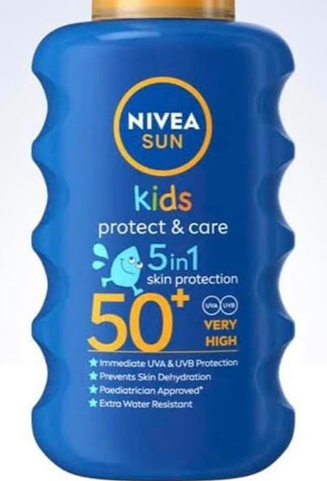

Queen’s Platinum Jubilee:
To celebrate our Queen’s truly incredible achievement of 70 years’ reign, we are planning to hold a day of celebrations on Friday 27th May at Russell Lower School. Lots of exciting (and highly secret!) plans are afoot already.
Please see below and attached for details of Ampthill’s community celebrations:

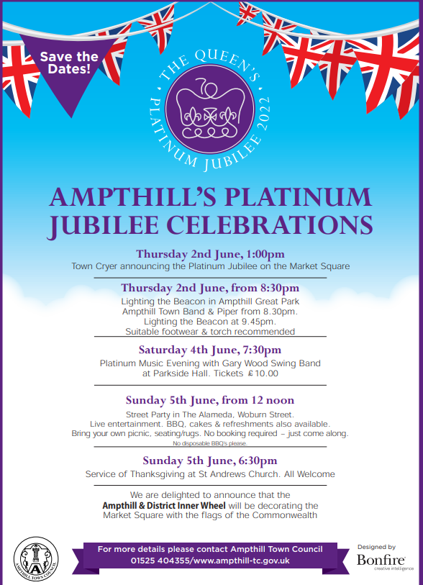
Keech Hospice:
Keech Hospice Care is a charity which supports adults from Luton and South Bedfordshire, and children from Bedfordshire, Hertfordshire and Milton Keynes, who have life-limiting illnesses. They are unique as they are one of the few hospices in the UK which provides care for both adults and children.
They are a charity, relying on their supporters for around 70% of their funding. This means they need to raise over £6 million every year (over £16,000 every day!) to continue their specialist care for adults and children, and their families. They are enormously grateful for whatever you can do or give.
After a very difficult 2 years for Keech, they are delighted to be holding their Colour Dash Family Fun 5K on Sunday 17 July 2022 at the Luton Regional Recreation Ground, St. Thomas’s Road, Luton, LU2 7UX. If you think you could join in to raise funds, please visit https://www.keech.org.uk/whats-on/colour-dash/ for more information. Thank you in advance.

And finally
Thank you for taking the time to read this newsletter. Have a lovely bank holiday weekend.
Many thanks and kind regards,
Nicki Walker
Headteacher

