Russell Lower School - Pupil Premium Executive summary 2021- 22
Intent and Implementation:

At Russell Lower School as of 2021-2022 we have adopted the RADY (raising the attainment of disadvantaged youngsters) approach. It is our intent to:
raise expectations;
raise awareness;
raise aspirations;

in order to close gaps between our disadvantaged pupils and their non-disadvantaged peers both in terms of attainment and holistic opportunities and experiences through focusing on equity not equality.

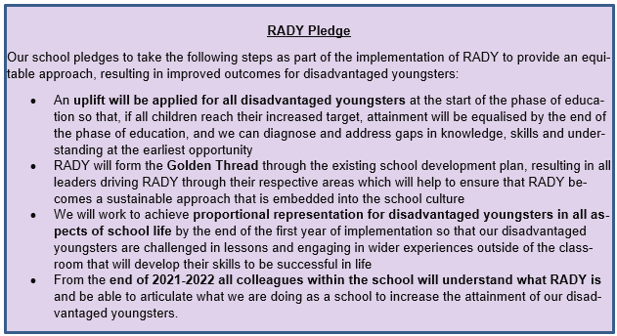

Research states that disadvantaged pupils have been disproportionately affected by the pandemic. In order to address this our strategy is integral to wider school plans and our SDP ‘golden threads’ for whole school improvement and education recovery:

Golden Threads 2021/22:
- ‘Visible consistencies’ - good teaching everywhere by staff who care
- Broad, balanced, ambitious coherently sequenced curriculum
- Inclusive – QFT - everything taking place in the classroom wherever possible
- Disadvantaged children’s needs addressed first
- Know our children well and plan to meet social, emotional and academic needs
- Good health (mental and physical) and well-being for all the community through the primacy of relationships
- High expectations of what children can know, do and understand: attainment, progress and behaviour
- Oracy and vocabulary at the heart of everything through active adult interactions
- Team around the child: school, home, community

We understand that by developing evidence-based practices (which we have been focussing on for several years now) that support our disadvantaged pupils we will also be enhancing staff skills and provisions for all pupils.

At Russell Lower high-quality teaching is at the heart of everything we do, with a focus on areas in which disadvantaged pupils require the most support. This is proven to have the greatest impact on closing the disadvantage attainment gap and at the same time will benefit the non-disadvantaged pupils in our school.

We also continue to make use of targeted support through the National Tutoring Programme for pupils whose education has been worst affected, including non-disadvantaged pupils with us making use of Tuition Partners (Third Space maths) and school led tutoring.

We believe accurate early identification of need and knowing our pupils well is key in supporting our disadvantaged pupils to make good progress and achieve high attainment in all subject areas. For this reason, teachers carry out PP passports within the first two weeks of pupils returning to school and appropriate support/provisions are identified and set up by the end of the third week back in September.

We also believe engagement of our PP/vulnerable families is key and continue to develop our communication with these families whilst being mindful to protect these families from any kind of stigmatisation or stereotyping. We invite them to contribute (via Your thoughts questionnaire) to influence the provision their children receive so that it has the greatest impact on raising attainment.

Through robust diagnostic assessment carried out by Phase Leaders, the Inclusion Lead (PP lead), the Deputy Head (PP strategy lead) and the Headteacher supported by LSAs and class teachers during half termly PP meetings/Pupil Progress Meetings (PPMs) we are able to ensure our approach to supporting our disadvantaged pupils is responsive to common challenges and individual needs.

Impact: (July 2021 and Autumn term 2021/22)
- During the academic year 2020/21, we successfully narrowed the gap for our PP children in all 3 core subject areas
- PP children are known well by all staff
- PP children attend well – above the NA for PP children
- PP children are a high priority in school in all areas
- Golden thread are woven through the SDP to enable consistency and best practice across the school
- The RADY project has begun in Year 4 during 2021/22 and the school is now working with Challenging Education
- A LA Deep Dive into PP returned a ‘good judgement’ in October 2021
- Interventions target PP children first and are having at least the expected impact, and often more than expected

Historically | End of last year 2020-2021 | 2021-2022
Data taken from whole school summary for summer 2019  - By the end of 2018-2019 we were successfully narrowing attainment gaps (this was being measured as PP against all)  - Reading -7%  - Writing -14%  - Maths -14% | All data taken from PP tracking/attainment and progress document  - By the end of 2020-2021 attainment gaps between PP and ‘other’ pupils were  - Reading -17%  - Writing -22%  - Maths -18%  - During 2020-2021 the attainment gaps between PP and other children reduced in R, W, M from Autumn to Summer  Non PP ARE+ PP ARE+ Gap Aut Gap Sum Gap narrowed by  Reading 69 78 51 61 -18 -17 1%  Writing 68 66 38 44 -30 -22 8%  Maths 63 73 41 55 -22 -18 4%  - Attainment gaps for PP children when comparing June 2019 and June 2021 are as follows (this is for significantly different group of PP children):  - R: gap narrowed by 7%  - W: gap increase by 15%  - M: gap increase of 4%  Attainment comparison from June 19 to June 21 (this is for significantly different group of PP children):  June 2019 June 2021 Difference  PP ARE+ PP ARE+  Reading 80% 61% -19%  Writing 65% 44% -21%  maths 68% 55% -13%  - Our disadvantaged pupils made more progress than ‘other’ pupils in years 2 and 4 for R, W and M.  Non PP Exp+ PP Exp+ Yr2 Yr4  Reading 63 74% Y2, 82% Y4 48 80% Y2, 85% Y4 +6% +3%  Writing 61 72% Y2, 81% Y4 48 100% Y2, 85% Y4 +28% +45  Maths 55 79% Y2 66% Y4 59 100% Y2 and 100% Y4 +21% +34% | Results Autumn 2021 taken from PPMs/classroom monitor  PP ARE+ Non PP Gap PP Exc SEND Gap  Reading 48 79 -31% 64 -16%  Writing 39 78 -39% 54 -15%  Maths 49 82 -33% 57 -8%  Focus on improving QFT in maths through training with BEST academy.  Whole school introduction of RADY (raising the attainment of disadvantaged youngsters). Year to focus on year 4.
- Historically PP numbers at RLS have remained fairly static. | - Over 2020-2021 we saw a 38% increase in PP pupils from 31 to 43  - We have seen an 11% increase in PP pupils also being on the SEN register since 2018-2019 from 19% to 30% | Inclusion Lead to take over operational side of PP strategy to ensure a consistent approach in supporting our disadvantaged children.
- National Average whole school attendance for Autumn 19/20 was 92.4%  - NA whole school Autumn 2020-2021 was 95% | - Whole school attendance remained high at 97.93%  - PP attendance 96.83 higher than whole school NA | Continual monitoring of attendance by DHT/HT. Appropriate support offered by DHT/HT/IL
- Use of limited research based interventions/provisions - SO used as reading and writing intervention | - Summer provisions for PP had an average of +0.08 impact. Indicating they were having a more positive impact than expected, this is higher than previous years.  - Continuation of SO with more members of staff  - 2 LSAs undertook Talk for All course - Lift off to Language  - Introduction of Third Space maths and Doodle Maths (year 1) | - Completing of RLS provision document  - EYFS NELI training  - Continued use of NTP support: KS2 Reading fluency training, Third Space Maths  - Doodle Maths to be used across KS1

