Tuesday 21st April 2020
SPaG
Spellings - The prefix im before a root word starting with m or p
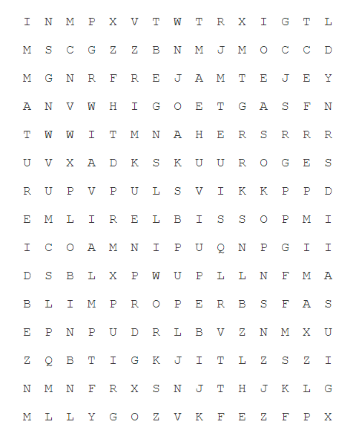

Find your spellings in the grid opposite.

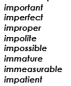

Word of the Day – anticipate

Definition ____________________________________________
_____________________________________________________
_____________________________________________________
Used it in a sentence: ____________________________________________________
_________________________________________________________________________
Word Class: ____________________________________________________
Synonyms

English
Sky Explorer’s Log
Have a look at the sky explorer’s log on the next page. Can you write your own version of a sky explorer’s log and explain what happened when you saw something in the sky that you didn’t expect? Perhaps it was a sky elephant or an air orca?
Things to Consider
Tell the reader how you felt - what happened to you? Use your senses - say what you saw, smelled, heard.
Think about your openers - are they exciting? Could you use a verb or an adverb? Remember DADWAVERS!
Add a question to pose to the reader. It makes them think!
Can you use language swaps to include better vocabulary? Use a thesaurus to help! If you don’t have one remember you can use an online thesaurus.

Sky Explorer’s Log

Date: Monday 4th September 2089
Location: 36,500” above the Pacific Ocean

A couple of hours ago, I heard the strangest noise. It was like singing, but incredibly high pitched and like nothing I have ever heard before. My heartbeat and breathing quickened, and I reached for my trusty telescope, which confirmed that I hadn’t imagined it. There, at the portside, appeared a bale of sky turtles! It was amazing!
All around the ship, they glided majestically, like giant lily pads floating on still water. Their calming scent of salt water filled my nostrils. This was exactly why I took this job, to see such wondrous and beautiful beasts. Who knew that they even existed?! Cautiously and carefully, with trembling fingers, I lassoed a rope around one of their shells, with the intention to let them guide me to land more quickly.
Then, in an instant, my excitement was brought to an abrupt halt. The rope snapped! Not only did I worry I would become stranded, but I also feared that I was going to miss out on accompanying these mystical creatures for part of their journey…

We will speak again later!

Maths – Mental
- 345 x 3 =
- 640 x 2 =
- What is the value of the 3 in 6349?
- ½ + ½ =
- How many minutes in a quarter of an hour?
- How many sides has a pentagon?
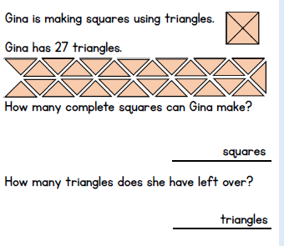

- 14 x 7 =
- Write the next 3 numbers in the sequence: 0.1, 0.3, 0.5,
- 624 – 415 =

Maths – Decimals
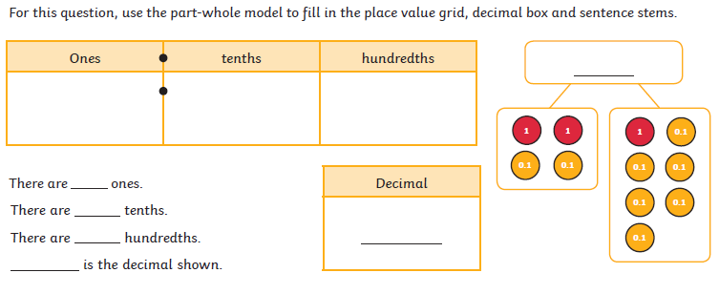

Geography
You will need an atlas or access to an online map.
You now know a little about the geography of Egypt. Use this knowledge to label a map of Egypt. You don’t need to print this page, you could draw your own sketch using an atlas or map to help you.
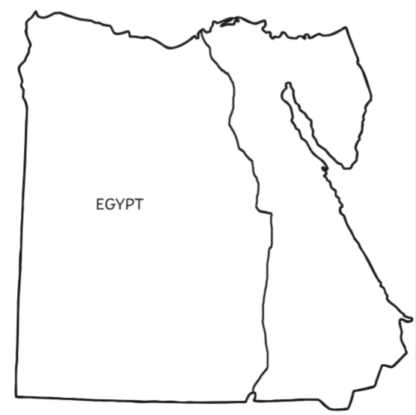

Can you label Luxor, Cairo, the Nile, Mediterranean Sea, red sea, Aswan, Giza.
Challenge: can you make a key for the airports, pyramids and the capital city?

