Monday 30th March 2020 – English

SPaG

Spellings - Word Families based on common words, showing how words are related in form and meaning.

sign - _____________________________________________________________________

design - ___________________________________________________________________

assign - ___________________________________________________________________

signature - ________________________________________________________________

solve - ____________________________________________________________________

dissolve - __________________________________________________________________

solution - __________________________________________________________________

insolation - ________________________________________________________________

Look up the meaning of each of these words in a dictionary so you understand what each word means.



Word of the Day – **ancestor**

**Definition ____________________________________________**

**_____________________________________________________**

_____________________________________________________

**Used it in a sentence: ____________________________________________________**

**_________________________________________________________________________**

**Word Class: ____________________________________________________**

**Synonyms**

**English**

Before you watch the clip called ‘Once in a Lifetime’ can you predict what is might be about?

_________________________________________________________________________________________________________________________________________________________________________________________________________________________________

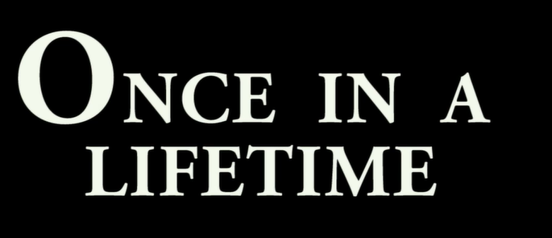

**The short animation can be found on -** <https://vimeo.com/23805703>

After you have watched the animation answer the following question:

Where do you think the turtle will take him? _______________________________

__________________________________________________________________________

**__________________________________________________________________________**

**__________________________________________________________________________**

**__________________________________________________________________________**

What type of story do you think this is? ______________________________________

___________________________________________________________________________

**___________________________________________________________________________**

**___________________________________________________________________________**

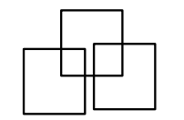**Maths - Mental**

1)How many squares can you count?

2) 7 + 7 + = = 21

3) 642 = 600 + + 2

4) What is the next number? 24, 27, 30, 33,

5) 4 x = 24

6) Write < or > 43 89

7) What is the biggest number you can make from these digits? 2, 8, 4

8) I think of a number, I add 8 to that number. My answer is 17. What number did I think of?

**Maths - Money**

Work out the price of the following bus journeys:

1. To the swimming pool and back.

2. Three tickets to the shopping centre.

3. 8 tickets to the cinema.

4. 10 tickets to school.

5. 2 tickets to the cinema and 2 tickets to school.

Single Bus Fares From My House

School 35p Cinema 50p

Swimming pool £1.20 Shopping Centre £1.30

**History – Romans**

Match each person to their description

