Wednesday 29th April 2020
SPaG
Spellings – To apply the prefix inter-
interact | interactive | intercity | international
intermediate | intermission | interconnect | interrelate

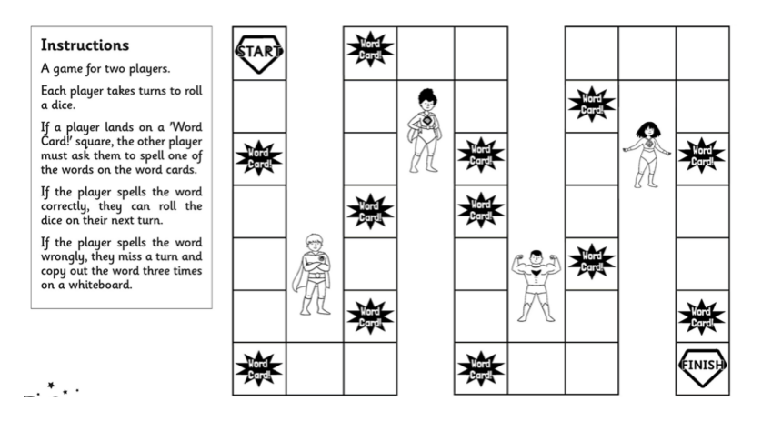
Challenge! Draw this board game out on a piece of paper and play with your grownups at home using this week’s spellings. Good luck!

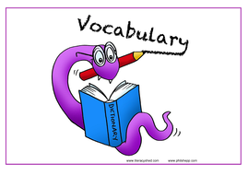
Vocabulary – Word of the Day!
gaze
Definition _______________________________________________
_________________________________________________________
_________________________________________________________
Used it in a sentence: ____________________________________
___________________________________________________________________________
Synonyms: _______________________________________________________________________
English

Today you are going to be looking at vocabulary that captures your interest and imagination as a reader.

Here is a paragraph from the first chapter of the story:

Taller than a house, the Iron Man stood at the top of the cliff, on the very brink, in the darkness. The wind sang through his iron fingers. His great iron head, shaped like a dustbin but as big as a bedroom, slowly turned to the right, slowly turned to the left. His iron ears turned, this way, that way. He was hearing the sea. His eyes, like headlamps, glowed white, then red, then infrared, searching the sea. Never before had the Iron Man seen the sea.

Which phrase do you think is the most interesting? Why?

Challenge!

Identify the different descriptive and figurative language within the paragraph.

Can you locate the nouns, adjectives, verbs and adverbs?

Can you locate a simile and personification?

Choose four phrases and order them from most to least interesting. Explain your decision.
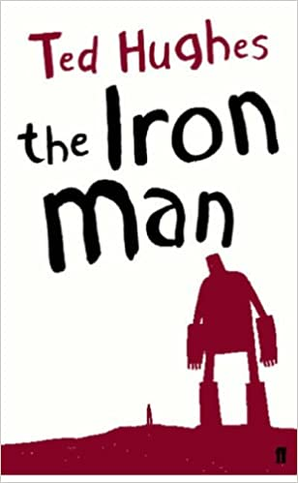

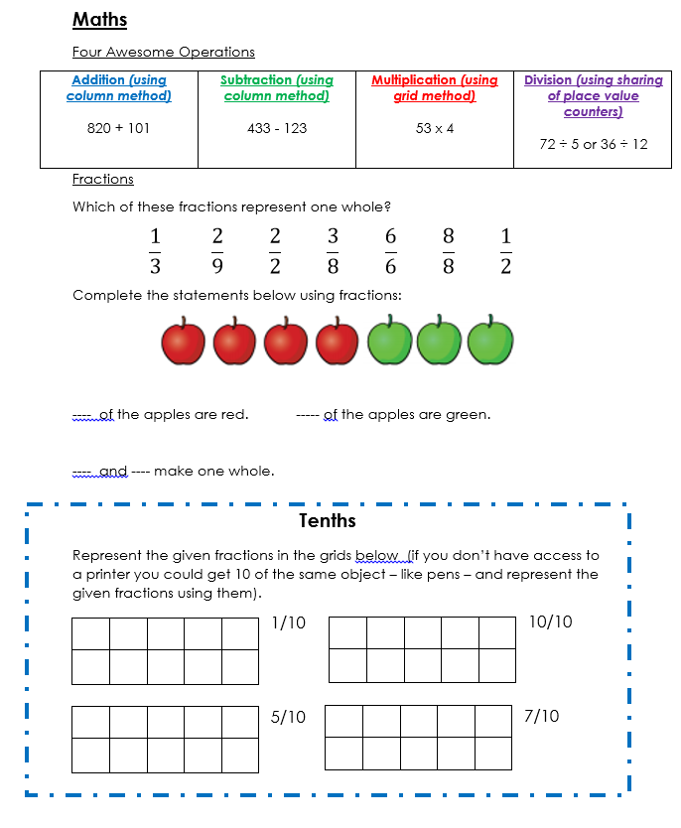
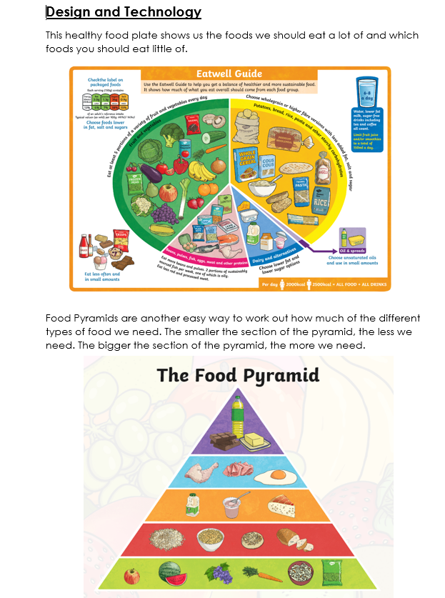
We need to know why each food group is important in keeping us healthy.
Food Group | Example | Why is it important?
Carbohydrates | bread pasta rice potato oats cereal | Carbohydrates are an important source of vitamins and iron. They contain sugars that give us energy. Some carbohydrates, such as wholegrain cereal, give us fibre to keep our digestive systems working properly.
Fruits and Vegetables | onion lettuce carrot banana peas berries | Fruits and vegetables are low in fat and contain natural sugars to give you energy. They contain lots of different vitamins, minerals and antioxidants to keep you healthy.
Proteins | fish beans pulses meat eggs | Protein helps the body to repair itself and to grow. Foods such as meat and fish also provide iron and minerals.  It is important for vegetarians to ensure they get enough protein by replacing meat and fish with eggs, beans, lentils and soya which are all good alternatives.
Dairy products | milk cheese butter yoghurt cream | Dairy products contain lots of calcium which is essential for keeping your bones strong. It also helps to keep your teeth healthy. Dairy products also have some vitamins in and some contain proteins.
Fats and Sugars | Sweets chocolate crisps oil cakes biscuits | Fats and sugars are necessary in a diet but in very small amounts. You can usually get the fats and sugars you need from other food groups. Fats give a fast release of energy and help absorb some vitamins.  Junk food like crisps, sweets, cakes and chocolate might taste nice but they don't have many nutrients in them to help the body and too many can be very unhealthy

Challenge!
Create a poster to show why each food group is important in keeping us healthy. Try to include examples of types of food in each food group.

