Year 2 Phonics/Spelling Practice – Wednesday 17.6.20.
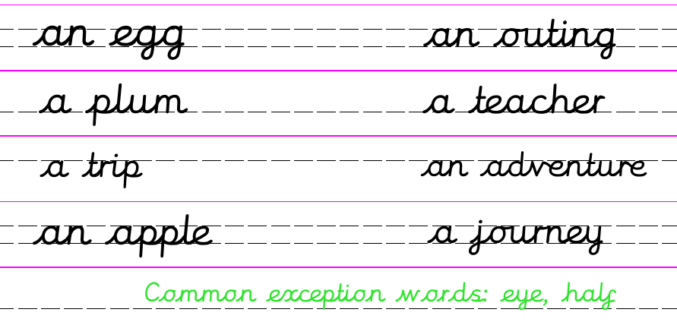
Yesterday we learned an exception to the rule of when to use a or an. Today we will learn another exception. Remember - An exception is when the rule doesn't work...
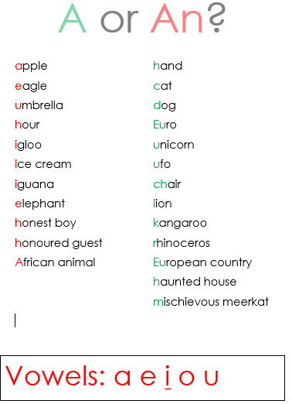
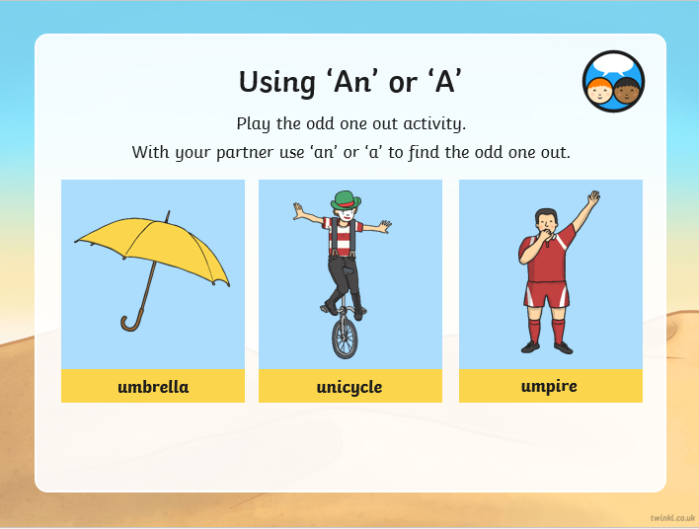
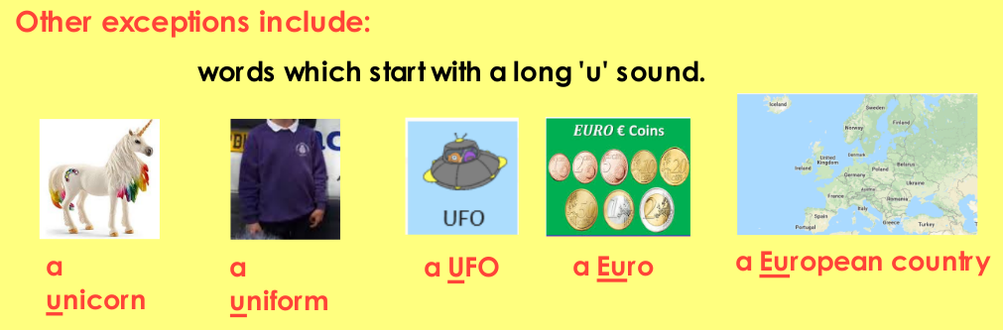
Task/Game: Ask someone to read out the words randomly – can you work out which use ‘a’ and which use ‘an’. Perhaps play this as a game outside – have two bases (one for A and one fo r An) and run to the correct base when you hear a word. Alternatively write down two lists – A and An.
Maths 17.6.20
Find a Half
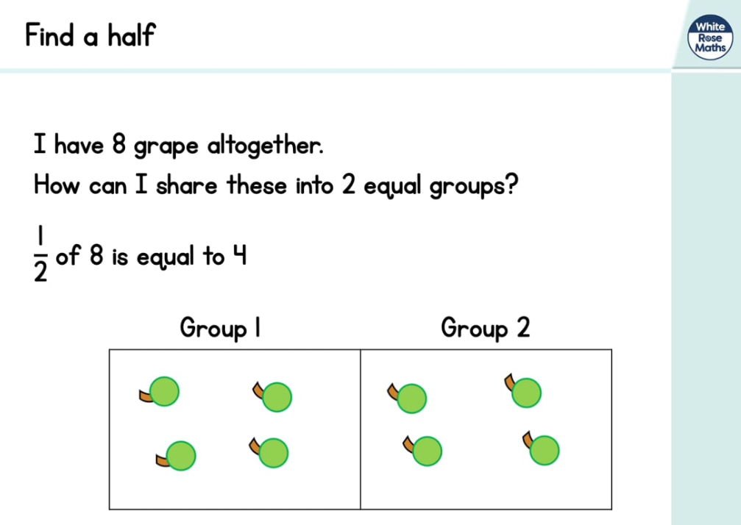
https://whiterosemaths.com/homelearning/year-2/ (Week 7 W/C 8.6.20)
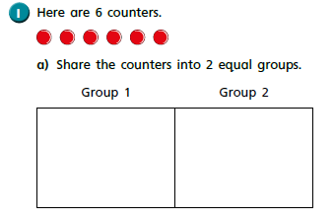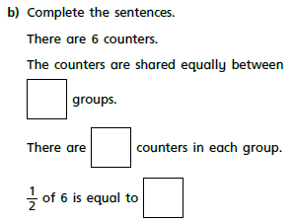
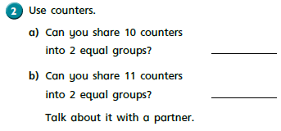
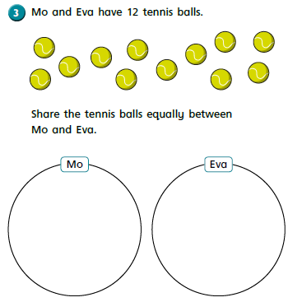

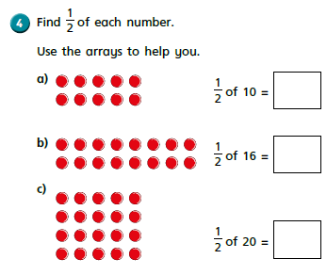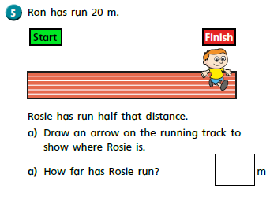
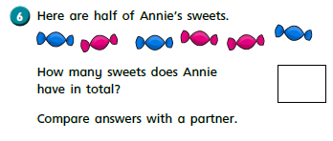
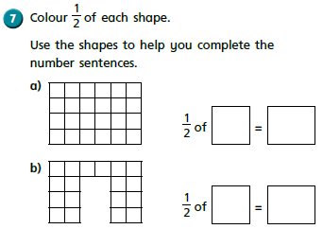

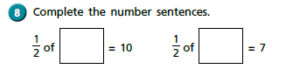

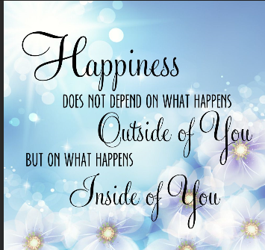
Wednesday 17th June 2020 Word of the day: glorious

WALT use descriptive language to describe a new sweet.

“The sweet-shop of my dreams would be loaded from top to bottom with Sherbet Suckers and Caramel Fudge and Russian Toffee and Sugar Snorters and Butter Gumballs and thousands and thousands of other glorious things like that.”

The sweets that were stocked in ‘The Grubber’ came from Willy Wonka’s Chocolate factory. Today we are going to design a brand new sweet.
It can be any time of sweet you like. How about a Minty Minecraft Montrosity, Sparkly Rainbow Love Laces, Chocalocca, Chewy Chacha Cartwheel Cups, Fizzalizzalemon Gumballs.
How imaginative can you be? Willy Wonka says the wackier and the weirder the better!
Can you name your sweet, describe how it tastes and say what happens when you eat it? Does it make you do silly things? Does it give you super powers?

Have fun……

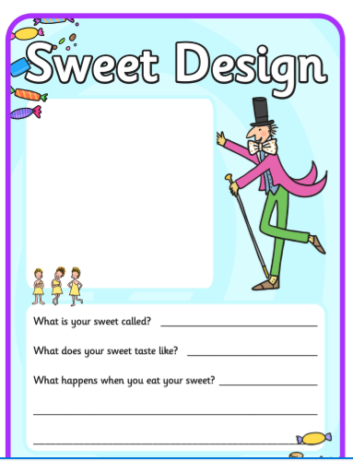

RE 17.6.20
WALT how can we spread the goods that we bring to our Year 3 teacher?

In R.E this term we have been investigating ‘The Good News that Christians believe Jesus brought to the world’. Last week we wrote a card or a letter to a friend sharing some of our good news. I had some lovely news this week, Scarlett in Greenfinch class sent me an email sharing her good news that she was now a big sister! It made my day and she shared some beautiful pictures of baby Lacey Mae.

The Year 2 teachers have all been speaking about all your good news and they agreed it would be lovely if you could share some good news to your new Year 3 teachers. You are their good news for next year!
They are so lucky to have you in their class.

Your task will be to tell them all about yourself. Tell them about your skills and talents; your hobbies, your family and your favourite things to learn at school. Perhaps you could draw a picture or include a photograph of yourself too.

We have told them to expect some ‘good news’ coming their way.

