Year 2 Phonics/Spelling Practice – Monday 29.6.20.
Last week we learned to use the prefix mis- to make words negative.
This week, we will look at another prefix in-.

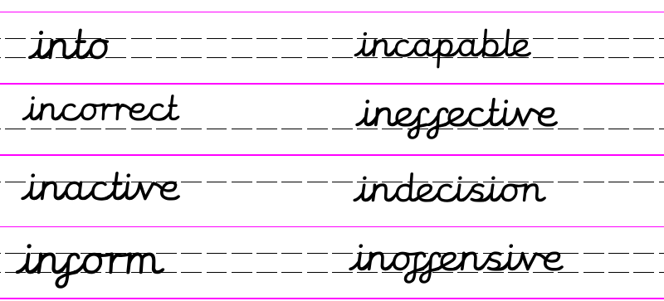
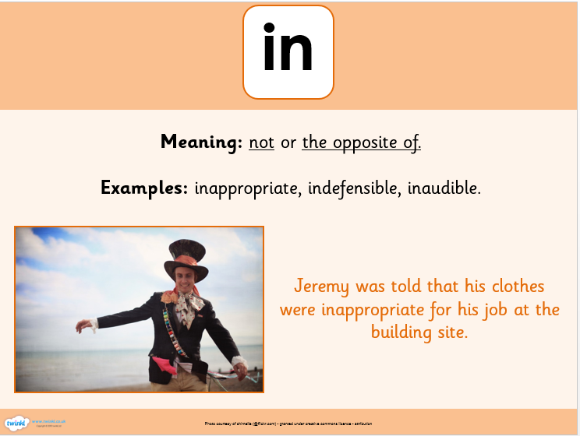
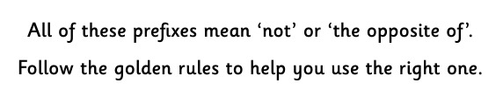
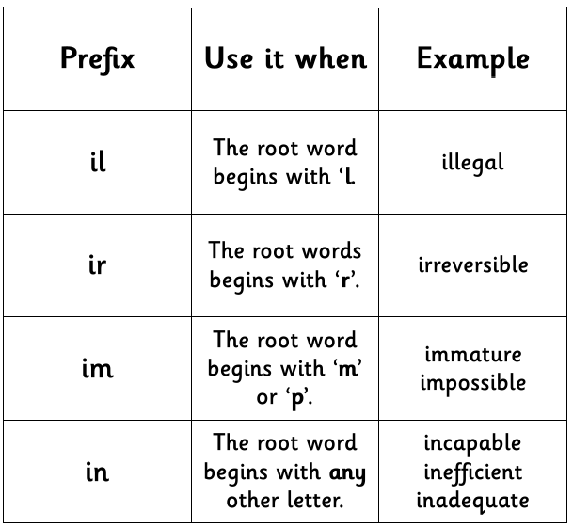
Dictation:
Ask someone to read out the sentence below so that you can write it down – try not to look until after you’ve written it. Check your punctuation and spelling.
The boy went into the incorrect classroom.

Maths 29.6.20
Measure Length (cm)
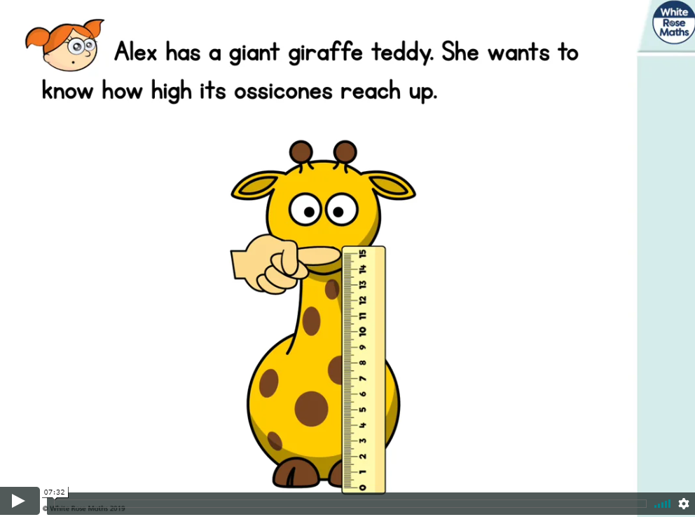
https://whiterosemaths.com/homelearning/year-2/ (Week 9 W/C 22.6.20)
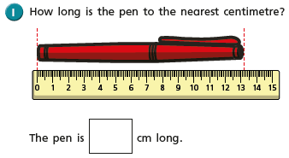
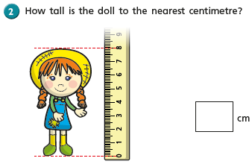
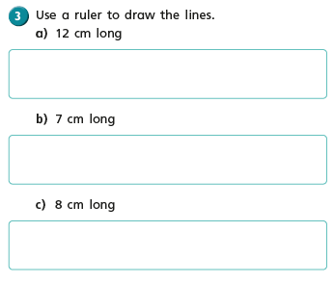
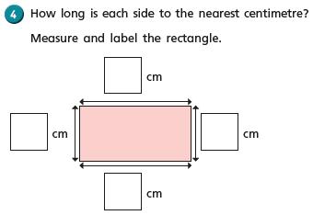
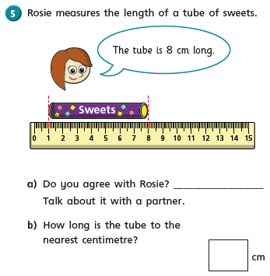
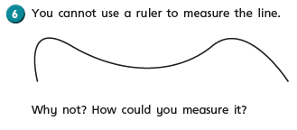

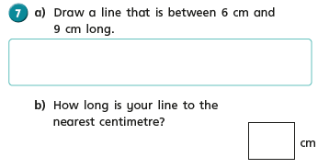
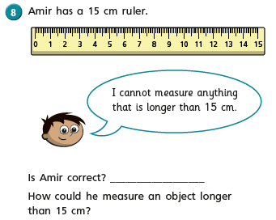
English - Monday 29th June 2020 DON’T FORGET TO WATCH THE LOOM VIDEO ON THE KIDS AREA WHERE I WILL TALK THROUGH THIS WEEK’S LESSON EVERY DAY.
Fact of the day: A pineapple is neither an apple nor a pine. It is, in fact, a large berry!
WALT write a list.
WALT read and respond to a text read.

Good morning, another Monday! I hope you are enjoying ‘The Giraffe, The Pelly and Me’! How did you get on last week with your information texts? I am sure you have now found out lots of amazing facts about giraffe, monkey and pelicans. They are all fascinating creatures aren’t they.

Today we will continue with our story. Who can remember what has happened so far?

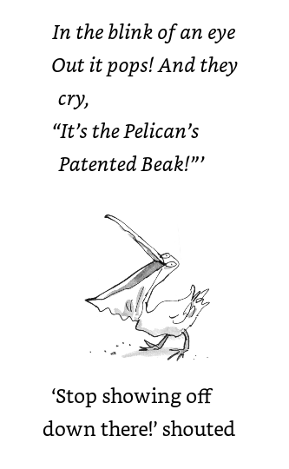

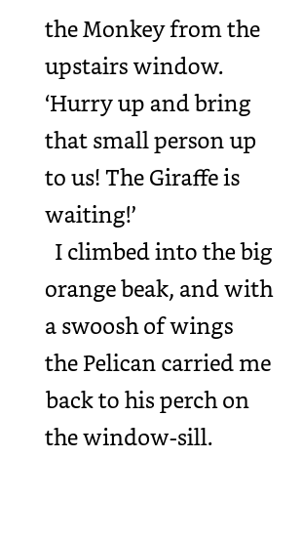
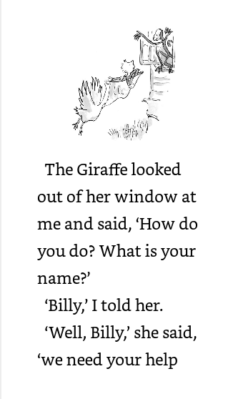

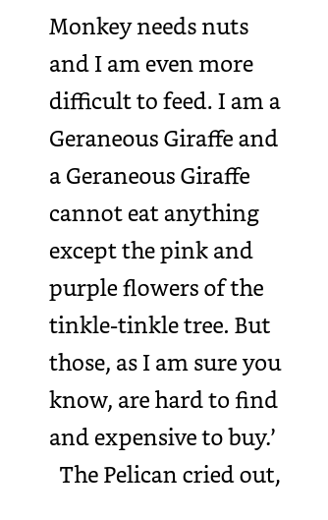
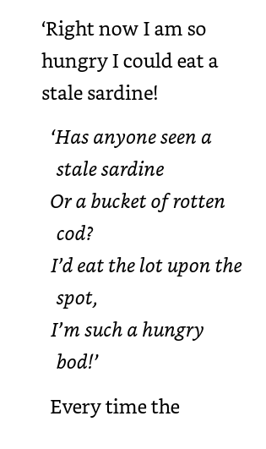

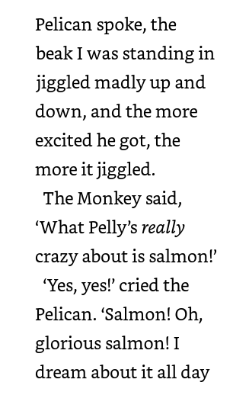
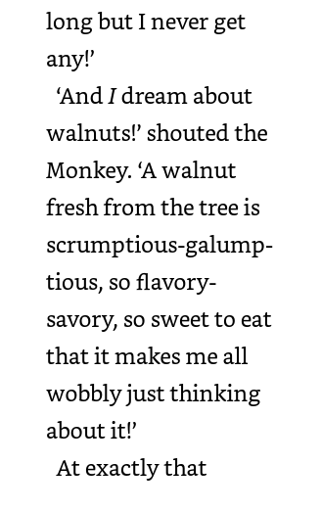
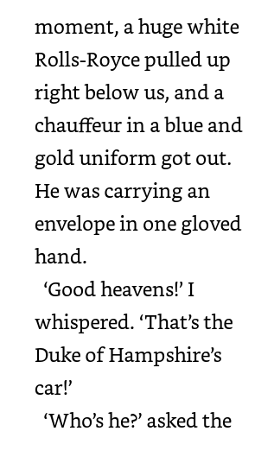
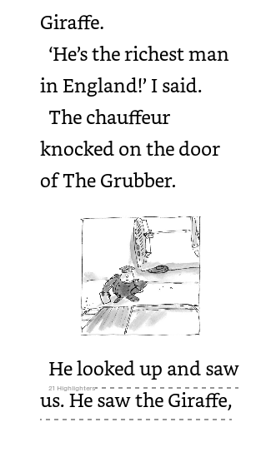
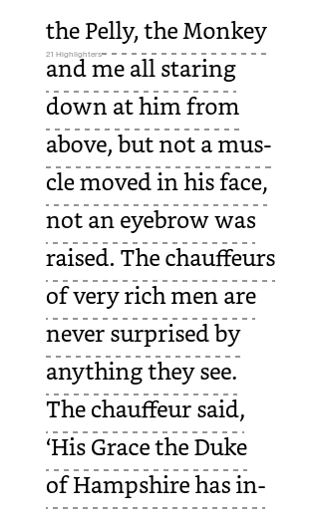
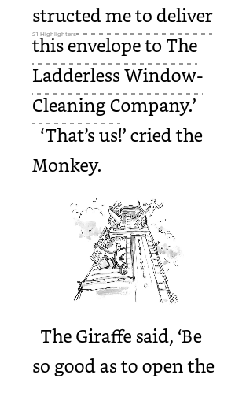
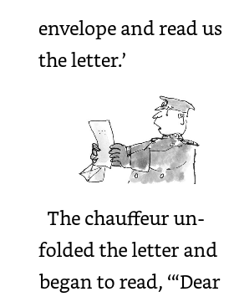

Wow, the story is beginning to get very exciting. I was really worried about the Giraffe, The Pelly and the Monkey. They are really hungry and are desperate to earn some money so they can buy food! I am desperate to know what is in the letter from the Duke of Hampshire! Can you imagine being the richest man in England? What would you spend all your money on? I can’t even begin to imagine; probably some really fancy jewellery, perhaps a brand new car, definitely a huge house, with stables for the new horses I would buy. I would definitely give some money to charity though too.
Your task today is to imagine you are the richest person in England. What would you spend your money on and why?
Challenge me /Feeling confident. NMP
Tell me what you would Write a list of all the things you
spend your money on. would spend your money on. Don’t
Tell me why! forget you need commas in a list.
Don’t forget to use
adjectives, verbs, nouns
and of course expanded noun
phrases.

PSHRE 29.6.20
Session 4 - WALT: understand that there are different forms of media.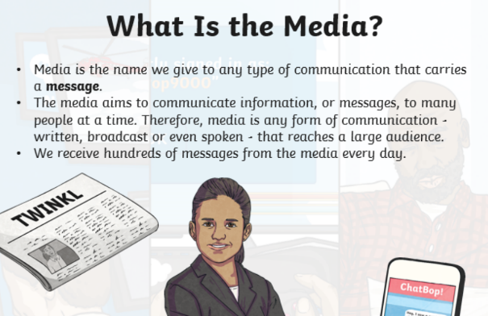

It doesn't reach many people at one time.

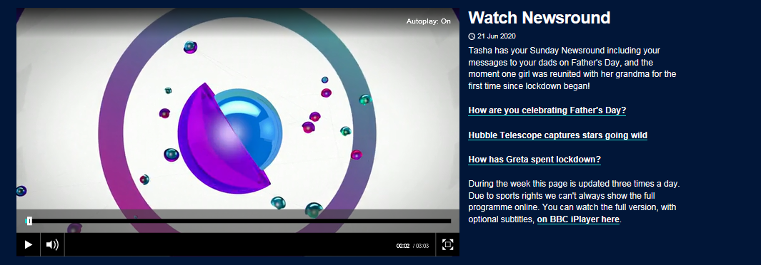
https://www.bbc.co.uk/newsround/news/watch_newsround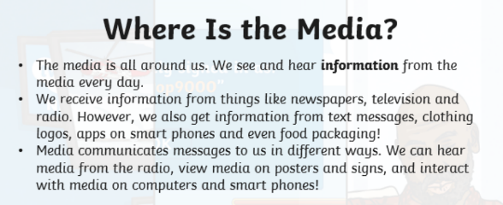
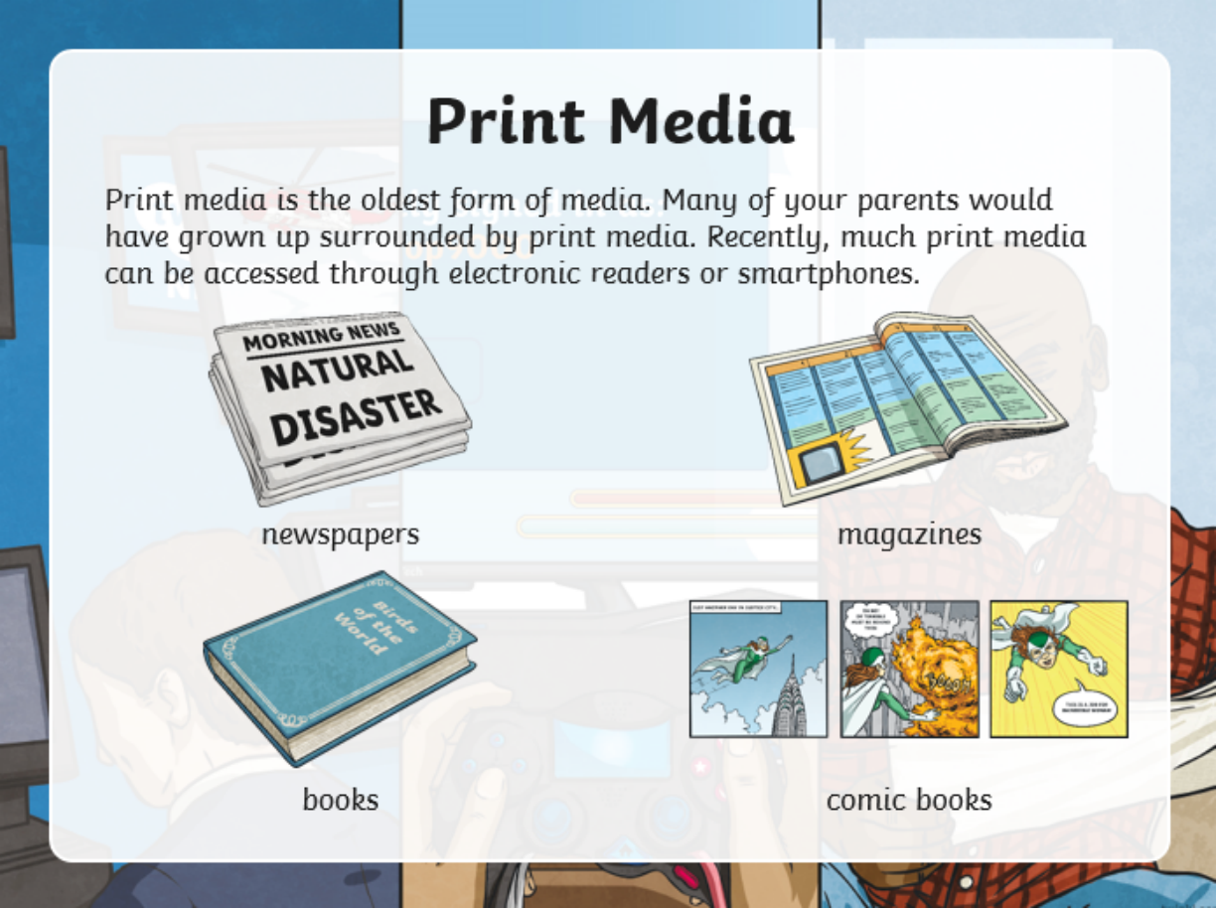
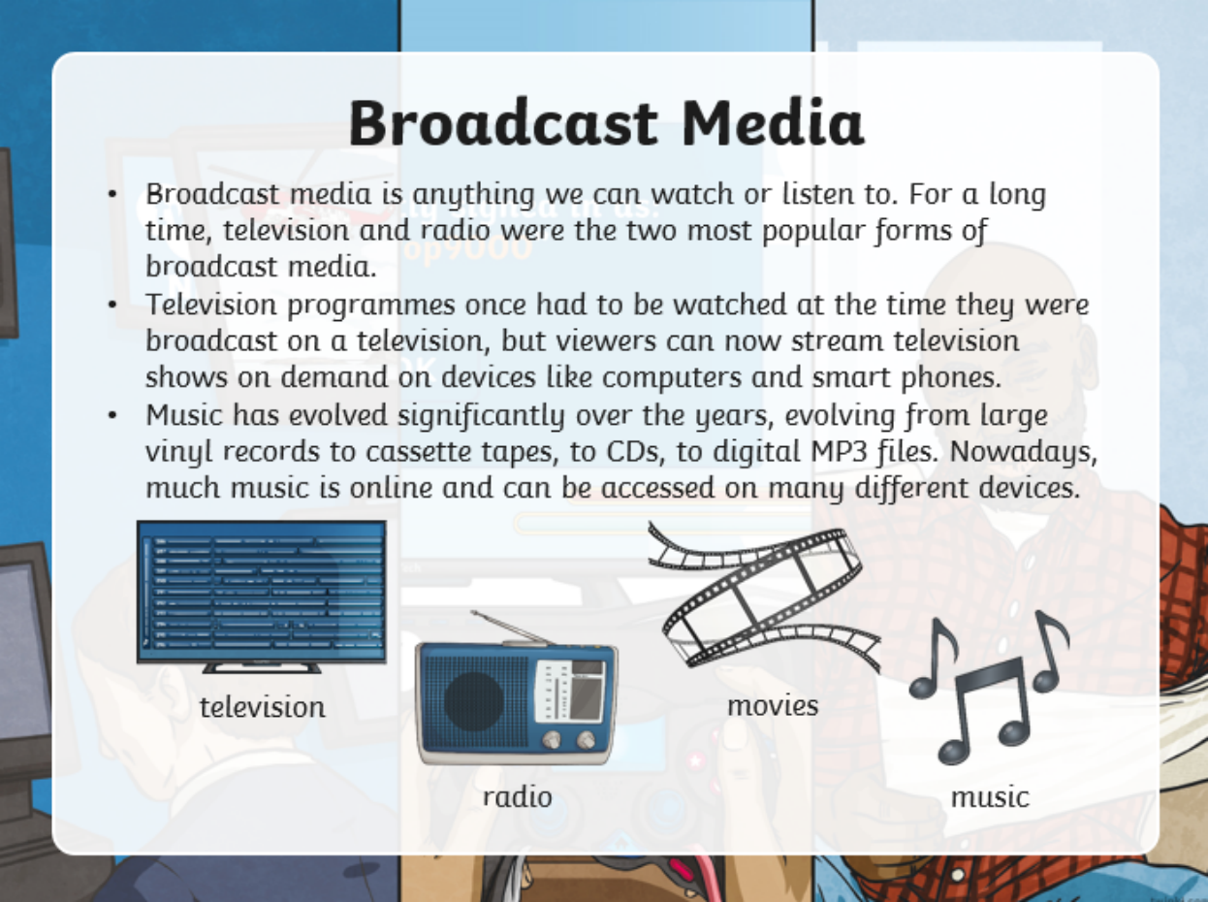
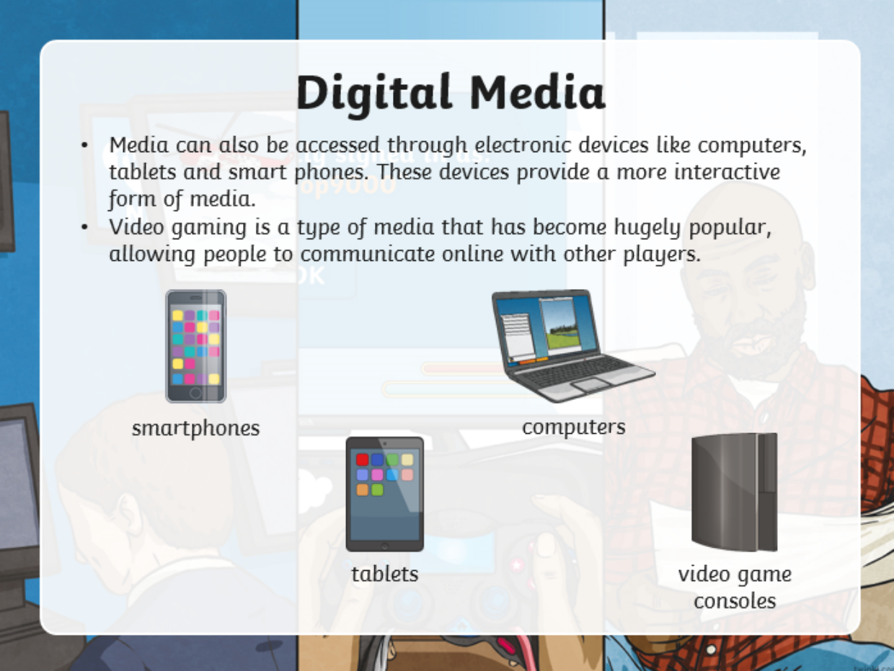
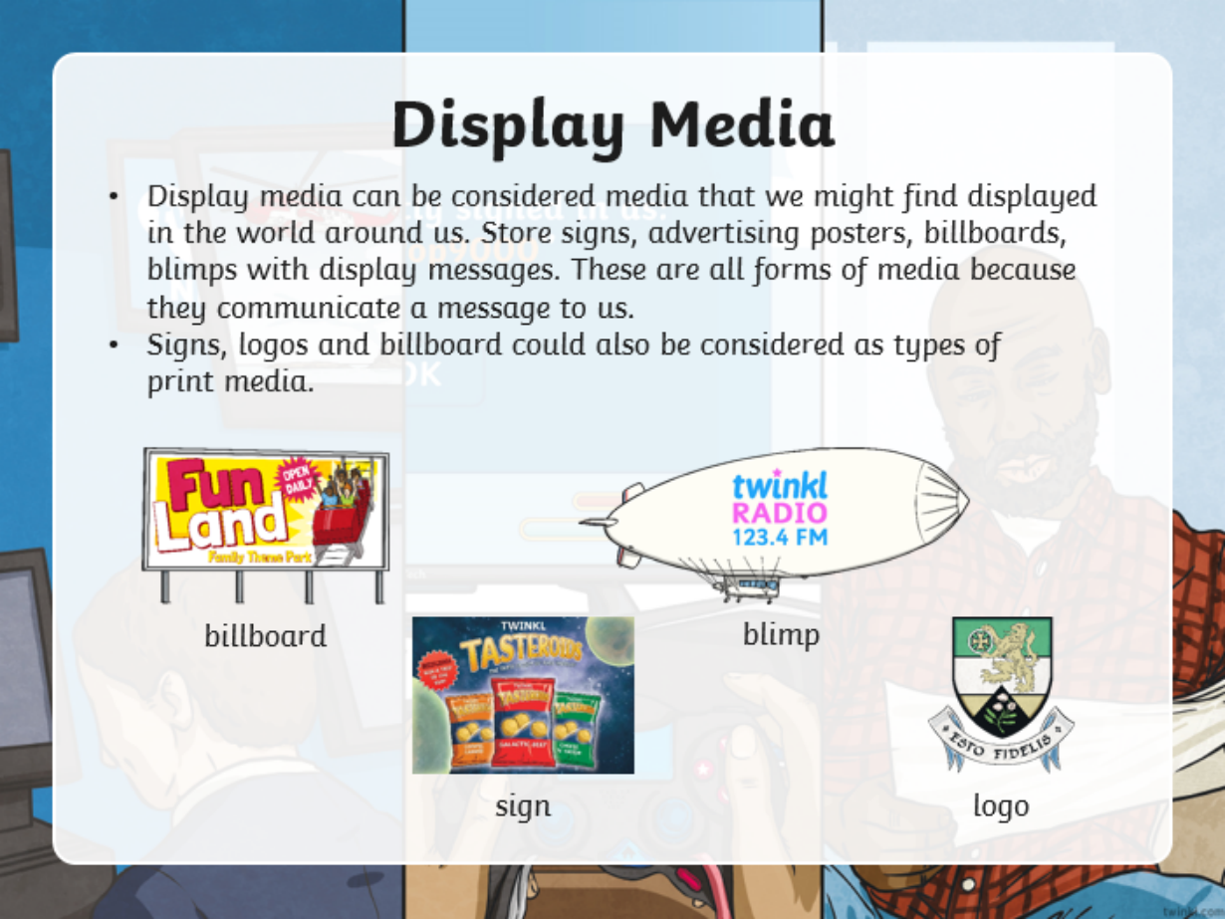
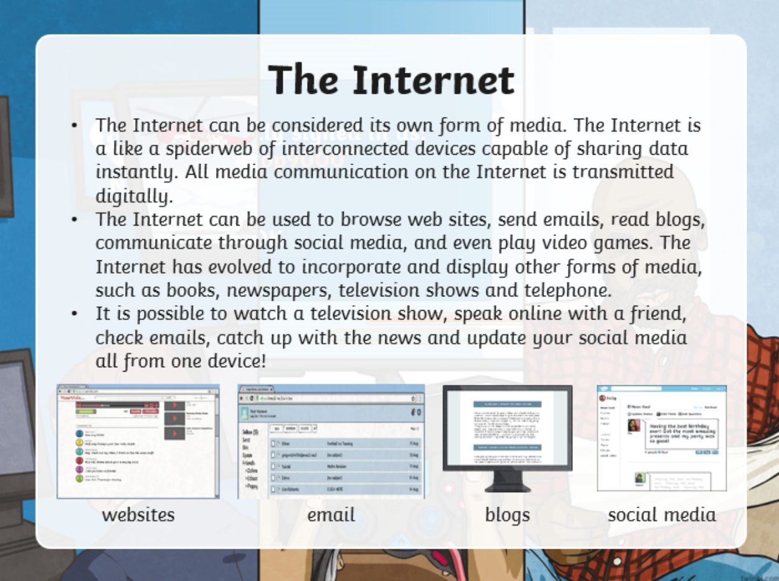

Choose a 'headline' about something that has been happening at school or at home and decide how you will spread this message.

You could use the Newsround style, writing a script to read, design a poster of Newspaper front page, or write an Internet Blog....

29.6.20 - Music
Listen to: Dance of the Sugar Plum Fairy by Pyotr Ilyich Tchaikovsky. 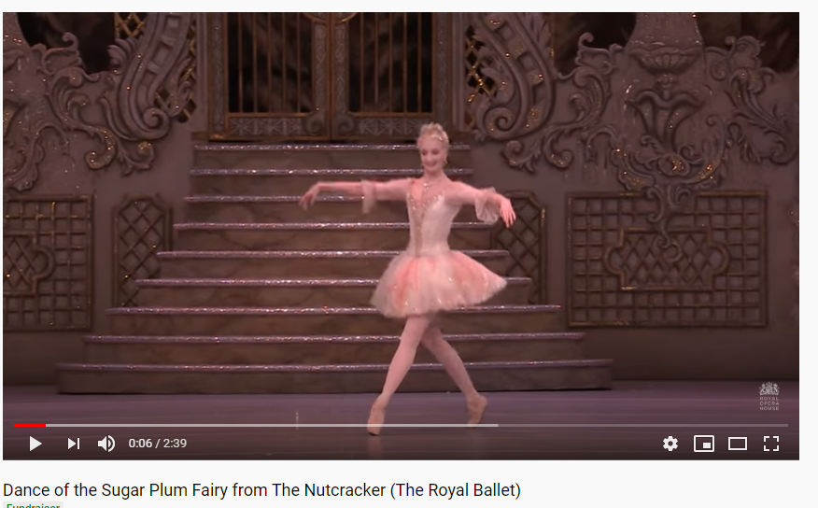 https://www.youtube.com/watch?v=zV1qLYukTH8
Reﬂect - an Orchestral composition from the Romantic period. Stand or sit to ﬁnd the pulse or just listen to the music. Discuss the music and what you can hear in it.
- “What can you hear?”
- “How does the music make you feel?”
- “How old do you think this music is?”
- “Does the music tell a story?”
- “Do you like the music?”

